AN ANALYSIS OF READING QUESTIONS IN THE
DUOLINGO ENGLISH TEST (DET)

(An Analysis Study of Reading Questions on the Duolingo English Test (DET)

UNDERGRADUATE THESIS

Submitted to the English Education Department of the University of Serambi Mekkah as a fulfilment for the degree of Sarjana Pendidikan

Ririn Agusnariyanti
NPM. 2011080010



ENGLISH EDUCATION DEPARTMENT
FACULTY OF TEACHER TRAINING AND EDUCATION
THE UNIVERSITY OF SERAMBI MEKKAH
BANDA ACEH
2024
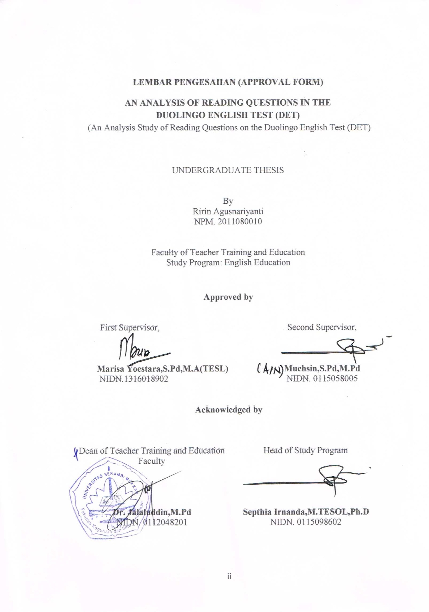
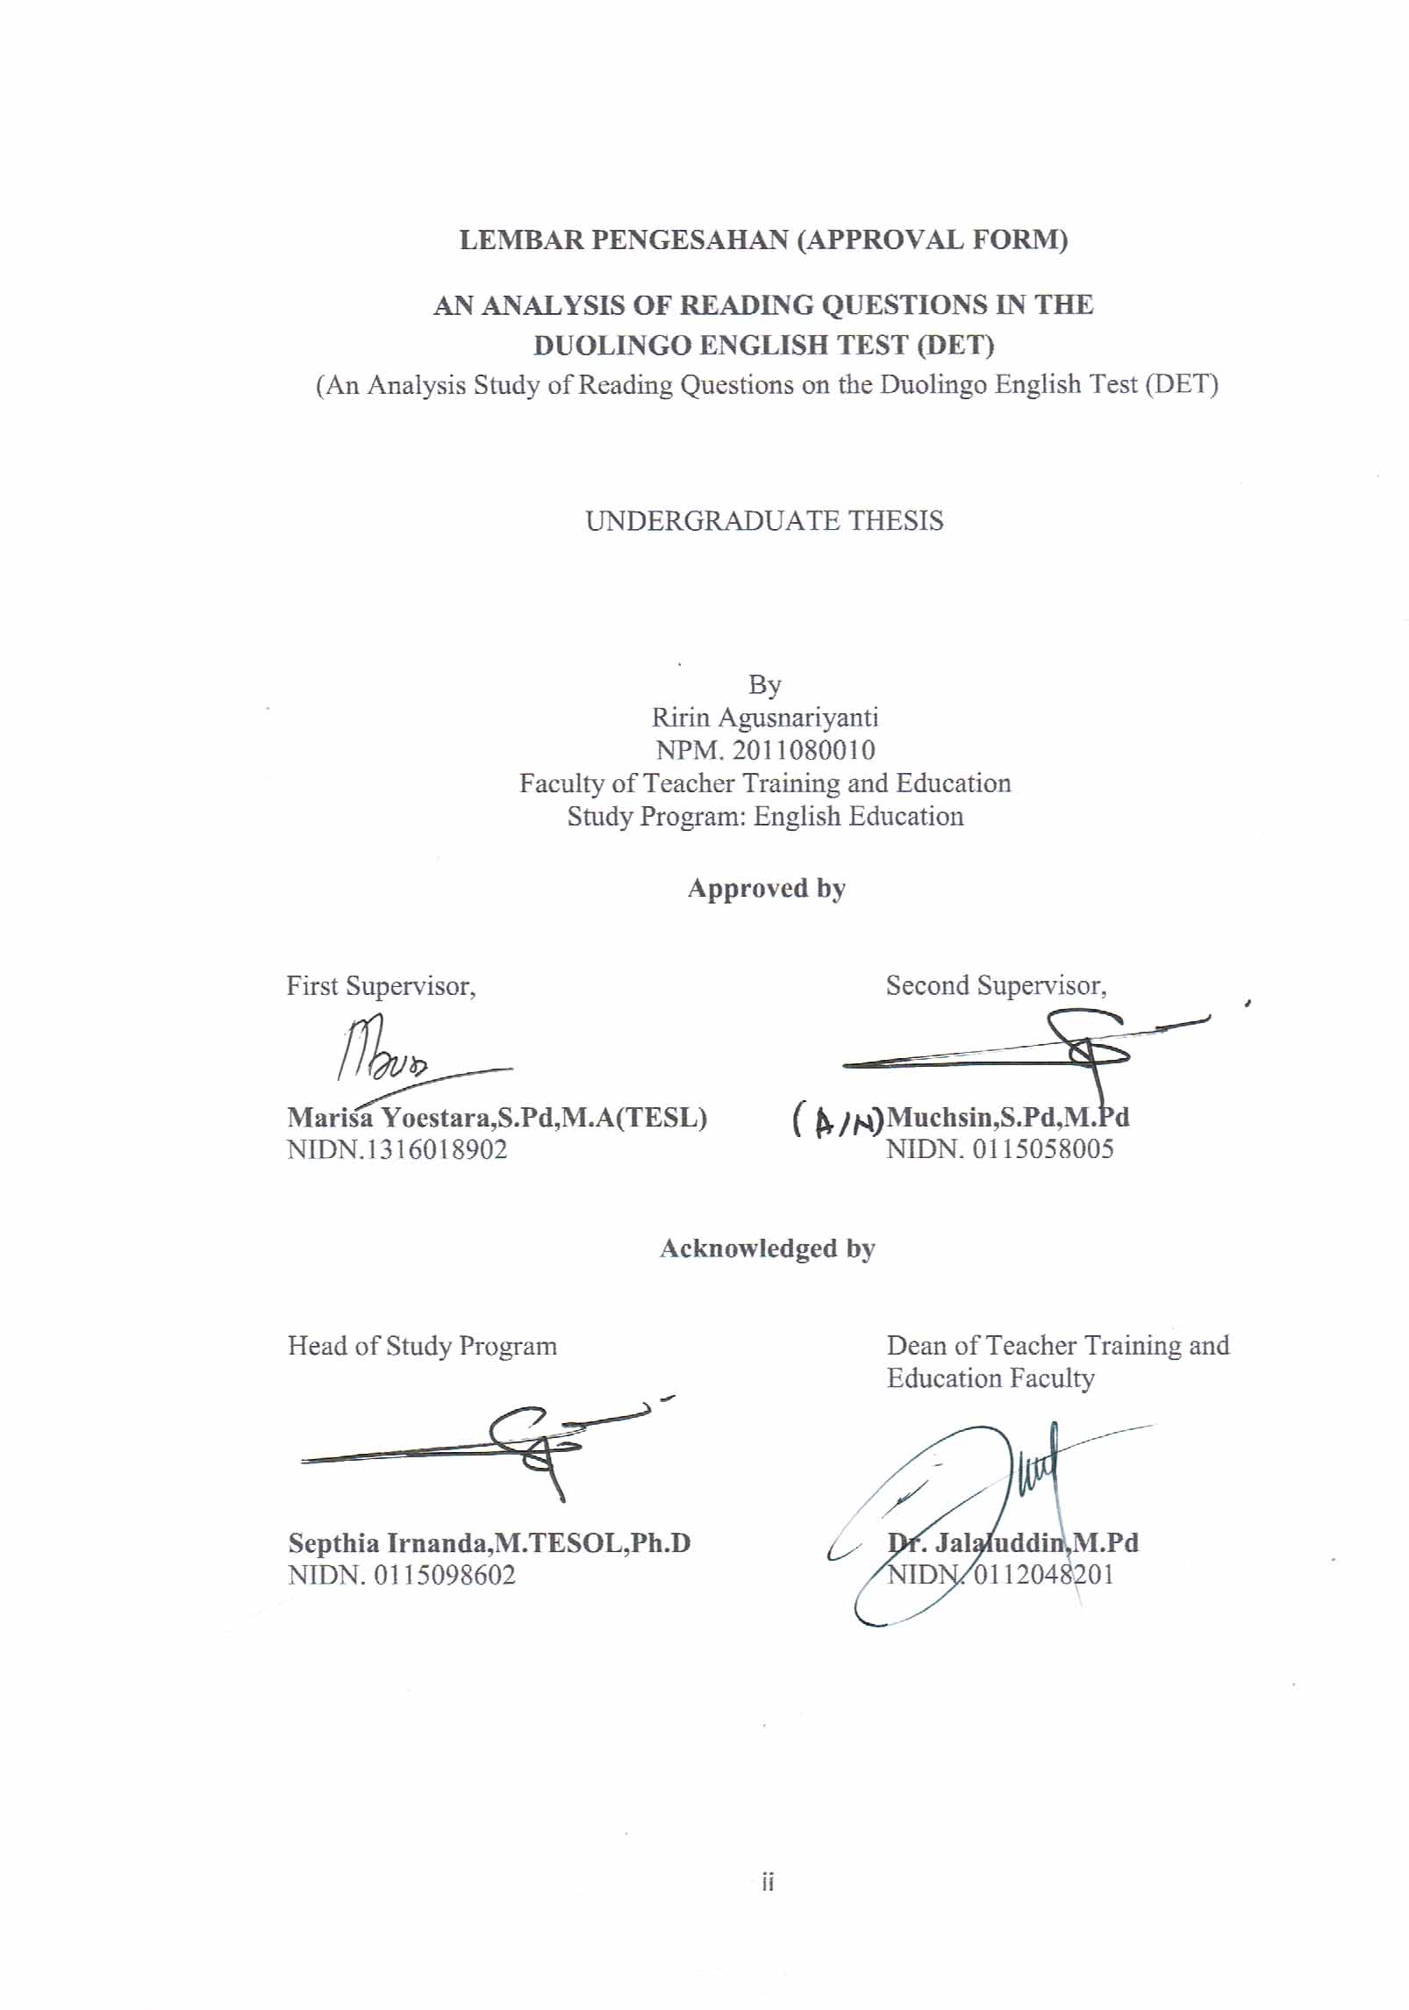

LEMBAR PENGESAHAN (APPROVAL FORM)

AN ANALYSIS OF READING QUESTIONS IN THE
DUOLINGO ENGLISH TEST (DET)
(An Analysis Study of Reading Questions on the Duolingo English Test (DET)

UNDERGRADUATE THESIS

By
Ririn Agusnariyanti

NPM. 2011080010

Faculty of Teacher Training and Education
Study Program: English Education

Approved by

First Supervisor, Second Supervisor,

Marisa Yoestara,S.Pd,M.A(TESL) Muchsin,S.Pd,M.Pd
NIDN.1316018902 NIDN. 0115058005

Acknowledged by

Head of Study Program Dean of Teacher Training and
Education Faculty

Septhia Irnanda,M.TESOL,Ph.D Dr. Jalaluddin,M.Pd
NIDN. 0115098602 NIDN. 0112048201

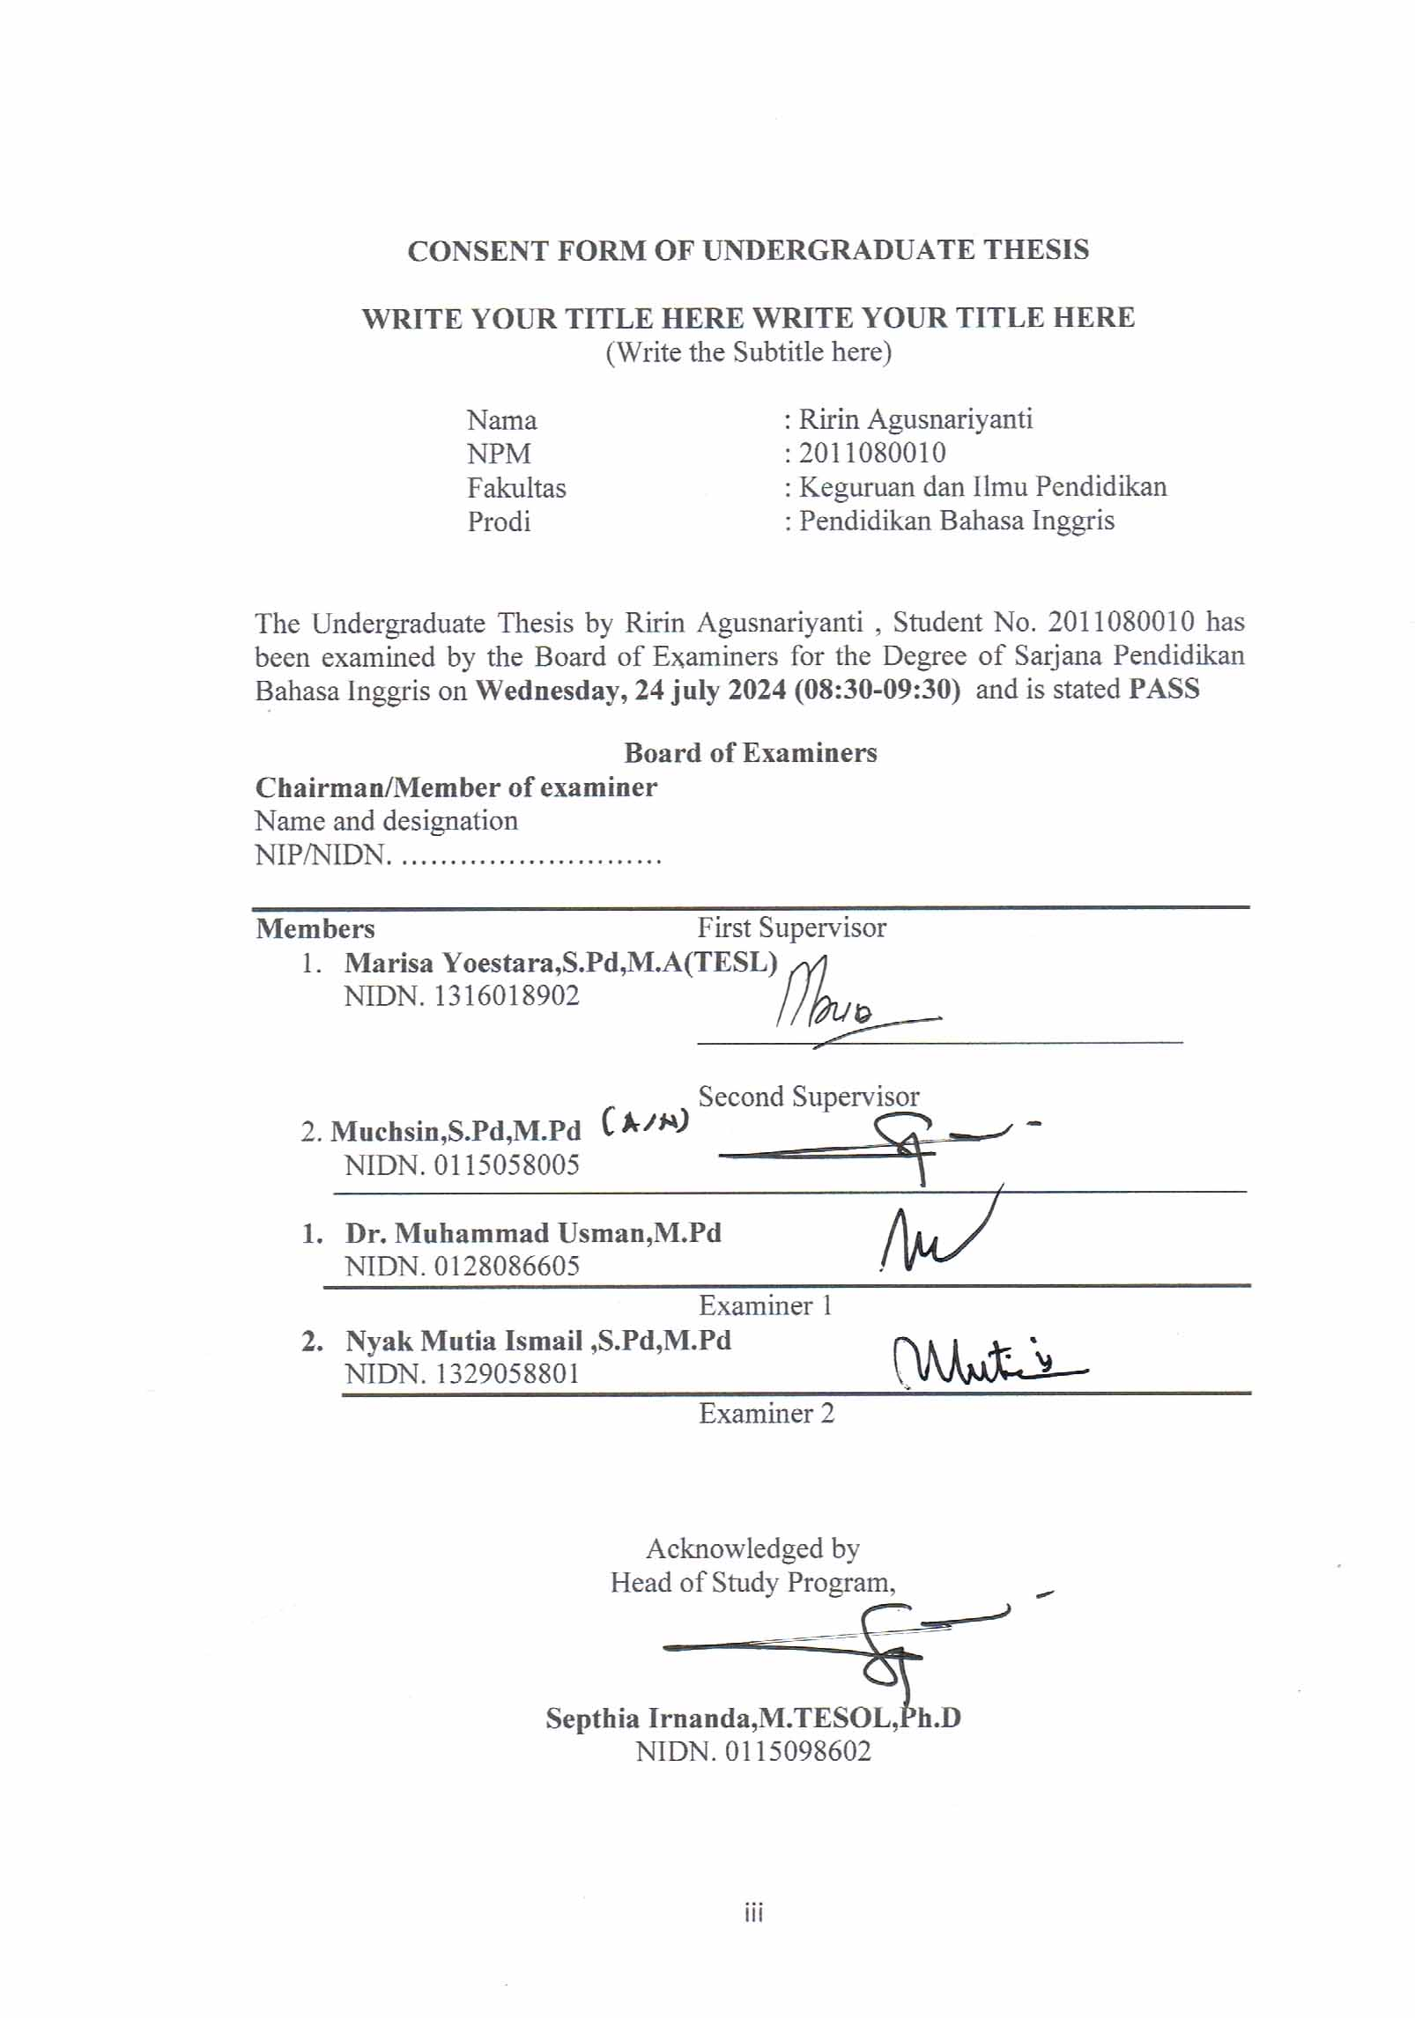
CONSENT FORM OF UNDERGRADUATE THESIS

WRITE YOUR TITLE HERE WRITE YOUR TITLE HERE
(Write the Subtitle here)

Nama : Ririn Agusnariyanti
NPM : 2011080010
Fakultas : Keguruan dan Ilmu Pendidikan
Prodi : Pendidikan Bahasa Inggris

The Undergraduate Thesis by Ririn Agusnariyanti , Student No. 2011080010 has been examined by the Board of Examiners for the Degree of Sarjana Pendidikan Bahasa Inggris on Wednesday, 24 july 2024 (08:30-09:30) and is stated PASS

Board of Examiners
Chairman/Member of examiner
Name and designation
NIP/NIDN. ………………………

Members First Supervisor
- Marisa Yoestara,S.Pd,M.A(TESL)
NIDN. 1316018902
_________________________________

Second Supervisor
2. Muchsin,S.Pd,M.Pd
NIDN. 0115058005

- Dr. Muhammad Usman,M.Pd
NIDN. 0128086605
Examiner 1
- Nyak Mutia Ismail ,S.Pd,M.Pd
NIDN. 1329058801
Examiner 2

Acknowledged by
Head of Study Program,

Septhia Irnanda,M.TESOL,Ph.D
NIDN. 0115098602

SURAT PERNYATAAN
(PERSONAL STATEMENT)

Saya yang bertanda tangan di bawah ini:

Nama : Ririn Agusnariyanti
NPM : 2011080010
Program Studi : Pendidikan Bahasa Inggris
Judul Skripsi : An Analysis of Reading Questions in the
Duolingo English Test (DET)

Dengan ini menyatakan bahwa Skripsi ini merupakan hasil karya tulis ilmiah saya sendiri, dan bukanlah merupakan karya orang lain yang pernah diajukan untuk memperoleh gelar sarjana atau dipublikasikan lewat media apapun. Adapun karya atau pendapat pihak lain yang dikutip, baik secara langsung atau tidak langsung ditulis sesuai dengan kaidah penulisan ilmiah yang berlaku.
Pernyataan ini saya buat dengan penuh tanggung jawab dan saya bersedia menerima segala konsekuensi apapun sesuai dengan aturan dan hukum yang berlaku bilamana dikemudian hari diketahui bahwa pernyataan saya ini tidak benar.

Banda Aceh, 10 Juli 2024

Ririn Agusnariyanti

ACKNOWLEDGEMENT
All praise and gratitude to Allah SWT Almighty who has bestowed grace, strength, guidance and compassion to researchers in completing and carrying out their extraordinary journey in completing their final research project.
Peace and blessings be upon the Prophet Muhammad, his family, friends and followers. The thesis entitled “AN ANALYSIS OF READING QUESTIONS IN THE DUOLINGO ENGLISH TEST (DET)” is submitted to the Department of English Education, Faculty of Education and Teacher Training, Serambi Mekkah University, as one of the requirements to fulfill part of the requirements in completing the Bachelor's Degree (S1) study.
The researcher would like to express his deepest gratitude to those who have helped in the completion of this thesis. First and foremost to my beloved parents, Mr. Supriadi and Mrs. Miswarti for their endless love, support, prayers, and encouragement to the researcher in every way. I would like to dedicate this thesis to them, because their help has given me life-changing experiences and learning.
Secondly, the researcher would like to express her deepest gratitude to the two supervisors, Ms. Marisa yoestara,S.Pd,M.A(TESL) and Mr.Muchsin, S.Pd,. M.Pd for the support, assistance, direction and enthusiasm that never broke during the researcher's education at the Postgraduate of Serambi Mekkah University. This thesis would not have been completed without their help and direction. In addition, the researcher would also like to take this opportunity to express appreciation to:
1. Mrs. Septia Irnanda, M. Tesol., Ph.D as the Head of the Department of English Education, Serambi Mekkah University
2. My entire extended family who have supported my thesis process, I am also grateful to my siblings Rudi Ismuhardi, Nurul Aslami, Maimun Saleh, Zuhrufiddin and Ahmad Fajri who always support me in completing my thesis.
3. To my best friends, Siti Nurhaliza, Muhammad Lutfi, Amanda Jaisa Nabila,Muhammad Haydar Mufti, Ainun Surlyanda, and Nina Nirmala,who have helped in the process of completing this thesis.
The researcher prays and hopes that Allah's blessings will be bestowed on all those who have helped the researcher in academic efforts that cannot be mentioned one by one. This thesis, according to the researcher, is far from perfect. Therefore, the researcher would greatly appreciate any constructive comments and recommendations from the readers to produce better research works in the future.

Banda Aceh, 24 July 2024

Ririn Agusnariyanti

ABSTRACT

Name : Ririn Agusnariyanti
Student No. : 2011080010
Study Program : English Education
Thesis Title : An Analysis of Reading Questions in the
Duolingo English Test (DET)

The research on Duolingo English Test (DET) Reading questions aims to find out what question patterns are used and how many frequencies of DET reading question types. The scope of this research is DET practice test questions, especially reading questions taken from the official DET website. The data consisted of 120 questions from 20 test sessions consisting of 6 questions per test. Data collection techniques used observation sheets and field notes. The data were analyzed using the descriptive interpretative method. The results showed the following: Question patterns used in DET reading questions are main idea (0.17%), detail information (0.5%), conclusion (0.17%), and vocabulary (0.17%). The frequencies of each type of DET reading question are multiple choice (0.33%), short answer or fill in the blank (0.33%), and matching test (0.33%). Based on the above research results, it can be concluded that the patterns and types used in reading DET are the same as other English language proficiency tests, with only minor differences. Understanding the questions and mastering vocabulary is also very important in answering unique DET reading questions.

Keywords: Analysis, Duolingo English Test, Reading Questions, Question Patterns and Types.

ABSTRACT

Name : Ririn Agusnariyanti
Student No. : 2011080010
Study Program : English Education
Thesis Title : An Analysis of Reading Questions in the
Duolingo English Test (DET)

Penelitian mengenai pertanyaan Reading Duolingo English Test (DET) bertujuan untuk mengetahui apa pola pertanyaan yang digunakan dan berapa banyak frekuensi dari tipe pertanyaan membaca DET. Lingkup penelitian ini adalah soal latihan tes DET, khususnya soal membaca yang diambil dari web resmi DET. Data terdiri dari 120 soal dari 20 sesi tes terdiri dari 6 pertanyaan per tes. Teknik pengumpulan data menggunakan lembar observasi dan catatan lapangan . Data dianalisis dengan dengan metode deskriptif interpratif. Hasil penelitian menunjukkan sebagai berikut: Pola pertanyaan yang digunakan pada soal membaca DET adalah ide utama(0,17%), detail informasi(0,5%), conclusion(0,17%) dan vocabulary (0,17%). Jumlah frekuensi dari setiap tipe soal membaca DET adalah multiple choiche (0,33 %), short answer or fill in the blank (0,33%) dan matching test (0,33%). Berdasarkan hasil penelitian diatas disimpulkan bahwa pola dan tipe yang digunakan membaca DET sama dengan tes kemampuan bahasa inggris lainnya , hanya sedikit terdapat perbedaan nya. Pemahaman soal dan penguasaan kosa kata juga sangat penting dalam menjawab pertanyaan membaca DET yang unik.

Keywords: Analisis, Duolingo English Test , Soal Membaca , Pola dan Tipe Soal.

TABLE OF CONTENT

Title Page
Approval Form ii
Consent Form ii
Personal Statement iii
Acknowledgement.............................................................................................. iv
Abstract.............................................................................................................. vii
Table of Contents ix
List of Tables x
List of Appendices xi

CHAPTER 1: INTRODUCTION 1
1.1 The Background of the Study 1
1.2 The Problem of the Study 3
1.3 The Aim of the Study 3
1.4 The Significance of the Study 3
1.5 The Scope of the Study 4
1.6 The Definition of Key Terms 5
1.7 Organization of The Study 5

CHAPTER 2: LITERATURE REVIEW 6

2.1 English Language Test 6
2.2 Kinds of English Language Test 6
2.3 Duolingo English Test 8
2.4 Pros And Cons of The Duolingo English Test 9
2.5 Reading Pattern 10
2.6 Reading Question 10
2.7 Types Of English Reading Question 11

CHAPTER 3: RESEARCH METHODOLOGY 14

3.1 The Research Design 14
3.2 The Research Object 14
3.3 The Research Instrument 14
3.4 The Data Analysis 14

CHAPTER 4: RESEARCH FINDINGS AND DISCUSSION 15

4.1 The Research Findings 15
4.2 Discussion 21

CHAPTER 5 CONCLUSION AND SUGGESTION 23

5.1 Conclusion 23
5.2 Suggestion 23
References 23
Appendices 25

LIST OF TABLES

Table 4.1 Title of the Table 16
Table 4.2 Title of the Table 18

LIST OF APPENDICES

1. Observation Sheet 2

CHAPTER I
INTRODUCTION

  - The Background of Study
In this world, almost all countries use language as a means of daily communication. Mailani et.al (2022) state that humans use language in all their daily lives. Language is so important in the whole of human life. Because when they want to convey an idea to others, they must use language so that others can understand what they are saying. Although each country has a different language, they are all united by the international language English. Rohmah (2005) Explain that English is a global language and not just an international one. Then, international language can be understood as a language used in international communication involving people from various countries. This makes learning English a very important thing.
Likewise, in the field of tests, be it entrance tests for several well-known universities or scholarships, english is defenitely used.Generally, the tests used are the TOEFL and IELTS tests. However,after the covid-19 pandemic, the duolingo english test became an alternative for english tests because it is easy to acces and the price is also affordable. So many test taker use this website to take the English test.
The Duolingo English Test (DET) is a modern English language proficiency evaluation for today's international institutions and students. The test is administered using computer-based adaptive technology, which means the difficulty of the questions is customized to each test taker. The entire test takes less than an hour. Test results are validated within two days and can be shared across institutions.
According to DET's official website, DET is also officially accepted by more than 4,500 institutions worldwide, and the number continues to grow. This opens up great opportunities for overseas scholarship hunters to get into prestigious universities such as Harvard Graduate Business School, Adams State University, and many more. However, this also requires extra learning. Although the Duolingo English test can be accessed anywhere and anytime, before starting the Duolingo test, it is better for participants to prepare things that make the test better and test takers score well by understanding the test structure, one of which is the reading test. The test includes several sections designed to assess different aspects of English language proficiency, such as listening comprehension, reading, writing, and speaking.One of the tests that has a difficulty level on the duolingo English test is the reading test. Some previous studies have analysed aspects of reading comprehension in various English tests, which can be helpful in this study.
The purpose of the reading comprehension test is to determine partisipant ability to understand and interpret the information contained in a text. Amin (2019) state that Good readers always have a purpose for reading. Making reading a goal will make us better at understanding reading
A previous study by Fauziati (2016), "Analysis of Reading Comprehension Items on the TOEIC Test", explains and describes the pattern of TOEIC reading questions in a simple way so that it is easily understood by test takers. So that later it can help participants in the reading test.
There are several kinds of elements in reading test questions. one of them is the pattern and type of reading questions.
Reading question patterns refer to the structure or arrangement of questions used to test reading comprehension. It includes different types of questions designed to measure different aspects of reading ability, such as literal, inferential, analytical and synthesis comprehension. Dyson and Haselgrove (2002) stated that Using different types of questions, comprehension was measured after reading from the screen at normal and fast reading speeds.
Reading question type refers to the category or classification of questions based on a particular purpose or focus. It includes questions designed to test various reading skills, including comprehension of factual information, inference, analysis, and synthesis. These question types provide a more detailed picture of the type of skill or comprehension tested by each question. Eason, et al (2012) stated that the main effects of text and question types, as well as the interactions in which the relationship between question types varies between text types.
However,there is no specific research that discusses the analysis of the reading test in duolingo english test ,therefore the researcher wants to analyse the reading test in duolingo english test.
  - The Problem of the Study
The problems in this study are as follow :
1. What are the patterns of reading questions on the Duolingo English Test ?
2. What is the frequency of occurence of each question type on reading questions in the Duolingo English Test?
1.3 The Aim of The Study
The purpose of this study are as follow :
- To find out the pattern of reading questions on the Duolingo English Test
- To find out the frequencies of each question type on reading questions in The Duolingo English Test
  - Significance of The Study
- Theoretical Significance
The significance of this study has two main points, namely:
- This study provides conclusions and solutions that, by analyzing the pattern of reading and describing the frequency of each type of question on text comprehension items in reading, it can help test takers in answering DET reading questions.
- To find out, this study can provide an argument that analyzing questions can help test takers prepare answers to Duolingo English Test reading questions.
- Practical Significance
- Students
Students can prepare themselves before taking the Duolingo English Test (DET) to take part in student exchanges and enroll in prestigious universities.
- Lecturer Lecturers can use the Duolingo English Test to continue their education abroad and can also apply the Duolingo English Test simulation to their students.
- For Future Research
language test can be used as a study base for future similar studies in mastering the language skills used in the Duolingo English Test.

  - The Scope of This Study
In this study, the researcher only limits the analysis of reading questions used in the implementation of the Duolingo English test.
- Variable analysis
The focus of this study is to thoroughly analyze the reading questions in the Duolingo English Test, with an emphasis on the patterns and types of questions used. Some key variables will be included in the analysis. The question patterns and types include main idea, detailed information, conclusion, multiple choice, short answer or fill in the blanks, and matching test questions. In addition, the purpose of this study is to ascertain the validity and relevance of the questions. The research will also evaluate the compatibility of the questions with other relevant English tests and examine key topics such as education, social, science, and culture. The results of this study are expected to provide a better insight into how effective reading questions are for measuring test takers' abilities and how this relates to the learning approaches they use.

- Variable description
This research focuses on analyzing the reading questions contained in the Duolingo English Test (DET). Specifically, it examines the patterns and types of questions presented, the complexity of the reading passages, and the linguistic features that affect test takers' comprehension. The scope is limited to the reading section of the DET, excluding other components such as listening, speaking, and writing. In addition, the analysis is based on a qualitative approach, using a sample of reading test questions from the DET. Through this analysis, this study aims to identify patterns and types of DET, and provide insights for test takers.
  - The Definition of Key Terms
1. Duolingo English Test
Duolingo English Test is a modern English proficiency evaluation for today's international institutions and students.
2. Reading
Reading is the act of reading written text or the process of deciphering and understanding it.
1.7 Organization of The Study
This study is divided into five chapters. Chapter I consists of the background the study,the problem of the study,the aim of the study, Significance of the Study, the Scope of this Study, the definition of key terms, and organization of the study. Chapter II contains a review of the literature related to English language tests which includes the definition of English language tests,kinds of english language test,duolingo english test, strength and weakness of duolingo english test,reading pattern,reading question,types of english reading question. Chapter III is information about methodology of the study. This chapter will discuss the situation of the field research that includes research design,research object,research instruments,data analysis. Chapther IV is the result of the study,which includes the research findings,discussion,and will be discussed in this chapther. And the last chapter V consists of conclusions and suggestions.

CHAPTER II
LITERATURE REVIEW

2.1 English Language Test

English language tests are assessments designed to assess a person's English language ability. According to Elder and Hardin (2008), the complexity of English as an international language and the growing prevalence of multilingualism necessitate a re-evaluation of English language tests. These tests are commonly used for a variety of purposes, including academic admissions, work requirements, immigration procedures, and language certification. English language tests typically assess skills such as reading, writing, listening, and speaking. Powers (2010) states that a comprehensive assessment of English language ability should include all four skills - reading, writing, listening, and speaking.English language test results are used by institutions and organisations to make decisions regarding an individual's ability to communicate effectively in English.
2.2 Kinds of English Language Test
There are different kinds of English tests designed to assess different aspects of language ability. According to Angraini (2016), different types of tests used in the teaching and learning environment are described. Meanwhile, Chen (2019) provides a comparative study of English proficiency tests with a focus on the College English Test (CET), Test of English as a Foreign Language (TOEFL), and International English Language Testing System (IELTS). There are different types of English language tests that are commonly used.
2.2.1 Academic English Test
IELTS (International English Language Testing System) is widely recognized as the English language test for non-native speakers. IELTS assesses your ability to communicate in English in all four language skills: listening, reading, writing and speaking. Hashemi and Daneshfar (2018) state that IELTS can be applied as a benchmark for English as an international language offering.
TOEFL (Test of English as a Foreign Language) is a standardized test that assesses English language proficiency for non-native speakers. This test is usually required for admission to English-speaking universities. Ortman et al. (1988) state that TOEFL requirements and English language proficiency depend on the English language proficiency of the test taker.
Cambridge Language Examinations (FCE, CAE, CPE, etc.) is a series of English language exams offered by the University of Cambridge. There are three main levels of the exam Cambridge English: First Certificate in English (FCE), Certificate in Advanced English (CAE), dan Certificate of Proficiency in English (CPE). Hawkey (2009) explains that the scale of the FCE and CAE examinations grew from an initial candidature of just 144 people to a significant contribution to the current total of over two million Cambridge ESOL candidates in 130 countries.
2.2.2 General English Test
TOEIC (Test of English for International Communication) is a widely recognised English language test that assesses the language skills of non-native English speakers in business and the workplace. It is used by companies, organisations and institutions around the world to measure a person's ability to understand and use English in a variety of professional environments.
OET (Occupational English Test) is a language test specifically designed for healthcare professionals, including doctors, nurses, and other healthcare professionals who wish to work or study in an English-speaking country. The test assesses a candidate's ability to communicate effectively in a medical setting, with an emphasis on language skills relevant to the medical field. Carr (2021) explains that medical candidates prefer OET over IELTS for medical professions
BULATS (Business Language Testing Service) is a language assessment service developed by Cambridge English Language Assessment, part of the University of Cambridge. BULATS is used to assess a person's language ability, especially in a business or professional context. Arifin (2018) explains that if a test is not reliable, it is considered invalid.
2.2.3 English Proficiency in Specific Skills
PTE Academic (Pearson Test of Academic English) The Pearson Test of English Academic (PTE Academic) is a computer-based English language test designed to assess the language skills of native English speakers who wish to study or work in English-speaking countries. The test is widely accepted by universities, colleges and government agencies around the world. Riazi (2013) stated that the academic performance of PTE Academic participants improved academically.
Linguaskill: Linguaskill is a suite of English language proficiency tests developed by Cambridge Assessment English, part of the University of Cambridge. These tests are designed to assess an individual's English language ability in a variety of contexts, such as academic, professional and general communication.
2.2.4 English Placement Test
Michigan English Test (MET) The Michigan English Test (MET) is a widely recognised English language test. It was developed by the University of Michigan and is administered by Cambridge Assessment English. The MET is used to assess the English language ability of non-native speakers. Liu et.al (2022) It is used for educational and occupational purposes, such as educational advancement, scholarships, and/or career progression.
2.2.5 English Test for Citizenship and Immigration
Versant English Proficiency Test : The test is often used in academic, professional and immigration settings to determine a person's language ability for specific purposes. Moere et al (2009) explain that a candidate's ability can be investigated and estimated in a fair and standardised way by presenting a series of independent items targeted with difficulty levels at different ICAO levels.
These are just a few examples, and the choice of a particular test is often dictated by the purpose of assessing language ability. It is important to research and choose the best test based on each participant's personal needs and requirements.
2.3 Duolingo English Test

Duolingo English Test is an adaptive English test that can be administered online. Maris (2020) describes the Duolingo English Test (DET) as a computer-adaptive English proficiency test with a proposed measurement model and real-time scoring system. The test is easily accessible anytime, anywhere. TOEFL and IELTS tests are commonly used. However, after the Covid-19 pandemic, Duolingo English tests emerged as an alternative to English tests as they are easily accessible and affordable. Therefore, many test takers are using this site to take their English exams.
The Duolingo English test has many different types of tests. Listen to a conversation or monologue and answer related questions. (Reading) Read text, answer questions, and complete text-based tasks. (Writing) Prove test takers' ability to write in English by writing essays and answering questions. (Speaking) Evaluate the test taker's ability to speak English, this includes answering oral questions or answering questions on the subject matter. (Grammar and Vocabulary) This test may target understanding of grammar and vocabulary in specific contexts. (General Communication Skills) This test covers the participant's general communication skills in English, including everyday language use and common expressions (Interactive Tests).
Some tests may include interactive elements. For example, click the answer on the picture or combine words. Duolingo English tests cost less than other tests, and results are said to be released within two days. By purchasing the Faster Results feature, participants can receive test results faster, within 12 hours of taking the test. Brenzel and settles (2017) explains that DET has advantages such as on-demand accessibility, low cost, and fast result reporting. Duolingo English tests are also accepted by more than 4,500 educational institutions around the world, making it easier for students and teachers to be accepted into prestigious universities.
2.4 Strength And Weakness of The Duolingo English Test
Every English proficiency test must have its own advantages and disadvantages. It depends on the needs of the participants who want to take the test. However, researchers hope that participants use tests that make it easier both in terms of cost and time to carry out the test.
  - The advantages of the duolingo English test are that it is easier to access, cheaper than other similar tests and test results come out faster than other language ability tests. Wagner (2020) The Duolingo English Test (DET) is praised for its accessibility, being an inexpensive "at home" test that can be taken anywhere and provides rapid score reporting.
  - The disadvantages of the duolingo English test are that the test result certificate is not generally accepted (all institutions in the world), difficult to access when network conditions are bad. Wagner (2020) explain that it is important to note that the test is not universally accepted and may not be suitable for all institutions.
2.5 Reading Pattern
Reading pattern refers to the way a person reads and processes information from written text. It includes various strategies and methods for understanding and processing reading material. According to Bock et al (2018), the cognition required to complete a pattern varies depending on the type of pattern.there are some examples of common reading patterns. There are some common reading comprehension test question patterns:
- Main Idea is The main idea, which is typically expressed in a single topic sentence in a paragraph, is the primary point or argument that the author intends to convey to the reader. Finding the main idea makes it easier to understand the overall message and purpose of the text. In longer texts, the main idea might be spread across several sentences or even paragraphs.
- Detailed Information is Detailed information often includes: Specific facts, examples, descriptions, and data that support and elaborate on the main idea provide depth and clarity, helping the reader understand and visualize the main idea more thoroughly.
- Conclusion In an essay or research paper, the conclusion summarizes the main conclusions and arguments discussed in the writing, restates the thesis based on the evidence, and may suggest additional research or implications of the findings.
- Vocabulary is the collection of words known and used by a person or group of people in a language. It includes meaning, pronunciation, and how words are used in various situations. Vocabulary can be divided into several categories: active vocabulary, passive vocabulary, general vocabulary, and specialized vocabulary.Author's purpose: What is the author's purpose or intention in writing this passage?
- Tone: Understanding the author's attitude or emotional perspective toward the subject or audience. You might be asked to determine whether the tone is sarcastic, enthusiastic, critical, etc.
- Style: Analyzing how the author's unique manner of writing contributes to the overall message or effectiveness of the text. You might need to comment on how the author's use of literary devices, sentence structure, or vocabulary contributes to the text's purpose or impact.
- Comparison and Contrast are techniques that analyze and present the similarities and differences between two or more things, ideas, or concepts. They are often used in writing, research, and conversation to highlight connections and nuances.
2.6 Reading Question
Reading questions are used to assess a reader's comprehension of specific reading materials, including books, articles, and texts. To make sure the reader has comprehended the information presented in the reading material, reading questions serve this goal. Reading questions can be closed or open-ended, asking readers to provide a brief response or mark their responses as correct or incorrect. Open-ended questions allow readers to discuss concepts or ideas they have read. Reading comprehension and ability are frequently assessed through the use of reading questions in the classroom.
2.7 Types of English Reading Question
Types of reading tests include different formats designed to measure different aspects of a person's reading comprehension ability. Kartini (2018) states that participants need to know the type of reading comprehension so that the content tested actually matches the expected content. Common reading comprehension tests include:
- Multiple Choice Test: Multiple-choice tests are commonly used in educational settings and standardized tests as they allow for quick and objective assessment. These tests assess knowledge, understanding, and sometimes application of concepts, as questions. A multiple-choice test is a type of assessment in which participants are presented with questions, each followed by several possible answers or choices. Only one of those choices is correct, and the test taker must select the correct one.
- True/False Test: A True/False test or question is a type of assessment where participants are given statements and must determine whether each statement is accurate (true) or inaccurate (false). These questions are often used to evaluate knowledge, understanding, and sometimes to measure critical thinking, as they require participants to recognize the validity of a fact or concept. They are popular in quizzes and exams because they are simple and easy to understand.
- Short Answer or Fill in the Blank Tests questions often require a concise and direct answer, usually in one or a few words or sentences, and participants are required to give a short answer or complete a sentence by filling in the words or sentences. Fill-in-the-blank questions include sentences or statements with missing parts that the participant must fill in accurately. This type of test is used to assess knowledge, recall, and understanding of specific facts or ideas. It requires more precise recall than the multiple-choice format.
- Matching Tests Matching tests are typically used to evaluate participants' understanding of relationships, connections, and comprehension of pairing information, making them suitable for superfection. In this type of test, participants are given two related lists, each of which contains prompts, terms, or questions, while the second list contains related answers, definitions, or concepts.
- Cloze Test are commonly used to assess reading comprehension, vocabulary, language skills and context. The test requires participants to fill in the blanks with missing words based on grammar, context or key concepts in the reading passage. They must also use their knowledge of the language and subject matter to meaningfully complete the text.
- Reading Comprehension Tests Reading comprehension tests are typically used to assess reading ability and are designed to measure their ability to comprehend, interpret, and analyze written text. These tests usually include a reading passage followed by questions that may require the reader to identify main ideas, recall details, make inferences, understand vocabulary in context, or understand the author's purpose and tone.
- Critical Reading Test Critical reading tests are commonly used to assess higher-order reading skills, including ability to read text analytically and thoughtfully, going beyond basic comprehension to evaluate deeper meaning, implications, and arguments contained in the text. Critical reading tests require readers to consider things like the author's intent, validity of arguments, underlying assumptions, tone, and rhetorical techniques.
- Speed Reading Test is a test that aims to measure how fast a person can read and process a text while still understanding it. Participants are usually given a text to read within a certain period of time, and then asked questions to check how well they understand the content of the text. The results of this test show one's ability to absorb information quickly.
- SAT/ACT Reading Test The SAT/ACT Reading Test is part of the standardized SAT and ACT exams that evaluate students' ability to read, comprehend, and analyze passages from a variety of subjects, including literature, social studies, history, and science. Students are required to read passages and answer multiple-choice questions that evaluate skills such as identifying main ideas, making inferences, interpreting data, and understanding vocabulary in context. This is a section intended to measure college and career readiness through the assessment of critical reading, comprehension, and analysis abilities, which are skills necessary to succeed in higher education.
- English as a Second Language (ESL) Reading is a test intended to measure the comprehension ability of people learning English as an additional language. The test usually consists of a reading passage followed by questions that evaluate their understanding of main ideas, details, vocabulary, inferences, and context clues. The questions and readings are often designed to suit non-native English speakers, focusing on vocabulary from colloquial to academic.

CHAPTER III
RESEARCH METHODOLOGY
3.1 Research Design

This research design is a descriptive qualitative study. According to Rahman and Kurniawati (2021) Descriptive qualitative research is a form of research that is systematic, planned, and has clearly structured guidelines from the beginning to the making of the research design. So in this research, researchers will describe the pattern of reading and describe the frequency of each type of question on text comprehension items in reading on the Duolingo English Test.
3.2 Research Object
The object of this research comes from the official Duolingo English Test website [https://englishtest.duolingo.com/home]. The number of test questions to be analyzed is 120 questions from 20 test sessions, consisting of 6 questions per test.
3.3 Research Instruments
In this study, researchers used an instrument in the form of an observation sheet consisting of a checklist of reading patterns and the frequency of each type of question on text comprehension items in reading on the Duolingo English Test. The observation sheet will be made by the researcher and supported by theories that discuss reading patterns, the checklist is a list of types and patterns of questions in the reading test. The researcher also used field notes which functioned to record other things found in the research but not included in the observation sheet checklist points.
3.4 Data Analysis
Data obtained from observation sheets and field notes were then analyzed using the interpretative descriptive method. Sugiyono (2005) states that descriptive methods describe or analyze research results, but are not used to make broader conclusions. Because Whitney (1960 ).Descriptive methods include finding facts along with proper interpretation. Descriptive research can be interpreted as research that aims to explain symptoms, events, or actual problems. In principle there are two main stages in this analysis, namely classification and description. The complete procedure can be explained as follows: First, the reading patterns will be grouped. Second, the reading patterns will be described clearly according to the results found.
CHAPTER IV
RESEARCH FINDINGS AND DISCUSSION
In this chapter, the researcher will describe the results of this study. After collecting data from 20 reading test sessions on the duolingo english test web.
4.1 Research Findings
From the data found using observation sheets and field notes, many differences were found in the patterns and types of reading questions in the Duolingo English Test. The observation sheets contained 7 points on the patterns of reading questions and 8 points on the types of reading questions.
4.1.1 Pattern of Reading Question
The components of the questions asked in the reading question patterns of the DET consist of the main idea, detailed information, conclusion, vocabulary, author’s purpose, tone and style, comparison, and contrast.
- Main Idea
In the main idea questions, the test takers' understanding of the main idea of the passage is assessed.
Example question

Teva has a passion for photography. He loves to take pictures of local spots and then sells the pictures as postcards. He goes to coffe shops and restaurants to show them his samples, and then offers them deals to buy postcards with pictures of their establishment. Teva makes several thousand dollars a year from this passion. Some of the photographed locations actually don’t have any plans to advertise,but the owners like his work so much that they purchase his products. Sometimes he offers them the photos to be used in their future advertisements,or he just gets permission to sell the photo as postcards. He takes advantage of the latter option whenever he can because it allows his work to be shared with people all over the world. | Select the idea that is expressed in the passage.  a. Teva has a passion for photography and he loves to take pictures of local spots.  b. Teva decided to take photography class because he was interested in taking better quality pictures.  c. Teva would take the same photos two or three times to get better shots.  d. Teva had hundreds of pictures on this camera, enough to run out of storage.
Source : Official Website Duolingo English Test
- Detailed Information
In this type of question, test takers are asked to understand the detailed information provided in the interactive reading passage.
Example question:
Ali was a bright child and loved stories,so his parents taught him how to read before he started school. He was excited to start school and he loved his teachers, Ms Tazi. She was kind and intelligent and Ali looked forward to her class every day. He learned fast and soon could read all the books at his reading level. Over the next few months, Ms Tazi. Made sure Ali could do his assignments in other areas like math and science. He loved being able to read by himself, and soon he had read all the books in his library. He even learned to write stories from his favorite books. | Click and drag text to highlight the answer to the question below.  What did Ali learn from reading his favorite books.
Source : Official Website Duolingo English Test

- Conclusion
In this type of question, which is related to the conclusion of the text below, test takers must understand the text in order to answer the conclusion of the passage.
Example question:
Ali was a bright child and loved stories,so his parents taught him how to read before he started school. He was excited to start school and he loved his teachers, Ms Tazi. She was kind and intelligent and Ali looked forward to her class every day. He learned fast and soon could read all the books at his reading level. Over the next few months, Ms Tazi. Made sure Ali could do his assignments in other areas like math and science. He loved being able to read by himself, and soon he had read all the books in his library. He even learned to write stories from his favorite books. | Select the best little for the passage .  a. Ms,Tazi’s Class  b. Ali’s Class Project  c. Ali’s First Year at School  l  d. The Big Brother Sharing Stories
Source : Official Website Duolingo English Test

- Vocabulary
In this type of question, which is related to vocabulary, test takers can answer well if they have a large vocabulary and can use it correctly in sentences according to grammar.
Example question:
The use plastics in industry and consumer goods has become a -------Important part of our daily ------ activities plastics are usually produced through chemical processes that ------ the physical structure of certain ---------materials some plastics are ------to make automobile bodies. Packaging, and disposable products. According to industry-----many more kinds of plastics will be seen in the future. | Select the best option for each missing word.  - Activities  - Change  - Very  - Statistics  - Added  - materials
Source : Official Website Duolingo English Test

The following table shows the frequency shows of occurance of key components in the main idea test questions that were administrered over 20 sessions.
Tabel. 1 Frequency of Main Idea Question

No | Main Idea | Detailed Information | Conclusion | Vocabulary | Total
session 1 | 1 | 3 | 1 | 1 | 6
session 2 | 1 | 3 | 1 | 1 | 6
session 3 | 1 | 3 | 1 | 1 | 6
session 4 | 1 | 3 | 1 | 1 | 6
session 5 | 1 | 3 | 1 | 1 | 6
session 6 | 1 | 3 | 1 | 1 | 6
session 7 | 1 | 3 | 1 | 1 | 6
session 8 | 1 | 3 | 1 | 1 | 6
session 9 | 1 | 3 | 1 | 1 | 6
session 10 | 1 | 3 | 1 | 1 | 6
session 11 | 1 | 3 | 1 | 1 | 6
session 12 | 1 | 3 | 1 | 1 | 6
session 13 | 1 | 3 | 1 | 1 | 6
session 14 | 1 | 3 | 1 | 1 | 6
session 15 | 1 | 3 | 1 | 1 | 6
session 16 | 1 | 3 | 1 | 1 | 6
session 17 | 1 | 3 | 1 | 1 | 6
session 18 | 1 | 3 | 1 | 1 | 6
session 19 | 1 | 3 | 1 | 1 | 6
session 20 | 1 | 3 | 1 | 1 | 6
Total | 20 | 60 | 20 | 20 | 120
Persentase ( %) | 16,7 | 50 | 16,7 | 16,7 | 100
From the data presented, the numbers for Main Idea, Conclusion, and Vocabulary are always the same in each session, which is 1. As for Detailed Information, the value is always 3 in all sessions. At the bottom of the table, there is a number row that shows the total number for each category, namely 20 for Main Idea, 60 for Detailed Information, 20 for Conclusion, 20 for Vocabulary, and 120 for the total number of tests. the percentage results show that in each test session the number of main ideas is 0.17%, detailed information is 0.5%, conclusion is 0.17% and vocabulary is 0.17%.
4.1.2 Types of Reading Question
Regarding the types of questions in the reading section of the Duolingo English Test (DET), analysis shows that there are several types of questions used.
- Multiple Choice Questions.
Select the idea that is expressed in the passage.
a. Line graphs show the relationship between two variables over time or across regions on a map.
b. A pie chart is used to show a pie slice. Which represents a certain percentage of the whole
c. Bar charts are versatile because there are many ways to present data using this chart type
d. Scatter plots display relationships between two variables, but they are limited to two variables as well.

Source : Official Website Duolingo English Test

- Short Answer or Fill in the Blanks Questions.
A bar chart is one of the most versatile chart types because there are many different ways to present and interpret data using this chart type. Bar charts are often used in business and marketing , but, in fact, they are used in many different situations. For example, a bar chart might be used to compare the time a company took to complete project. The type of bar chart you choose will depend on what data you have and how you want to present it. If you’re considering using a bar chart, then make sure you understand the strengths and weaknesses of this chart time . with a little knowledge , you can find the right bar chart to accurately portray your data. | Click and drag text to highlight the answer to the question below.  How should you decide on the type of chart to use?
Source : Official Website Duolingo English Test

- Matching Test Questions

A bar chart is one of the  versatile chart types because there  Many different ways to present and interpret data using this chart bar chart are often used in business and marketing ,but, in fact, they are in many different | Select a word  Select a word  Select a word  Select a word
Source : Official Website Duolingo English Test

In testing participants' reading ability, different types of reading questions are often used to evaluate their understanding of the text. These questions vary based on the level of difficulty and the purpose of the assessment.
The following table shows the frequency of the types of reading questions commonly used in reading tests.

Tabel. 2 Frequency of Types of Reading Questions

No | Multiple Choiche | Short Answer Or Fill In The Blank | Matching Test | Jumlah
session 1 | 2 | 2 | 2 | 6
session 2 | 2 | 2 | 2 | 6
session 3 | 2 | 2 | 2 | 6
session 4 | 2 | 2 | 2 | 6
session 5 | 2 | 2 | 2 | 6
session 6 | 2 | 2 | 2 | 6
session 7 | 2 | 2 | 2 | 6
session 8 | 2 | 2 | 2 | 6
session 9 | 2 | 2 | 2 | 6
session 10 | 2 | 2 | 2 | 6
session 11 | 2 | 2 | 2 | 6
session 12 | 2 | 2 | 2 | 6
session 13 | 2 | 2 | 2 | 6
session 14 | 2 | 2 | 2 | 6
session 15 | 2 | 2 | 2 | 6
session 16 | 2 | 2 | 2 | 6
session 17 | 2 | 2 | 2 | 6
session 18 | 2 | 2 | 2 | 6
session 19 | 2 | 2 | 2 | 6
session 20 | 2 | 2 | 2 | 6
jumlah | 40 | 40 | 40 | 120
Persentase (%) | 33,3 | 33,3 | 33,3 | 100

This table shows the frequency of question types in the 20-session reading test. There are four question types listed, namely: Multiple Choice: There are 2 multiple-choice type questions in each session. Short Answer or Fill in the Blanks: There were 2 short answer or fill-in-the-blank type questions in each session. Matching Test: There are 2 matching type questions in each session. Each session consists of a total of 6 questions of all four types. In the last row, the table shows the total number of questions of each type for 20 sessions, which is 40 questions of each type. The percentage of each question type is 33.3% of the total 120 questions. This table gives an idea of the composition and number of questions of the different types used in the reading test, as well as the balanced distribution among the four types of questions tested.

4.2 DISCUSSION
This research question aims to find out about what are the patterns of reading questions in the Duolingo English test. Based on the results of the analysis, the Duolingo English Test uses 3 question patterns commonly used in other English tests, to assess participants' reading skills. There are 3 patterns used in DET reading questions, the question pattern is centered on understanding the text as a whole, starting from identifying the main idea, detailed information to drawing conclusions. These results are similar to previous research by Fauziati (2016) where researchers found that the TOEIC test also uses the same pattern which includes (1) Questions about the main idea or main discussion points in the reading, and the possibility of the right title (2) Questions about information that is directly stated in this reading; (3) Questions about information that is implied, suggested, or can be concluded. In the DET reading question pattern, the main idea answer is longer than the TOEIC answer. For the pattern of questions about detailed information in DET questions only explicit information, while in TOEIC questions about information there are 3 types, namely explicit and implied, suggested or inferred. The question pattern about inference in DET questions refers more to the title that is suitable for a paragraph, while in the TOEIC test inference is included in information questions.
The frequency of question types used by DET is more varied compared to the TOEIC test which only uses multiple choice question types on all questions in accordance with previous research by chon and shin (2010) for predicting the level of difficulty of the test will be more effective for predicting the overall level of difficulty than for individual test items of the CSAT type (i.e., multiple choice format). while DET uses multiple choice, matching, short form and fill in the blank question types. These different patterns and item types allow for the assessment of reading ability from various aspects, such as contextual comprehension and vocabulary recognition. Understanding the pattern and type of reading questions is very helpful for test takers in answering questions in accordance with previous research that explains and describes the pattern of TOEIC reading questions in a simple way so that it is easily understood by test takers. However, previous research concluded that mastery of vocabulary is very important for success in the TOEIC test because 50% of it is mastery of vocabulary. in DET reading questions also cannot be separated from mastery of vocabulary as well as the TOEIC test. DET not only focuses on vocabulary but also on comprehension questions that are a little unique compared to the TOEIC test.
The results of this study are in line with previous findings in English language education, particularly regarding the use of technology in learning. As previous studies have shown, the use of digital media and online platforms is proven to be effective in increasing students' motivation and engagement in English language learning. However, this study also uncovered some new findings that expand our understanding. For example, the use of technology turns out to be highly dependent on teachers' readiness to integrate digital tools into their learning. In addition, this study found problems that students face when adapting to technology-based learning. This is an issue that has not been widely discussed in previous studies.
In the context of education, this finding emphasizes the importance of continuous training for teachers in the use of learning technologies. Educational institutions need to consider developing comprehensive training programs to enhance the digital competence of educators. Additionally, the results of this research can also serve as a basis for revising the English language curriculum to more effectively integrate the use of technology. From an academic perspective, this study opens up opportunities for significant further study. Researchers can further explore how specific technologies affect specific components of language learning, such as speaking or writing ability. The methodology used in this research can also be adapted to investigate the effectiveness of technology-based learning in other subject contexts or different levels of education. This paves the way for a more comprehensive understanding of the role of technology in enhancing learning outcomes in various disciplines and educational levels.

CHAPTER V
CONCLUSION AND SUGGESTION
5.1 Conclusions
Based on the results of data analysis and discussion, the researcher obtained the following conclusions:
1. the results of the analysis of the question patterns used in reading DET questions are not much different from other English proficiency tests, such as determining the main idea, detailed information, conclusions and vocabulary. for the type of question using the same type as other English tests, such as: mulptiple choice test, short answer and fill in the blank, matching test. However, the discussion is quite unique and uses shorter texts, usually 3-5 sentences that form a paragraph. Topics can vary from science, history, culture, to daily life.
2. The data obtained from the observation sheet on the detailed information question pattern appears more often than other patterns. So that the test takers must focus more on this. The results of analyzing field notes show that understanding and speed in reading and answering questions are needed. Because each reading session is only given 7-8 minutes. accuracy in answering questions also determines how the next question will be. DET is an adaptive test, the more correct answers, the more difficult the next question will be if many questions are wrong, the easier the test will be.
5.2 Suggestions
Based on the research results and conclusions previously described, the researcher provides several suggestions, among others:
1. Duolingo English Test can be an alternative test for applying for scholarships or exchanges abroad because it has been accepted by more than 4,500 institutions around the world. By learning the patterns and types of questions DET makes it easier for us to answer questions.
2.Researchers suggest that for future research, researchers can conduct research on other DET skills. such as listening, writing and speaking skills.
3. This research is a small study, therefore it is expected that in future studies, researchers will increase the level of discussion of the analyzed questions to a higher stage.

REFERENCES

Amin,M,R (2019) Developing reading skills through effective reading approaches. International Journal of Social Sciences & Humanities.4(1),35-40. https://doi.org/10.5281/zenodo.255799
Angraini,N. (2016) Types of english language test. Global Expert Jurnal Bahasa Dan Sastra. 5 (1 ),19-24. http://surl.li/peroq
Arifin,M,.A.(2018) Validity, reliability and practicality of the first certification in english (fce) and the business language testing service (BULATS). Journal of Language Teaching and Learning, Linguistics and Literature.6(1),80-97. http://ejournal.iainpalopo.ac.id/index.php/ideas
Brenzel,j. & settles,B. (2017) The Duolingo English Test — Design, Validity, and Value. DET Whitepaper (Short). https://s3.amazonaws.com/duolingo-papers/other/DET_ShortPaper.pdf
Bock,A.M,. et.al. (2018) Patterning,reading,and executive functions. Original Research.9 ,1-11. https://doi.org/10.3389/fpsyg.2018.01802
Carr,A. (2019) OET vs IELTS: finding the most appropriate way to test language skills for medicine. Journal Of English Specific Purposes At Tertiary Level. 9(1),89-106. https://doi.org/10.18485/esptoday.2021.9.1.5
Chen,Y. (2019) Comparative study of english proficiency tests. South Asian Research Journal of Arts, Language and Literature.1(1),19-24. www.sarpublication.com/sarjall
Danuwijaya, A. A. (2018). Item analysis of reading comprehension test for postgraduate students. English Review: Journal of English Education, 7(1), 29-40. doi:10.25134/erjee.v7i1.1493.
Eason, S. H., et al (2012). Reader–text interactions: How differential text and question types influence cognitive skills needed for reading comprehension. Journal of Educational Psychology, 104(3), 515–528. https://doi.org/10.1037/a0027182
Elder,C & Hardin,L. (2008) Language testing and english as an international language constraints and contributions. Australian Review of Applied Linguistics. 31:3, 34.1-34.11. DOI 10.2104/aral0834
Fauziati, E. (2016) Analisis pertanyaan pada butir soal reading comprehension pada test TOEIC. jurnal Penelitian Humaniora, 17( 1) ,9-22. https://journals.ums.ac.id/index.php/humaniora/article/view/2347/1689
Frimasary,A,E & Syahrial (2018) USING SHORT STORY TO IMPROVE STUDENT’S READING COMPREHENSION (A STUDY AT THE SECOND YEAR STUDENT OF SMPN 2 KOTA BENGKULU: JOALL (Journal of Applied Linguistics and Literature) .2(1),44-50 DOI:10.33369/joall.v2i1.5868
Hashemi,A.& Daneshfar,S. (2018) A review of the ielts test: focus on validity, reliability, and washback. Indonesian Journal of English Language Teaching and Applied Linguistics. 3(1),39=52. file:///C:/Users/USER/Downloads/9dba7d05bcf5db6c0fed744f9645c773e3fe.pdf
Hawkey,.R.(2009) Examining FCE and CAE Key issues and recurring themes in developing the First Certificate in English and Certificate in Advanced English exams. Cambridge University Press.
Liu,T., et.al.(2022) Examining the factor structure and its replicability across multiple listening test forms: Validity evidence for the Michigan English Test. Sage Journals.39(1),142-171.. https://journals.sagepub.com/doi/10.1177/02655322211018139
Kartini , A.(2018) Tes keterampilan membaca. Jurnal Pendidikan Bahasa Dan Sastra Indonesia Serta Bahasa Daerah. 7(1), 109-117. http://surl.li/peuas
Mailani et .al (2022) Bahasa Sebagai Alat Komunikasi Dalam Kehidupan Manusia. Kampret Journal 1( 2), 2 https://plus62.isha.or.id/index.php/kampret/article/download/8/6/36
Maris,G.(2020) The Duolingo English Test: Psychometric considerations. Duolingo Research Report DRR. 20(2),1-11. https://duolingo-papers.s3.amazonaws.com/reports/DRR-20-02.pdf
Dyson,M & Haselgrove,M (2002) The effects of reading speed and reading patterns on the understanding of text read from screen.Journal Of Research In Reading.23(2), 210-223. https://doi.org/10.1111/1467-9817.00115
Moere,.A,.V. et al (2009) Implementing icao language proficiency requirements in the versant aviation english test. Australian Review Of Applied Linguistics. ), 32(3), 27.1-27.17. DOI 10.2104/aral092
Oltman,P.,K.et.al (1988) native language,english profiency, and the structure of the test of english as a foreign language. Educational Testing Service Princeton, New Jersey.
Powers ,D,E. (2010) The case for a comprehensive, four-skills assessment of english-language proficiency. R&D Connections.(14),1-11, https://www.ets.org/Media/Research/pdf/RD_Connections14.pdf
Rahman, D.& Kurniawati,D. (2021) Pemanfaatan media sosial bagi pengembangan pemasaran umkm (studi deskriptif kualitatif pada distro di kabupaten sumenep). Jurnal Pemikiran & Penelitian Ekonomi . 9(2),112-122. https://journal.uim.ac.id/index.php/equilibrium/article/view/1296/795
Riazi,M.(2013) Concurrent and predictive validity of Pearson Test of English Academic (PTE Academic). Papers in Language Testing and Assessment. 2( 2), 1-27. https://shorturl.at/BFQS0
Rohmah,Z (2005) English as a global language:its historical past and its future. jurnal BS.1(1), 107-117.https://sastra.um.ac.id/wp-content/uploads/2009/10/English-as-a-Global-Language-Its-Historical-Past-and-Its-Future-Zuliati-Rohmah.pdf
Sugiyono. 2005. Memahami Penelitian Kualitatif. Bandung: CV. Alfabeta.
Wagner,E. (2020) Duolingo English Test, Revised Version July 2019. Language Assessment Quarterly. 1-16. https://doi.org/10.1080/15434303.2020.1771343
Whitney,F.L (1960).The Elements of Resert.Asian Eds. Osaka: Overseas Book Co.

APPENDIX

OBSERVATION SHEET FOR ANALYSING READING QUESTION PATTERNS AND READING QUESTION TYPES ON THE DUOLINGO ENGLISH TEST (DET)
No | Aspek Yang Diamati | Ya | Tidak
1 | Patterns of reading questions :  - Whether the question pattern refers to main idea
 | - Whether the question pattern refers to detailed information
 | - Whether the question pattern refers to conclusion
 | - Whether the question pattern refers to vocabulary
 | - Whether the question pattern refers to author's purpose
 | - Whether the question pattern refers to tone and style
 | - Whether the question pattern refers to comparison and contrast
2 | Types Of Reading Questions :  - Whether this question belongs to the type multiple choice test
 | - Whether this question belongs to the type true/false test
 | - Whether this question belongs to the type short answer or fill in the blank tests
 | - Whether this question belongs to the type matching tests
 | - Whether this question belongs to the type cloze test
 | - Whether this question belongs to the type reading comprehension tests
 | - Whether this question belongs to the type critical reading test
 | - Whether this question belongs to the type speed reading test

Soal Duolingo English Test
Session 1

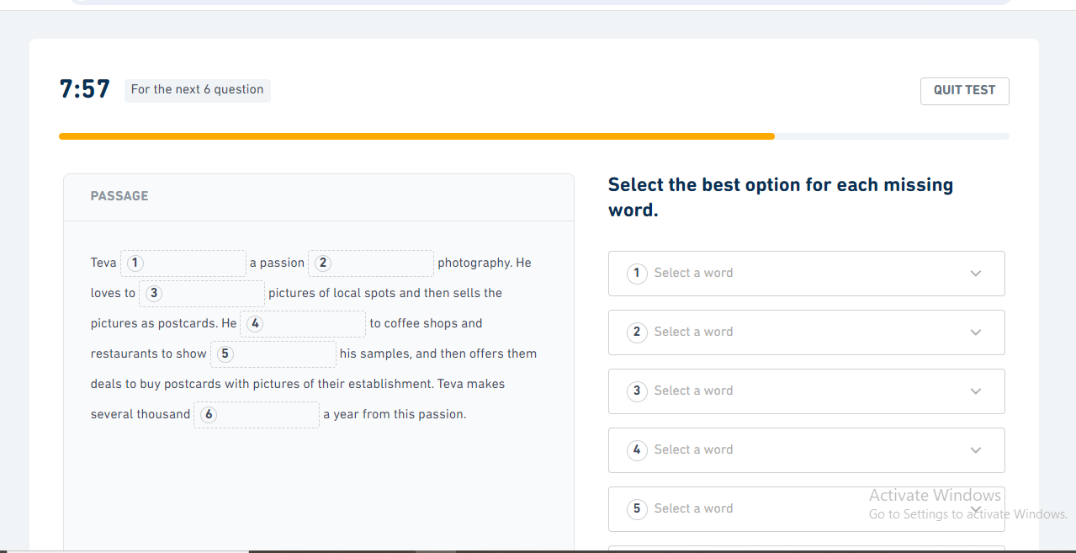

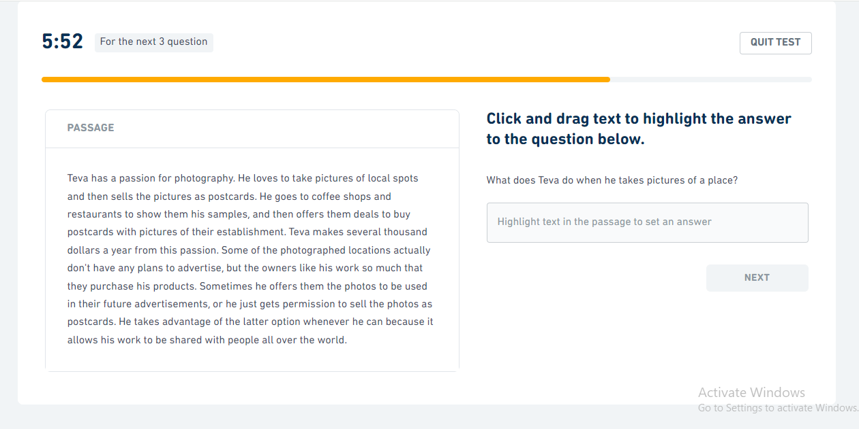
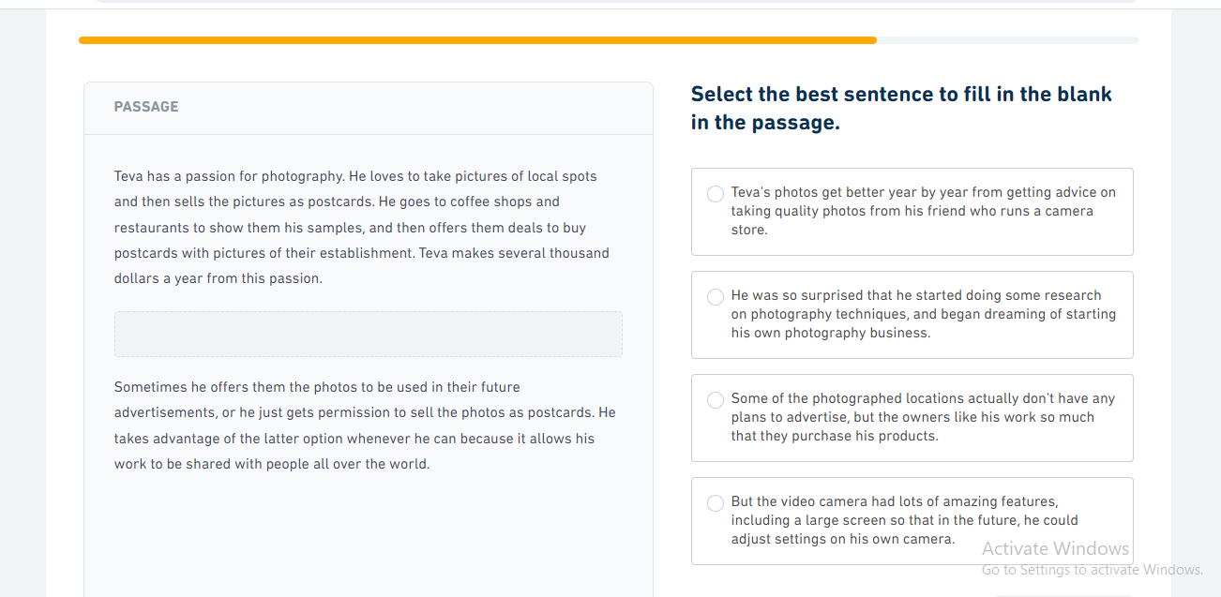

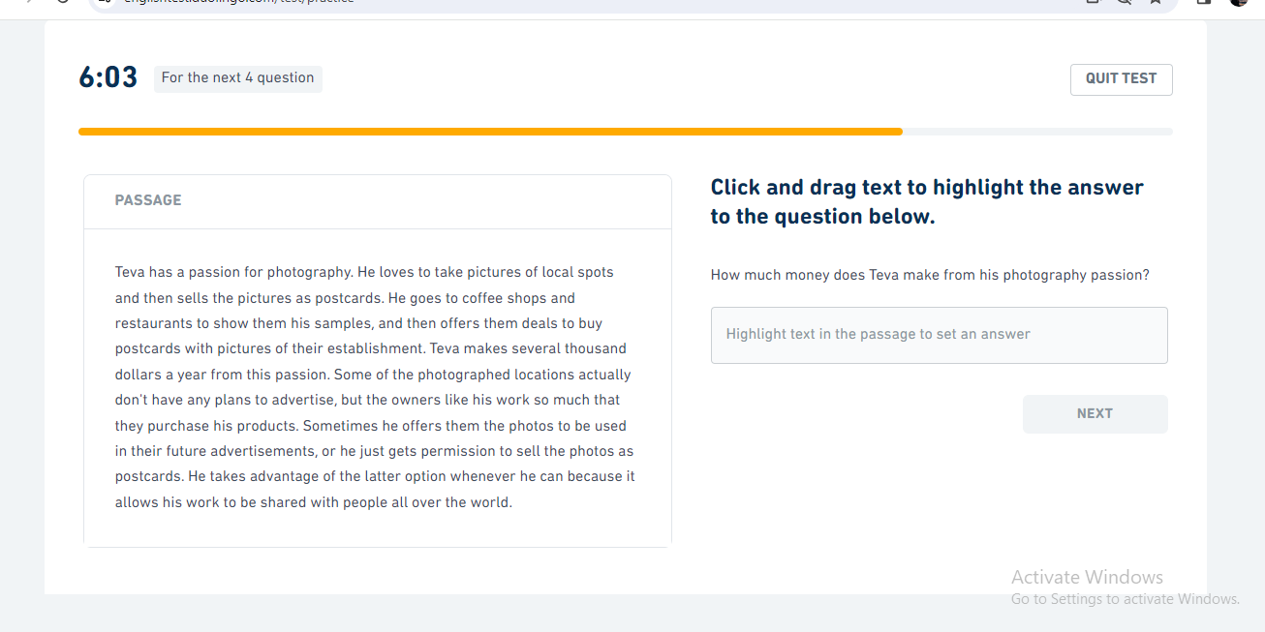

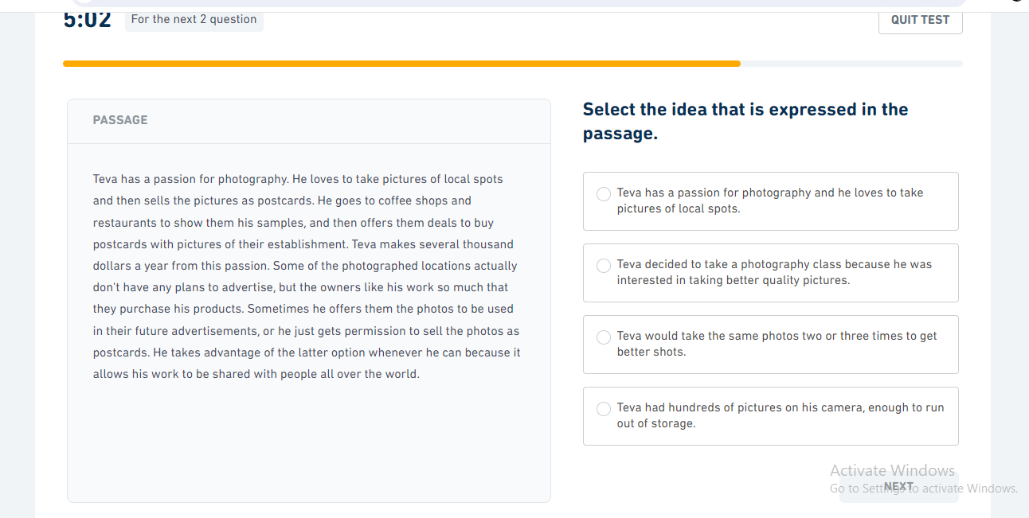

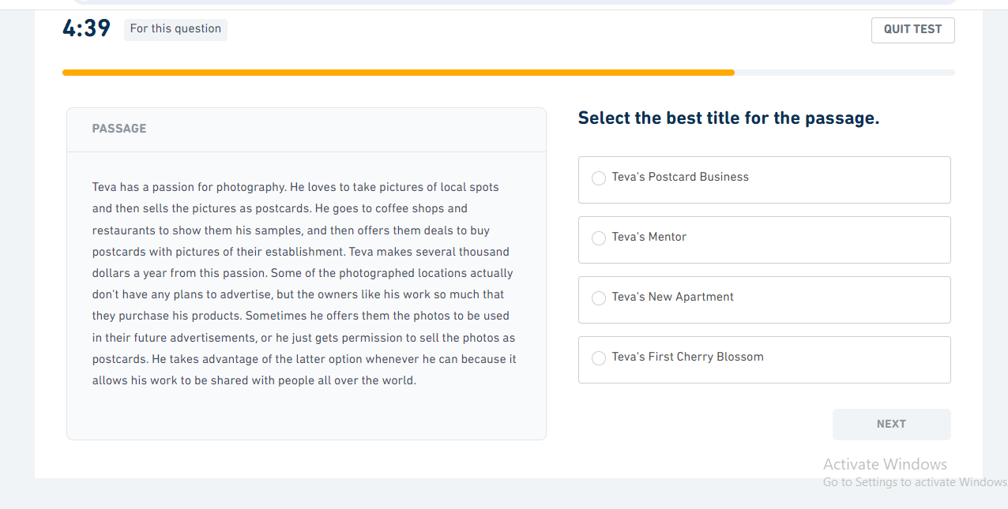

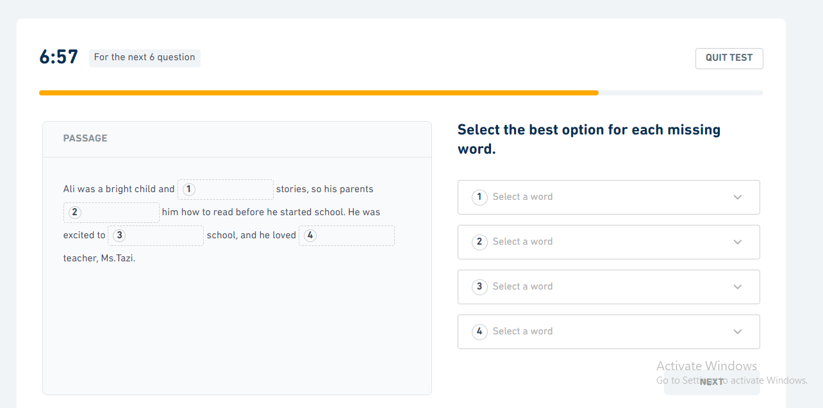
session 2

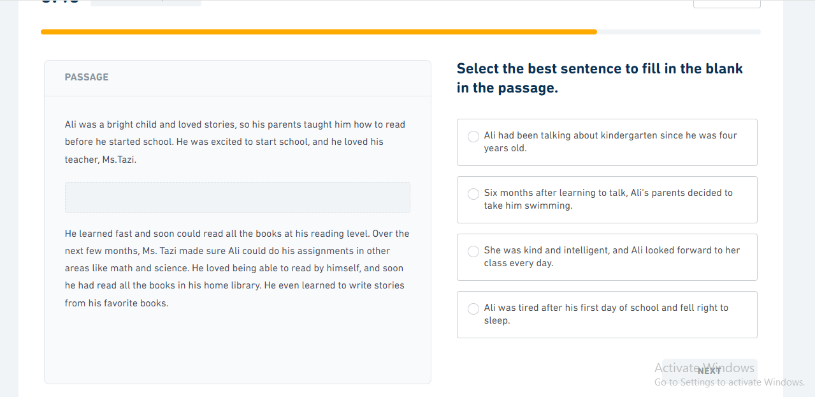

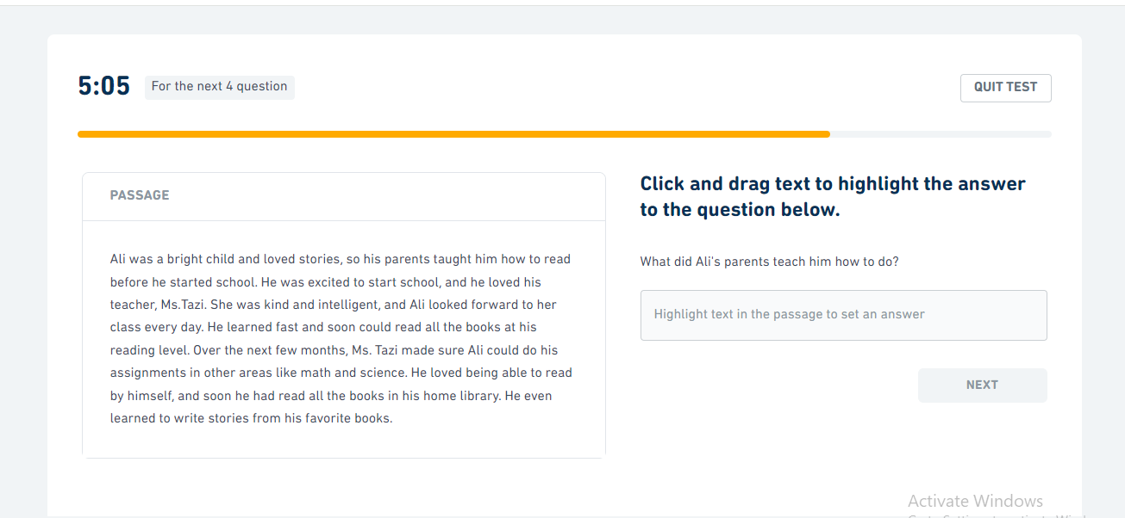

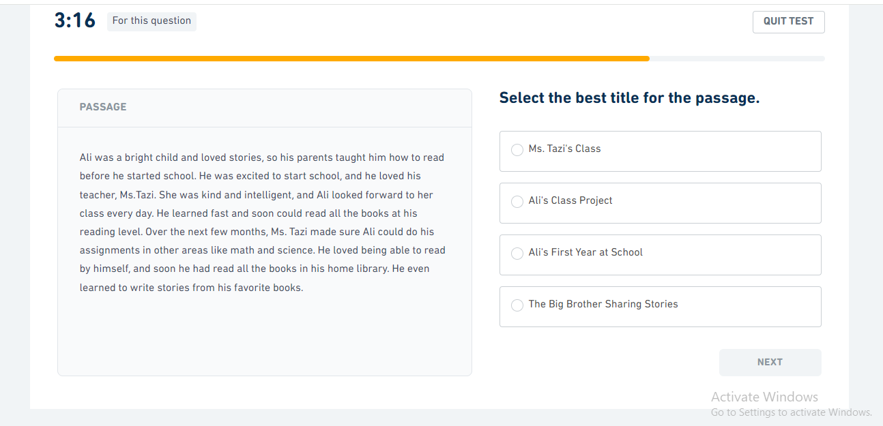

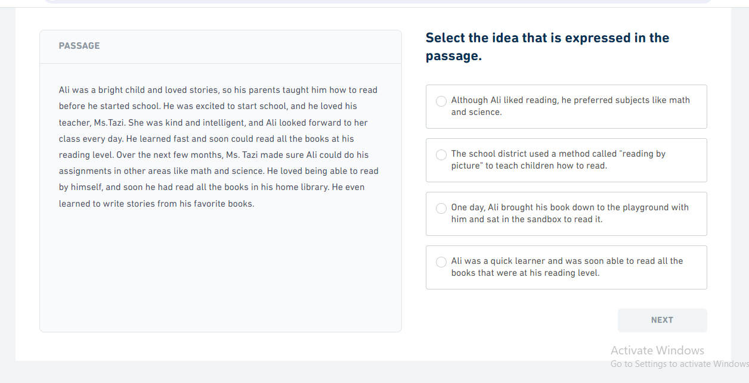

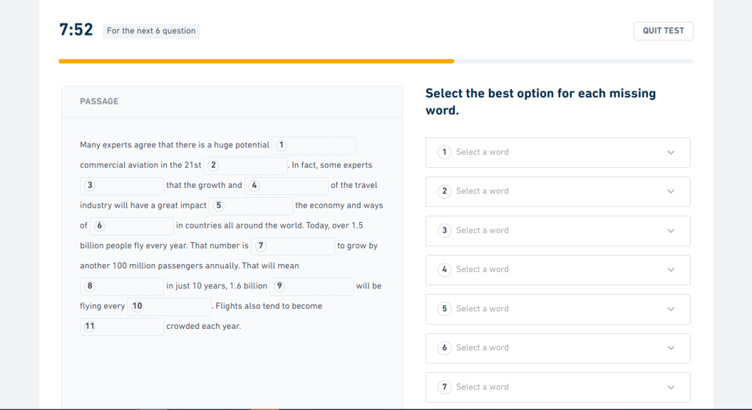
session 3

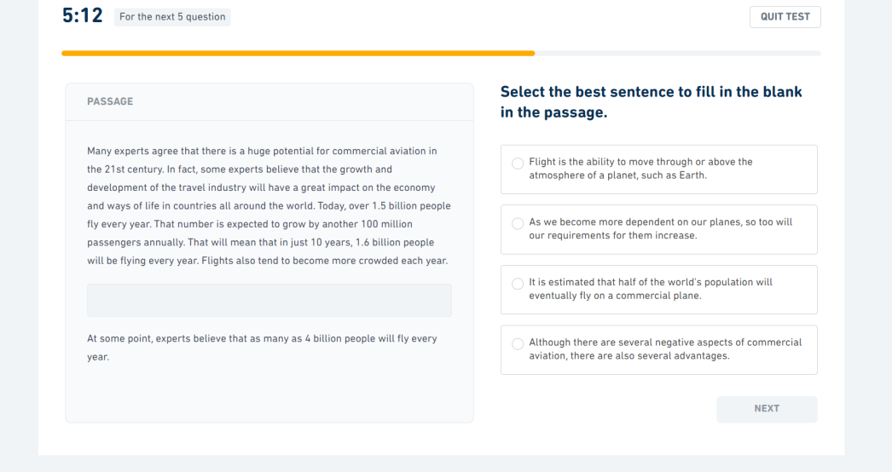

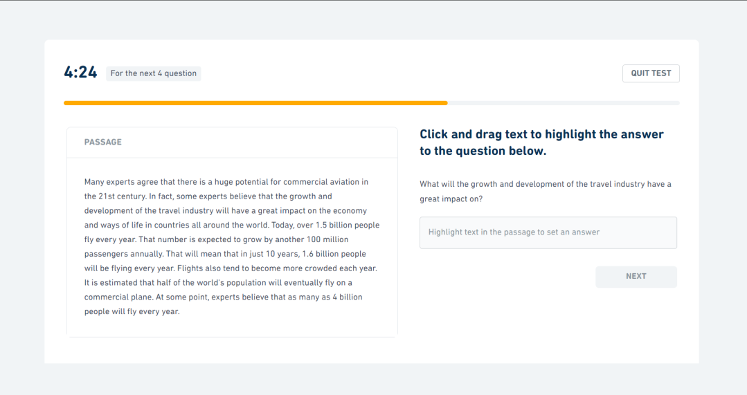

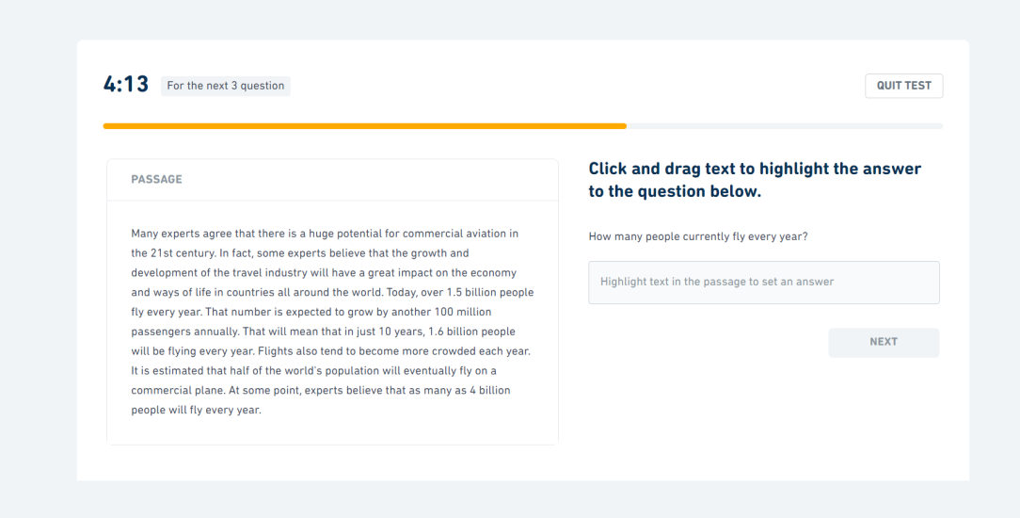

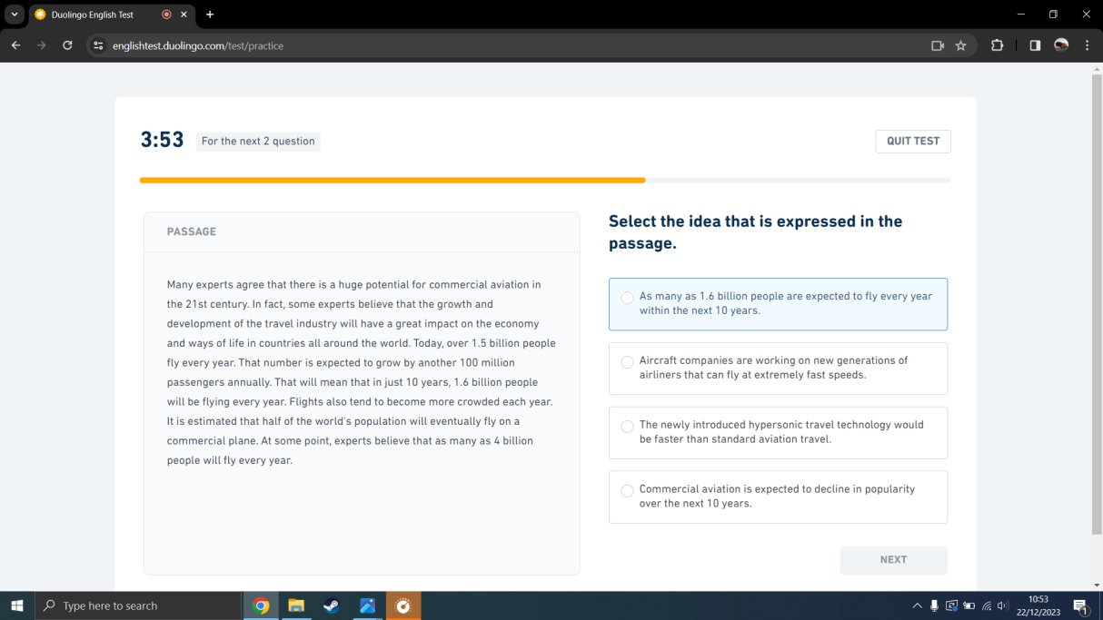

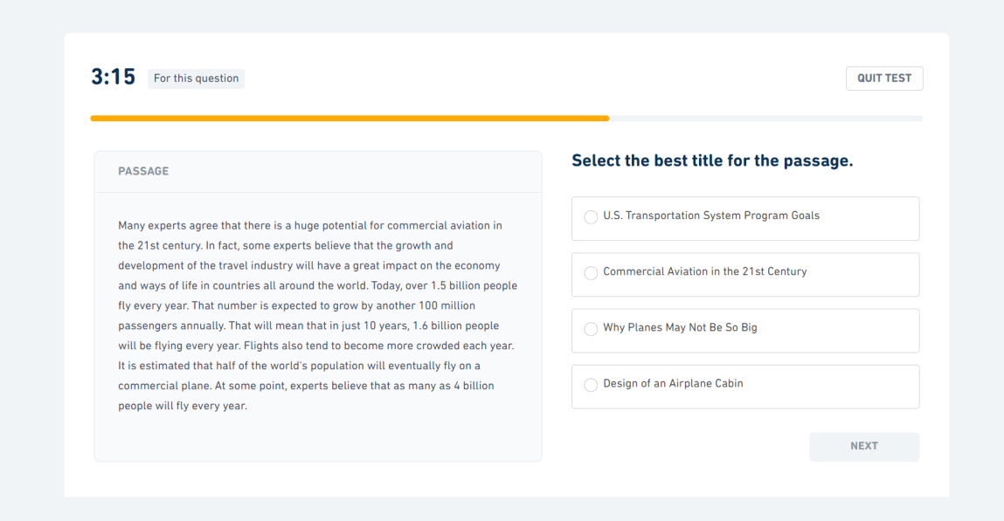

Session 4
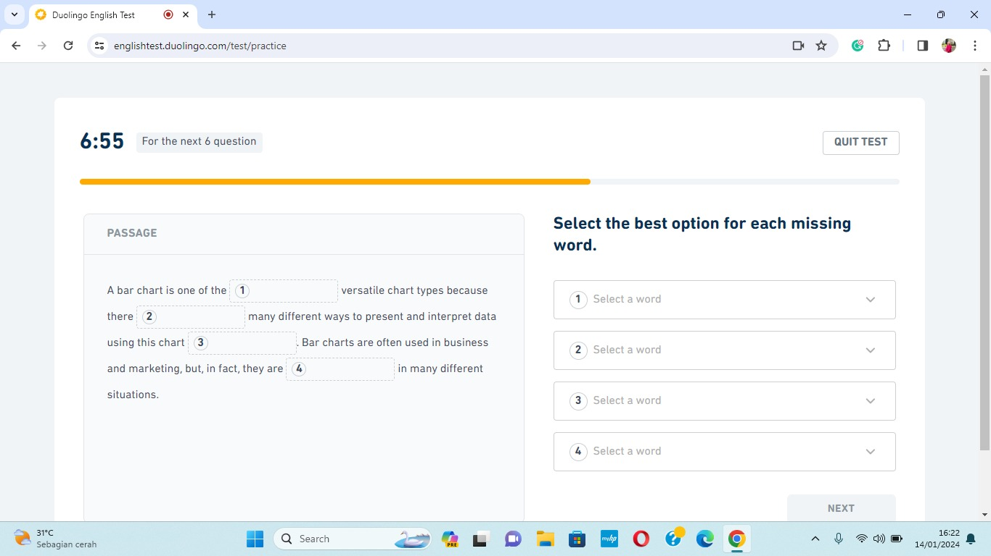

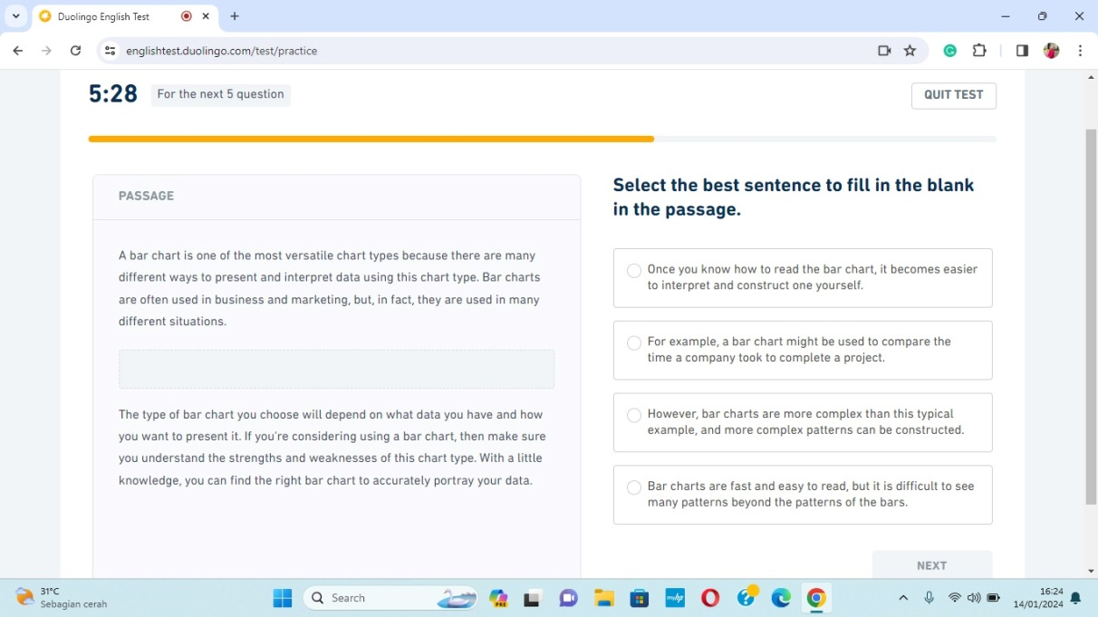
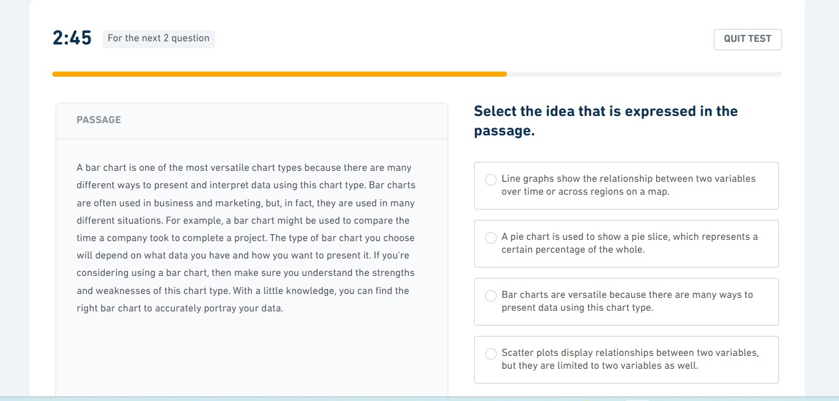

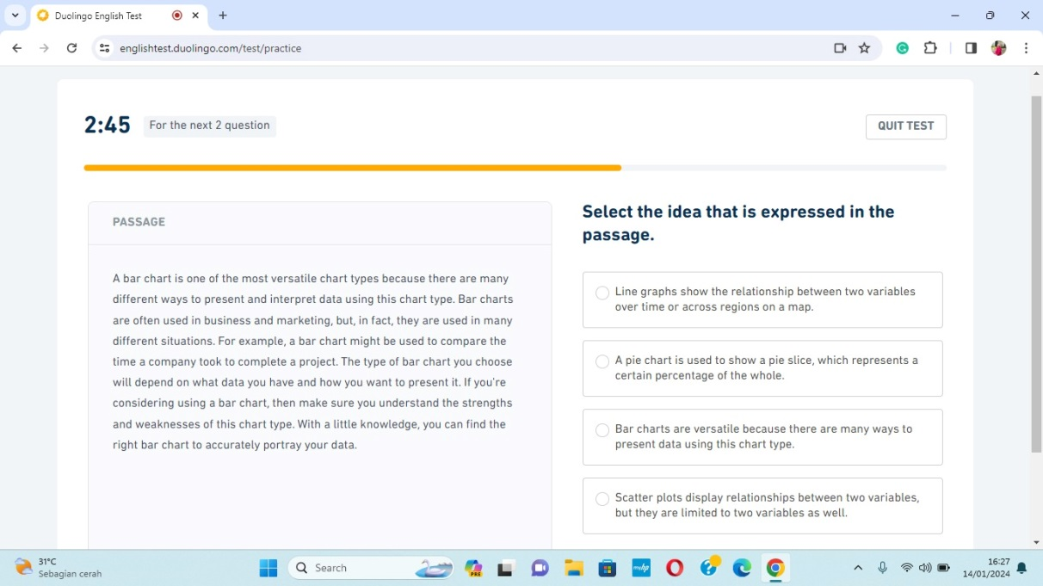

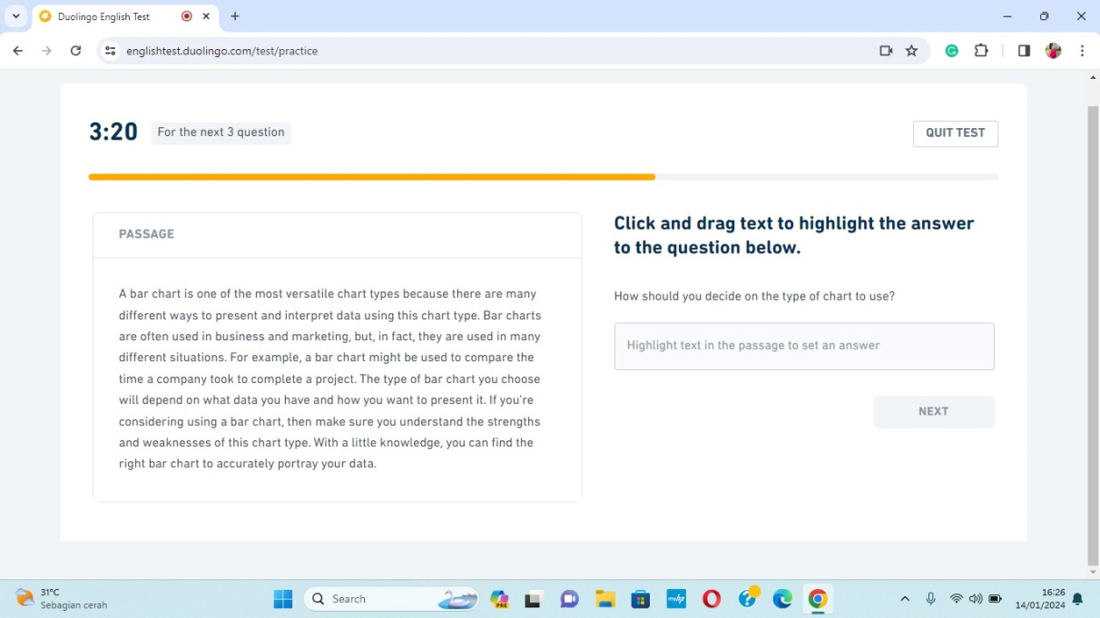

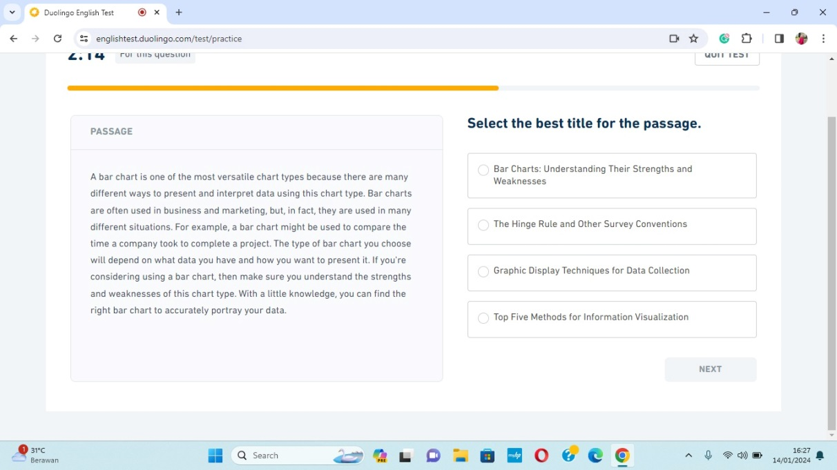

Session 5
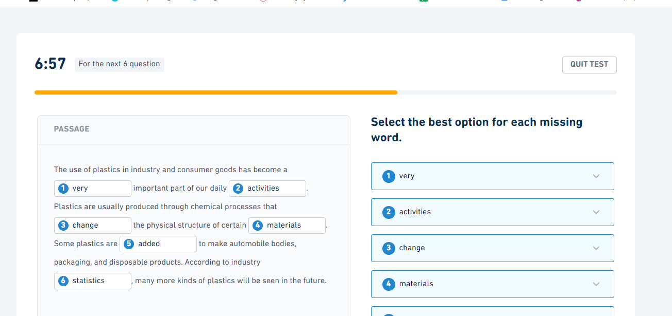
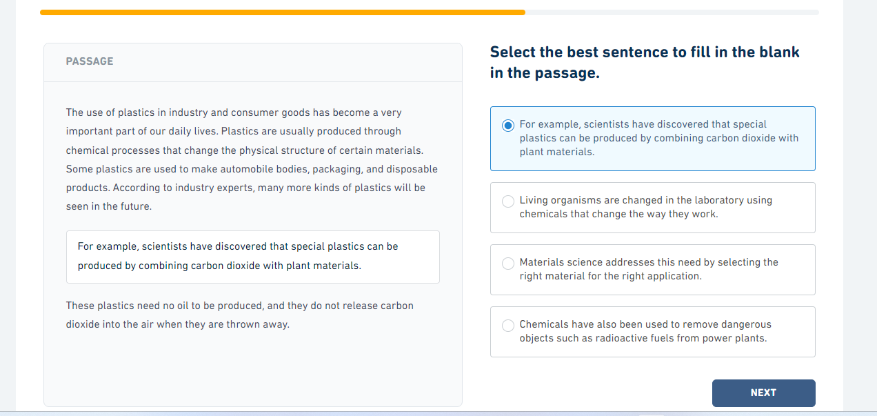

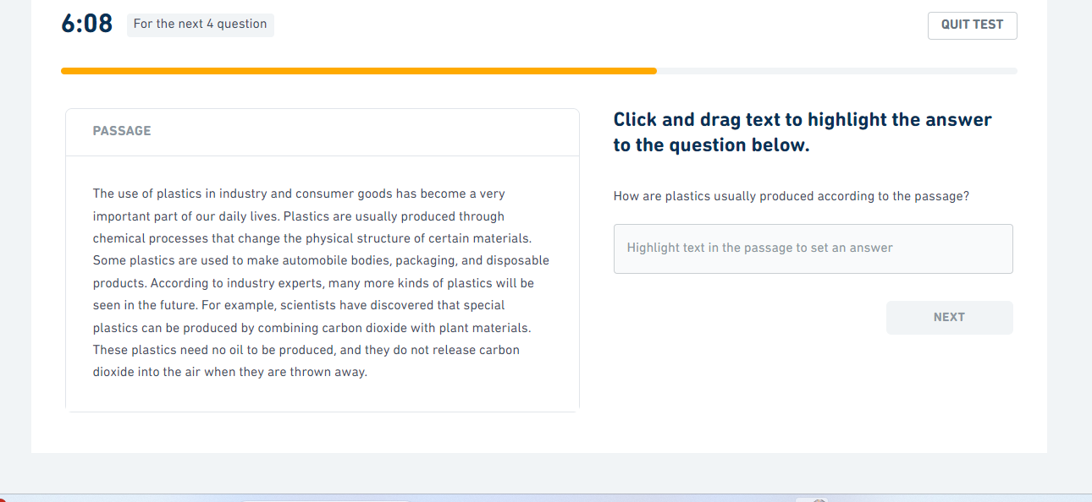

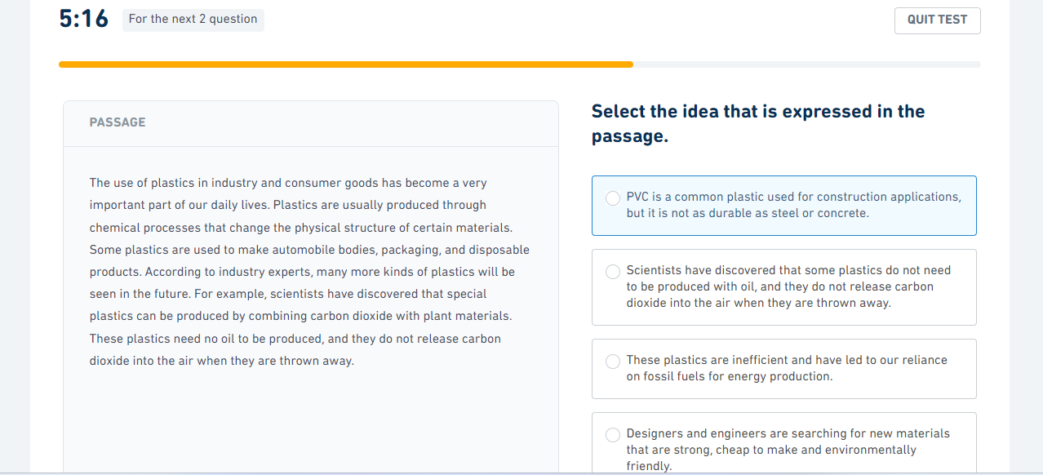

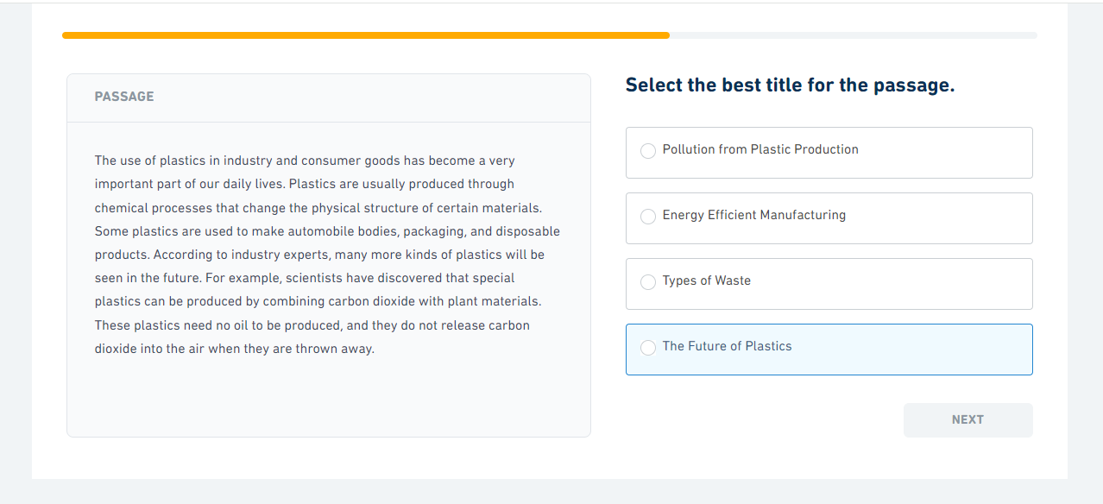

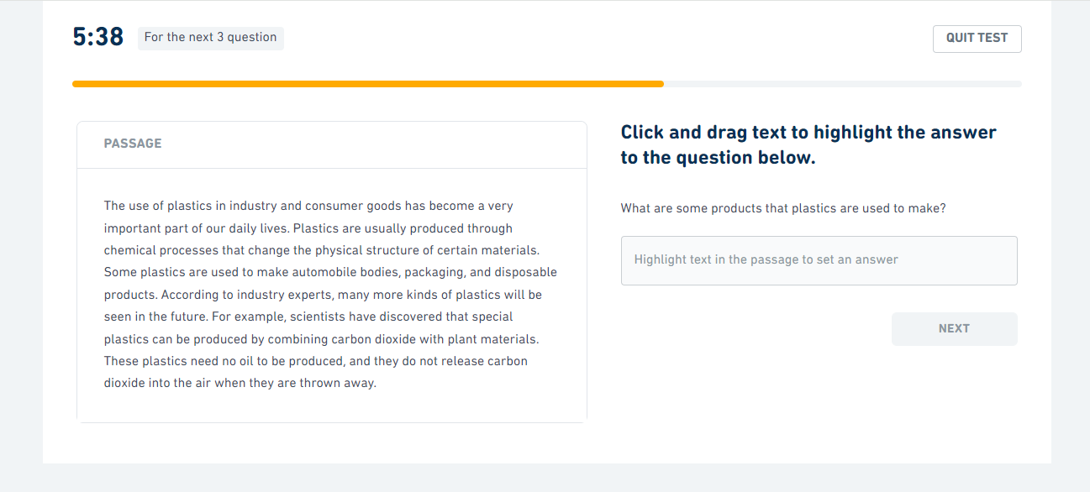

Session 6
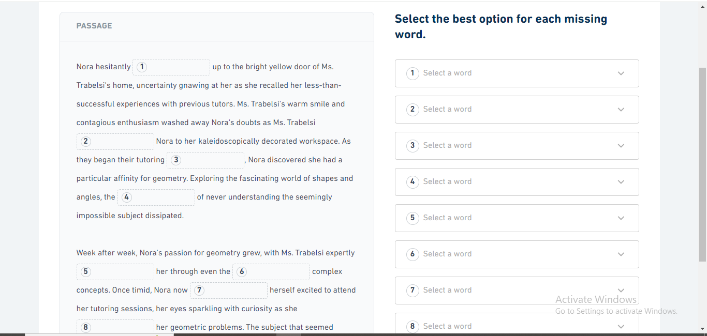
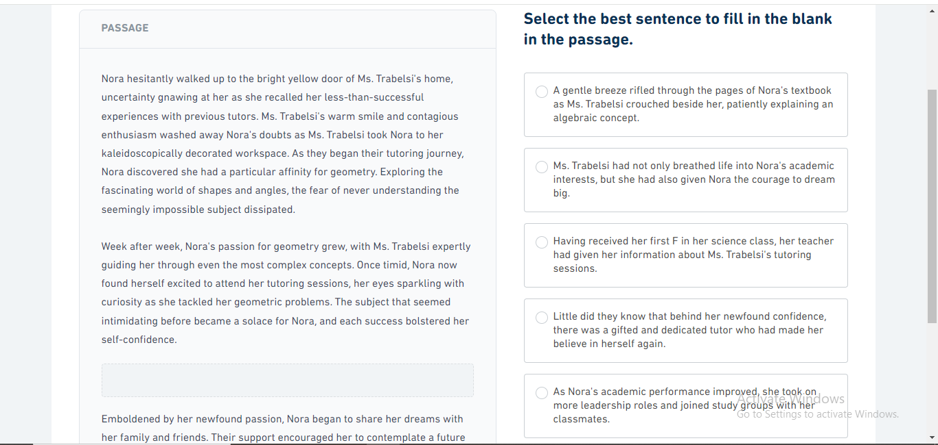

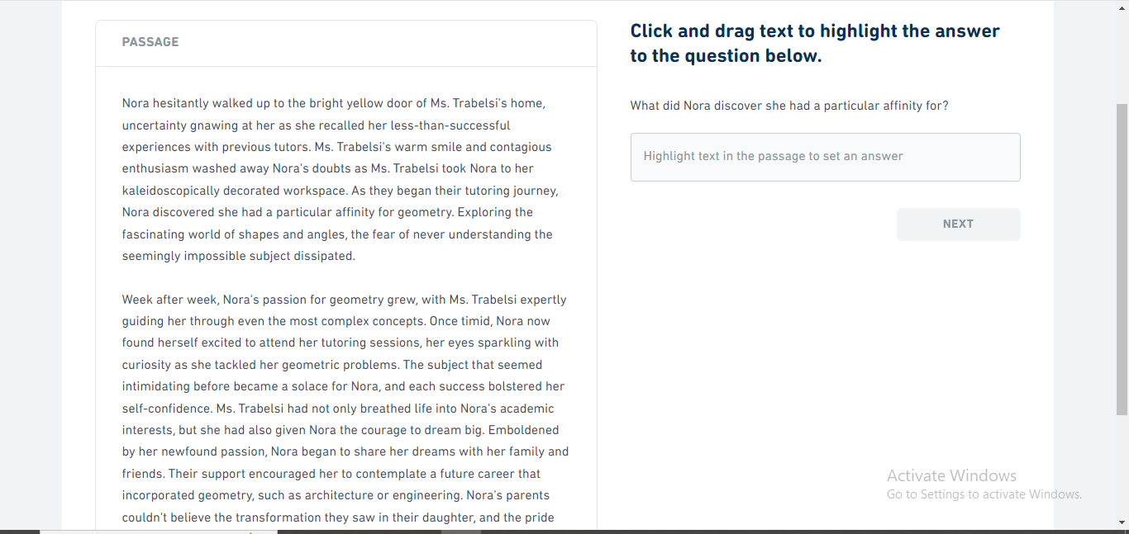

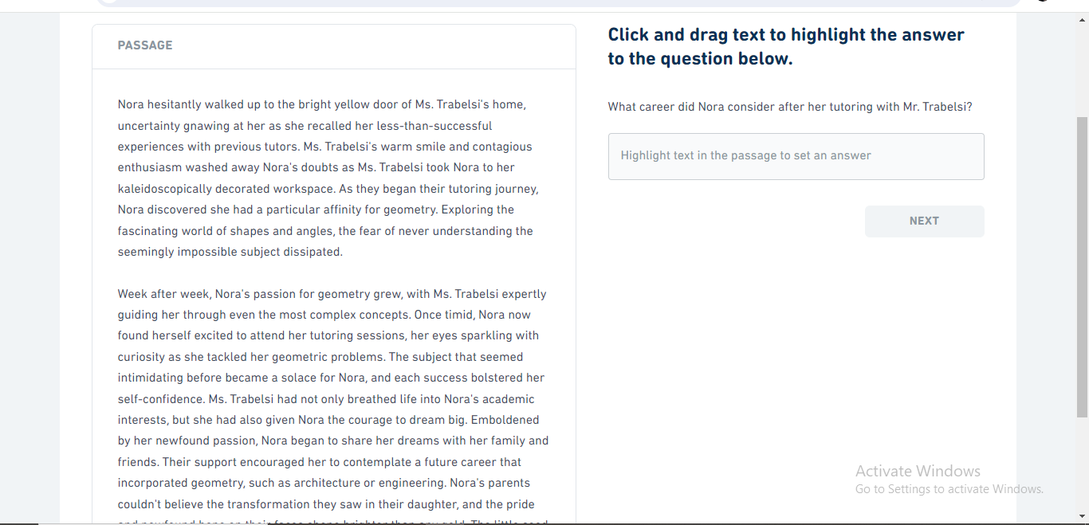

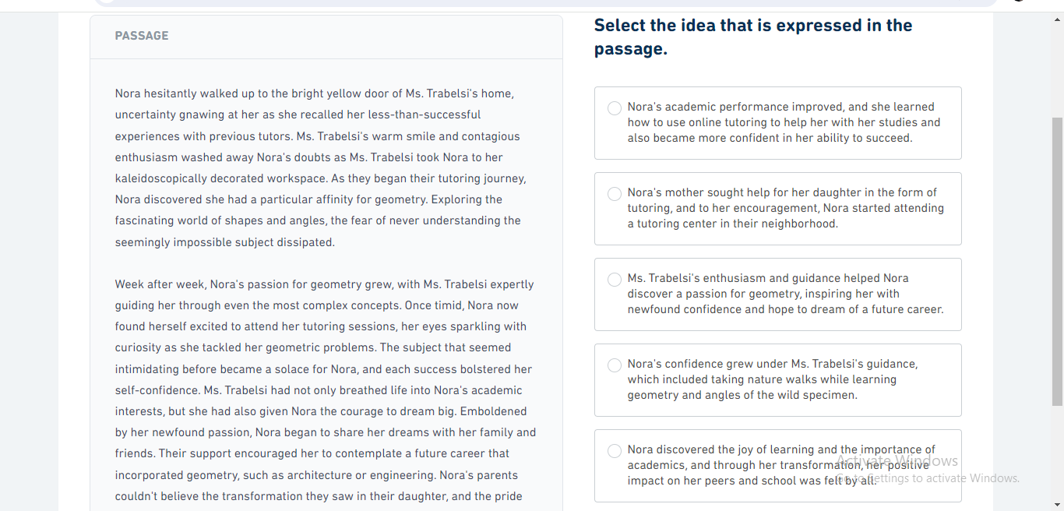

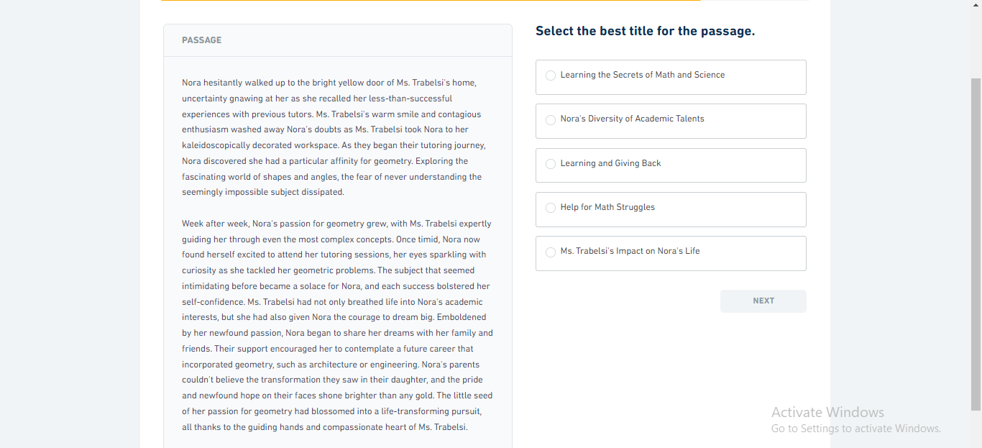

Session 7
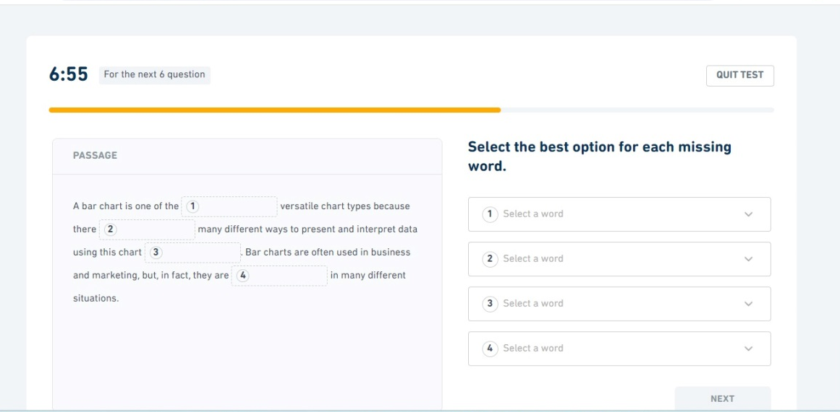

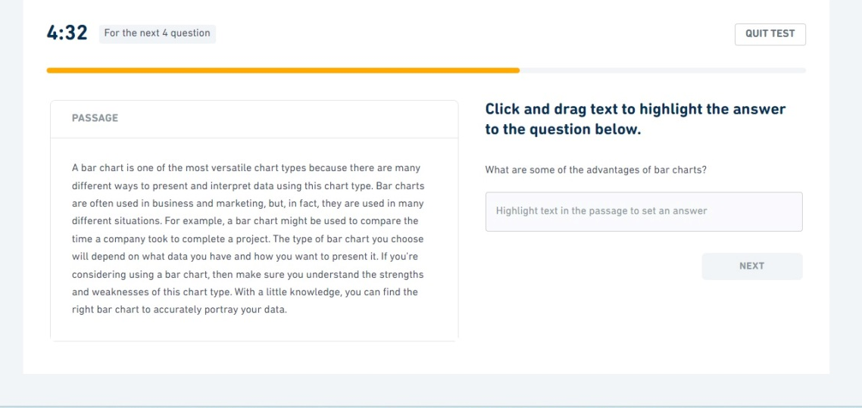

Session 8
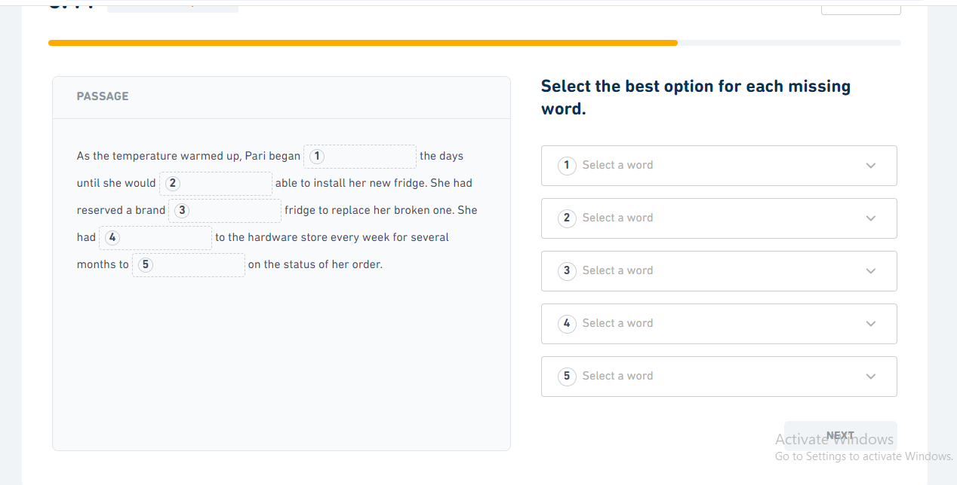

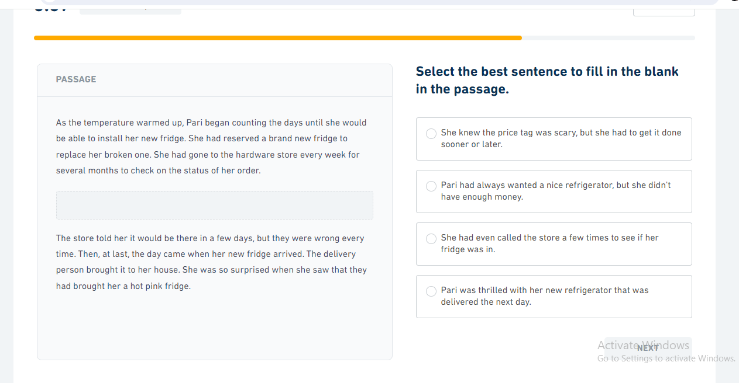

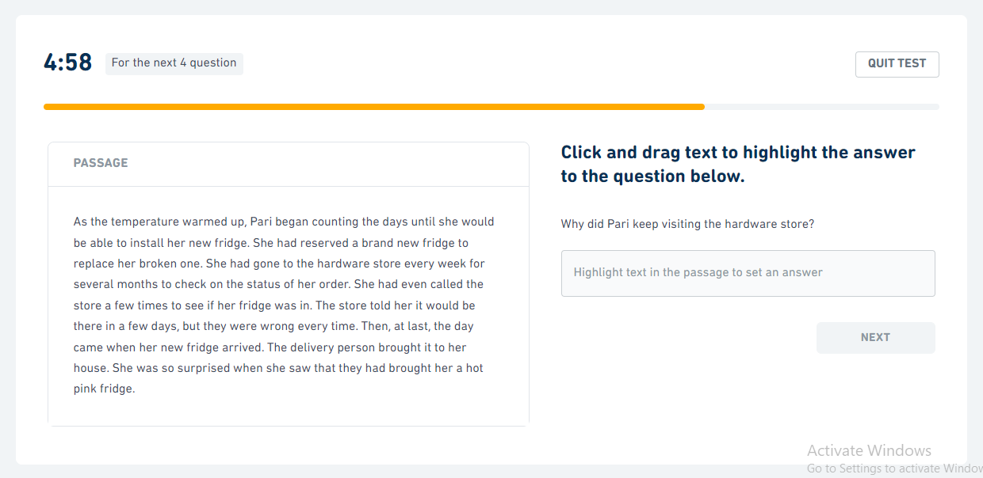

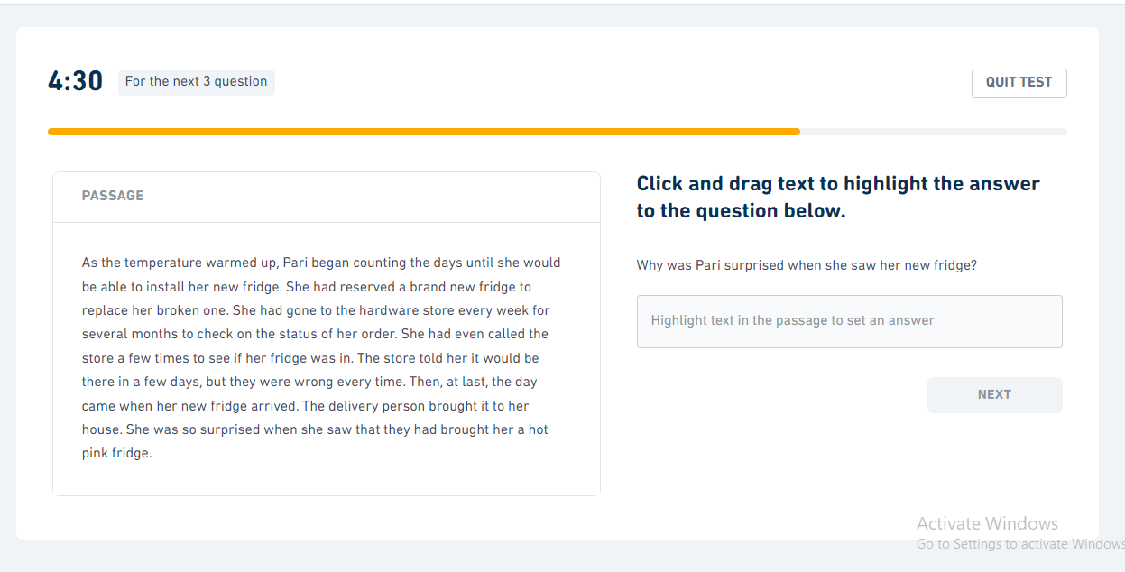

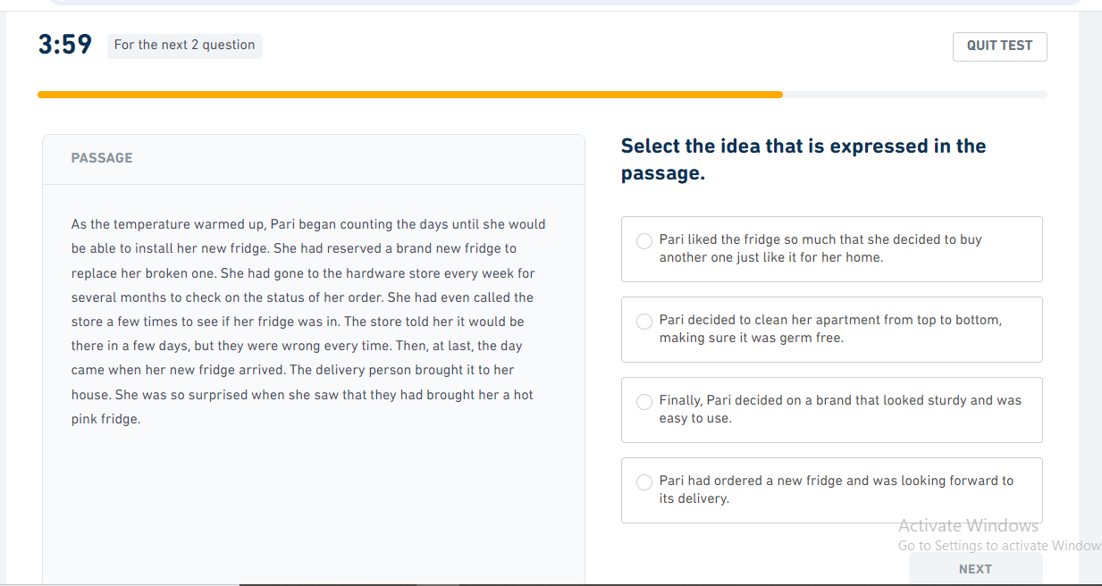

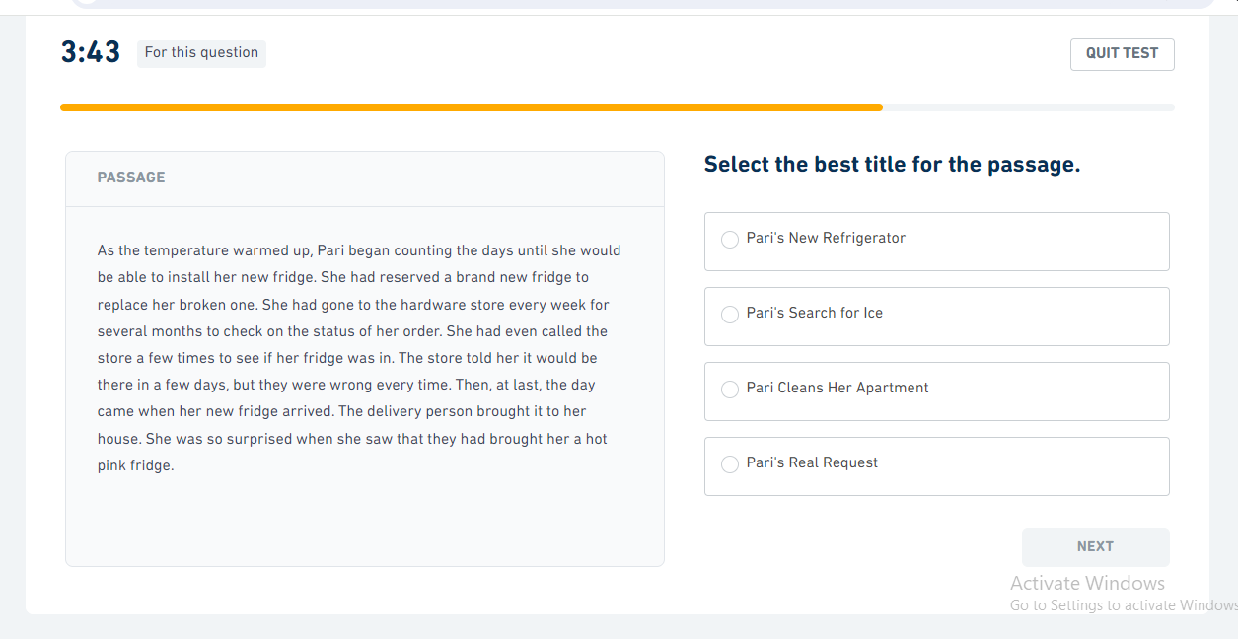

Session 9
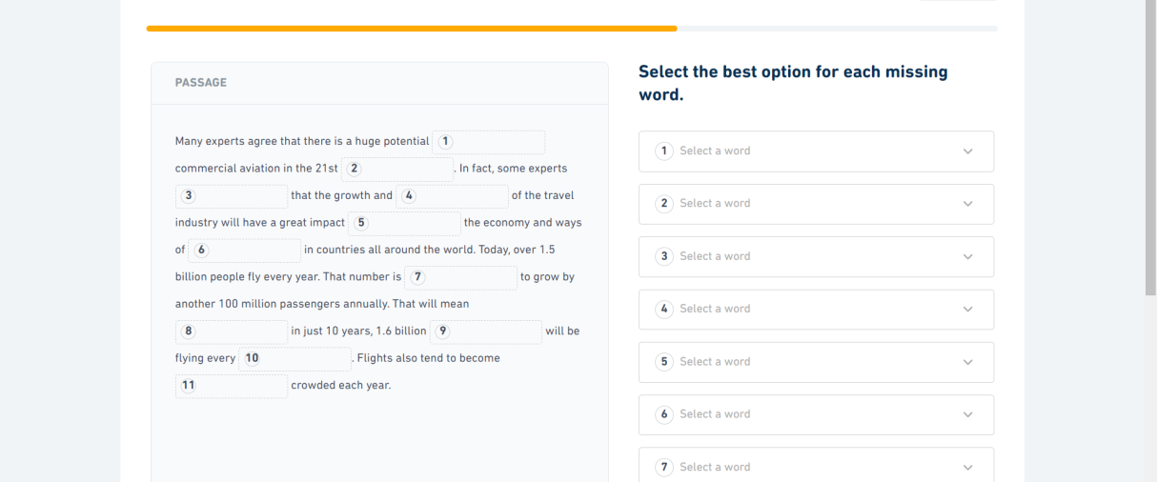

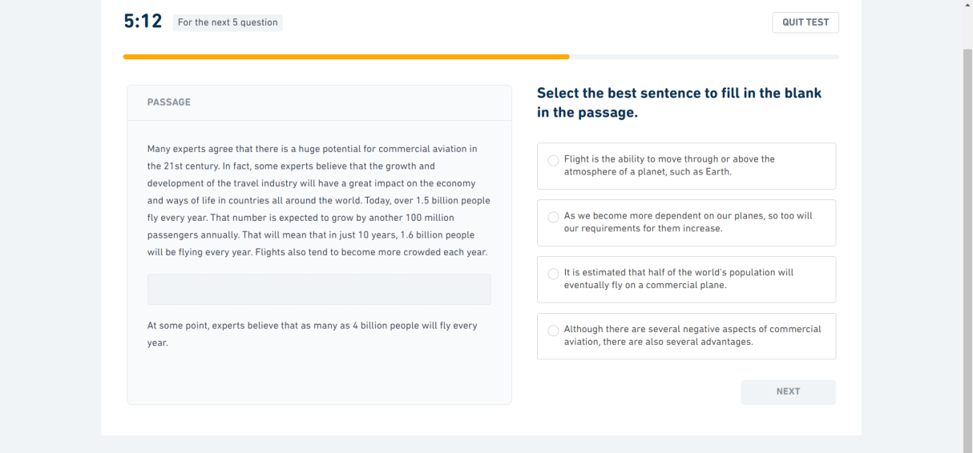

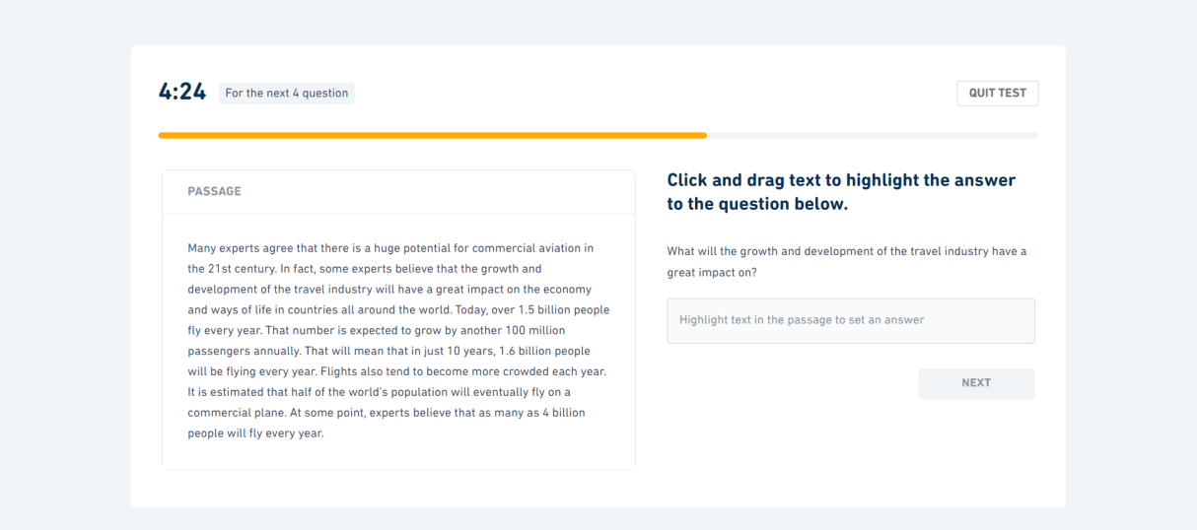

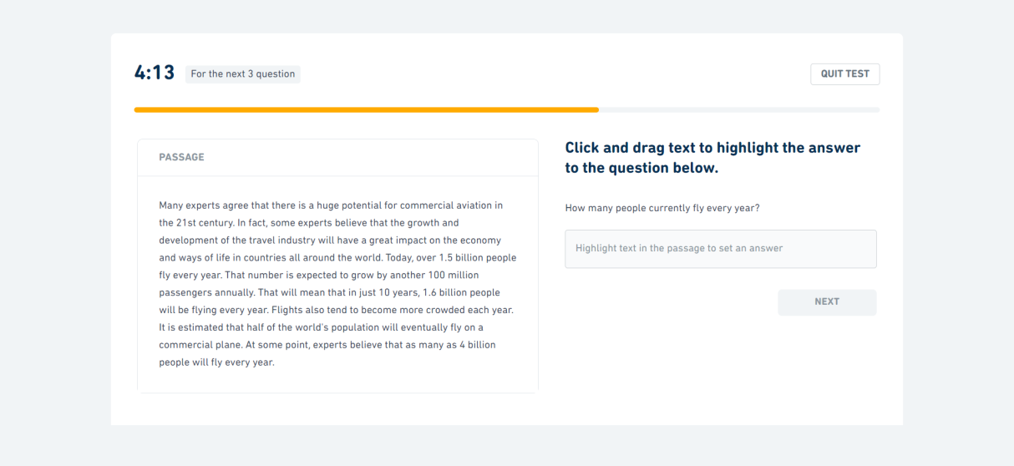

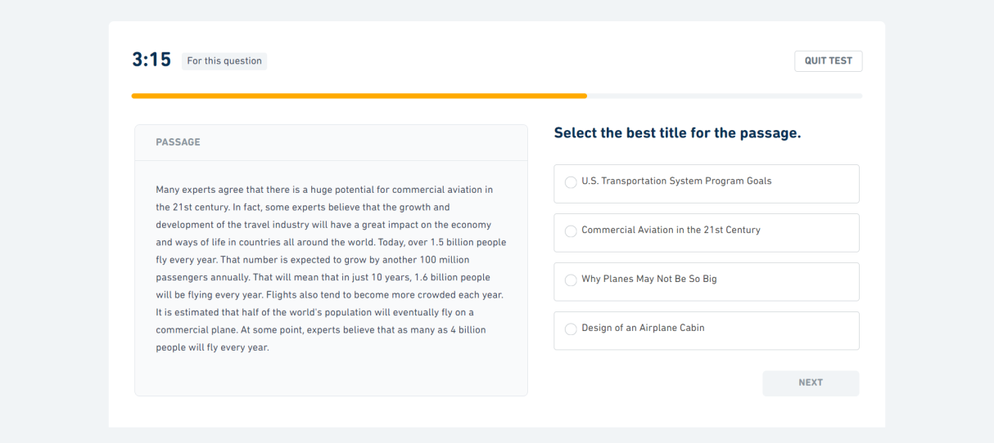

Session 10
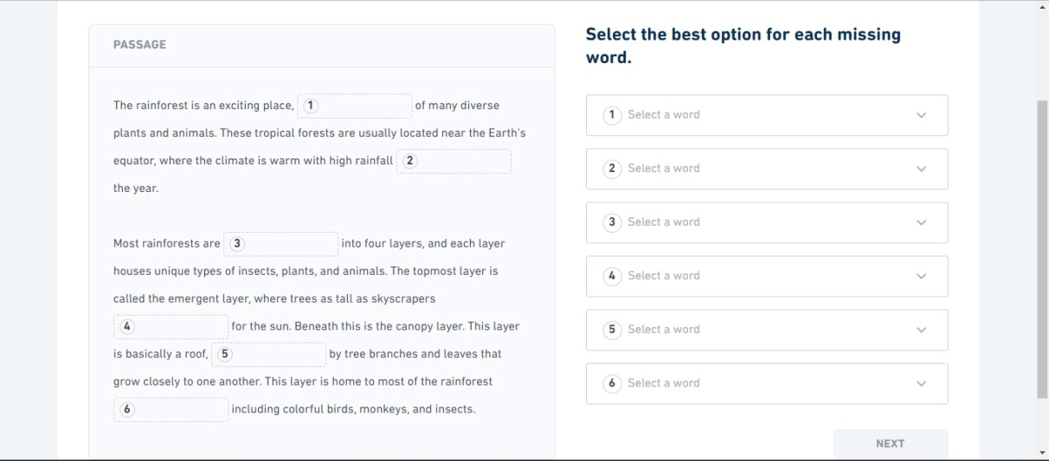

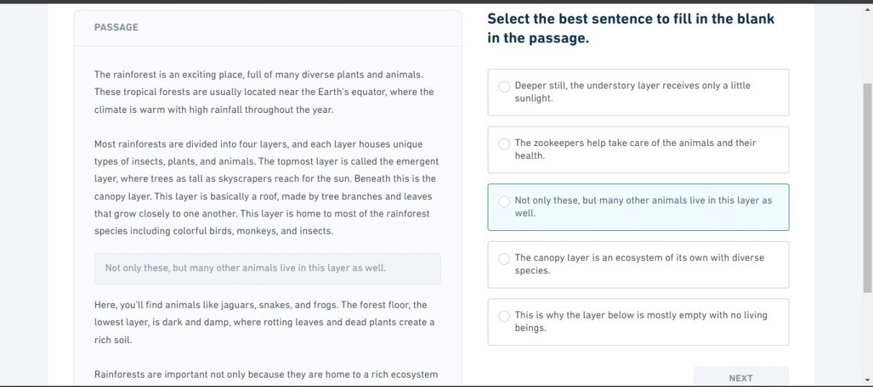

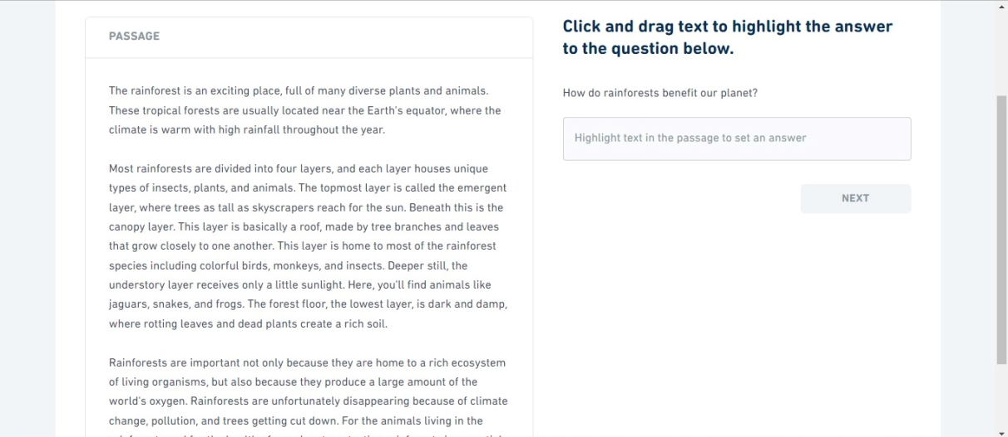

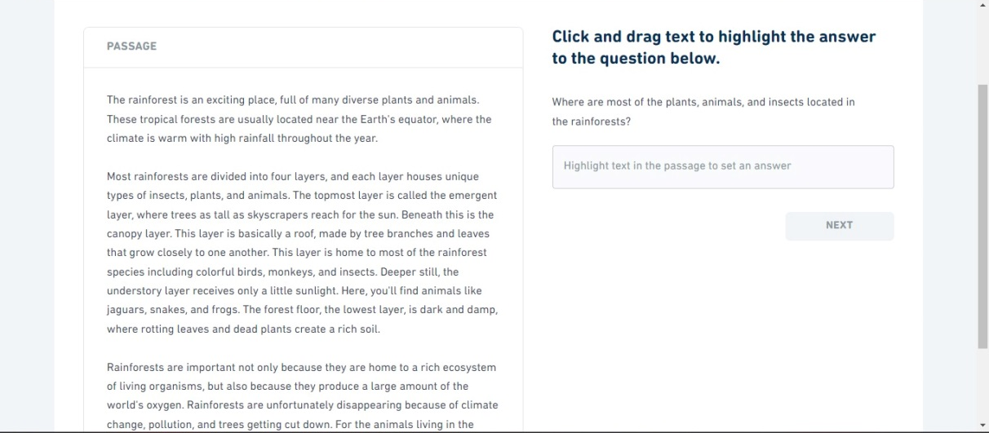

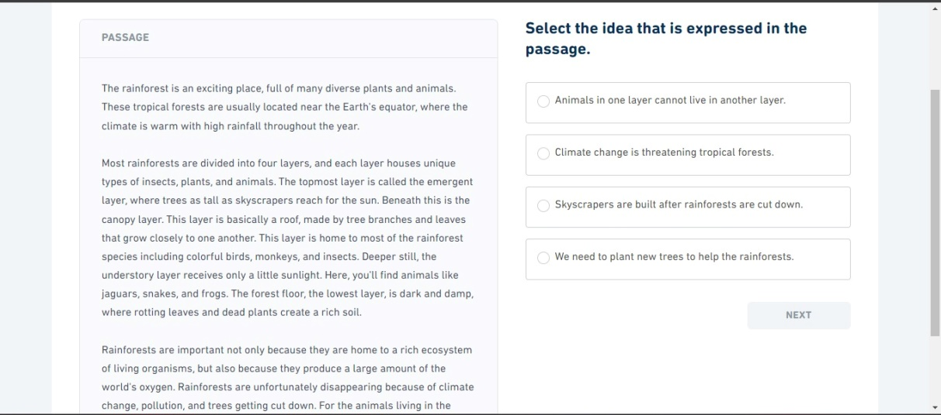

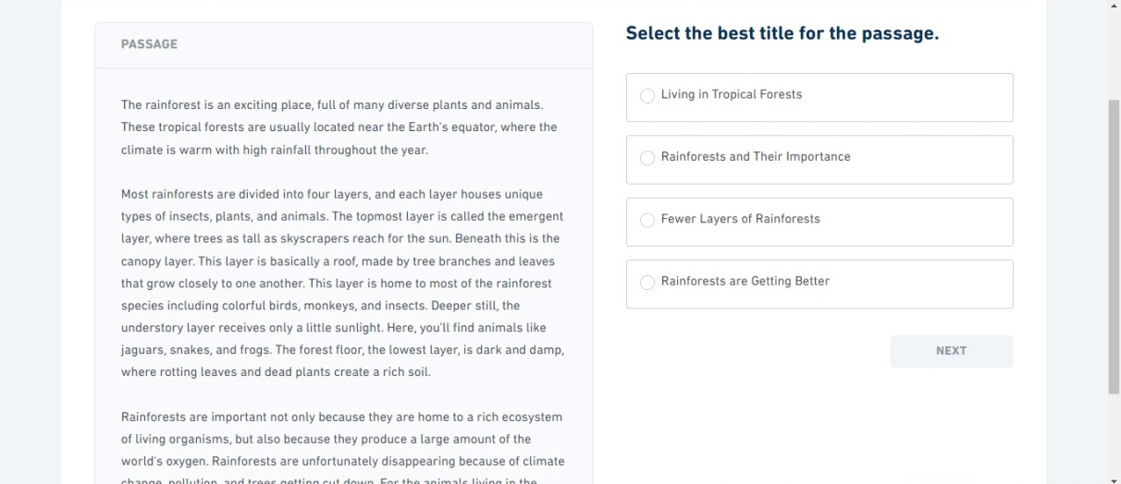

Session 11
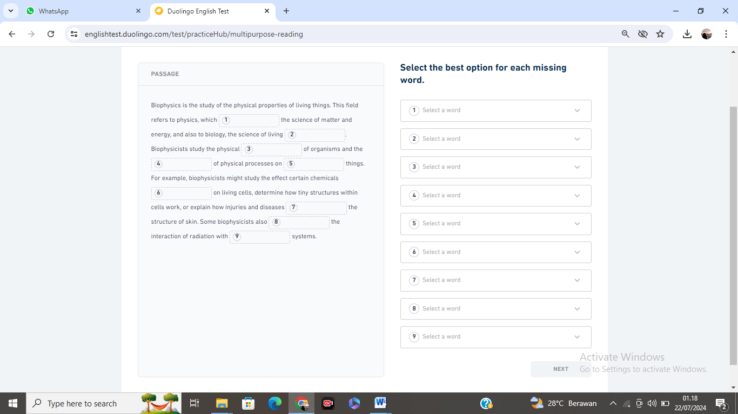

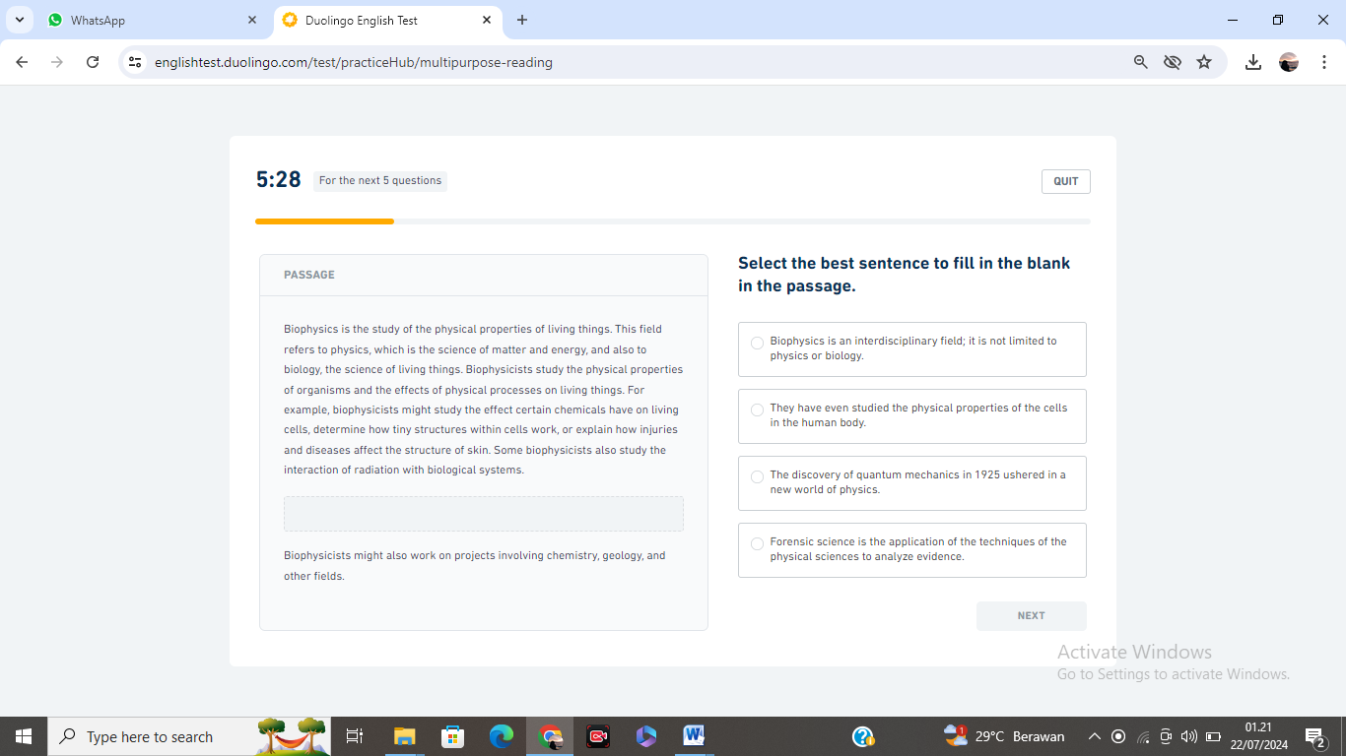

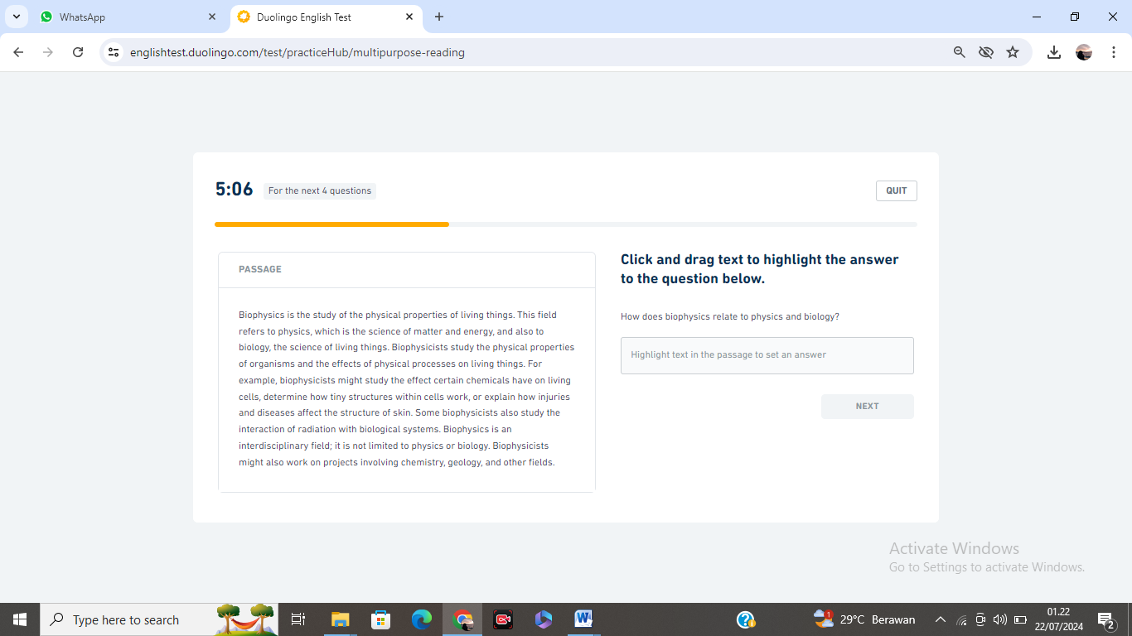

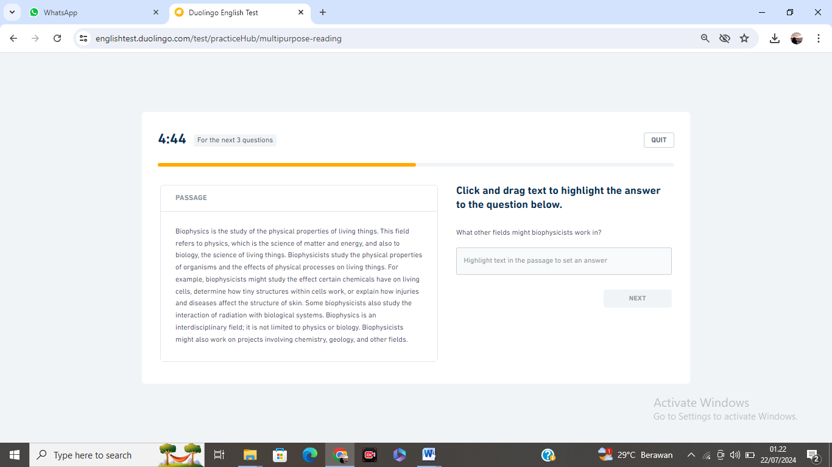

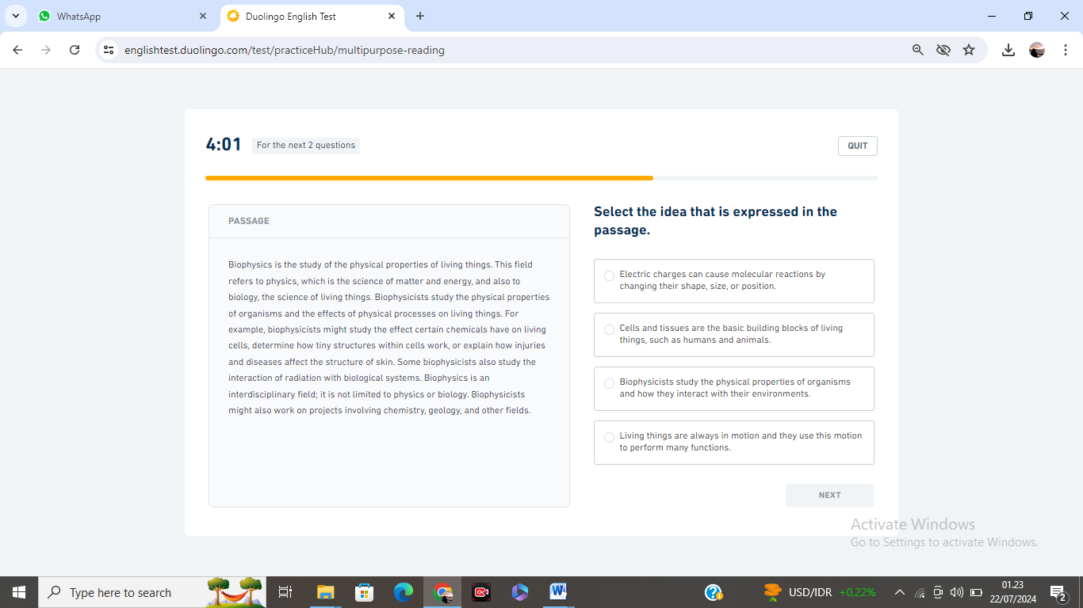

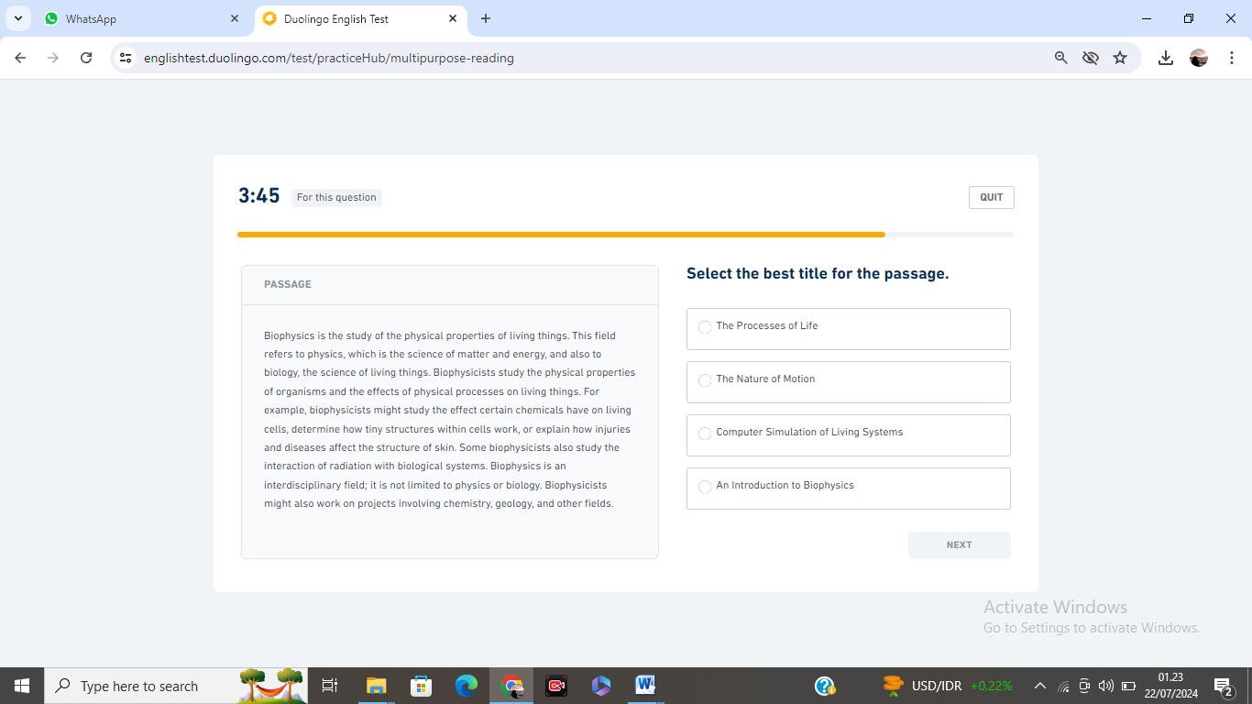

Session 12
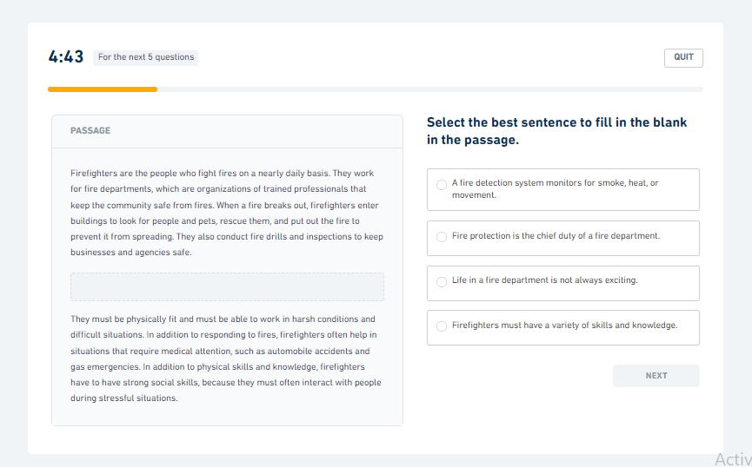

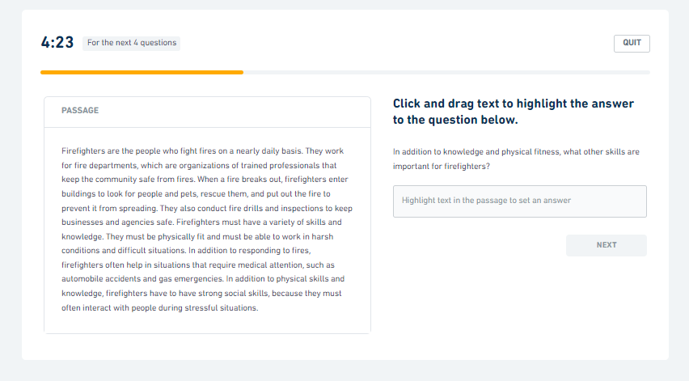

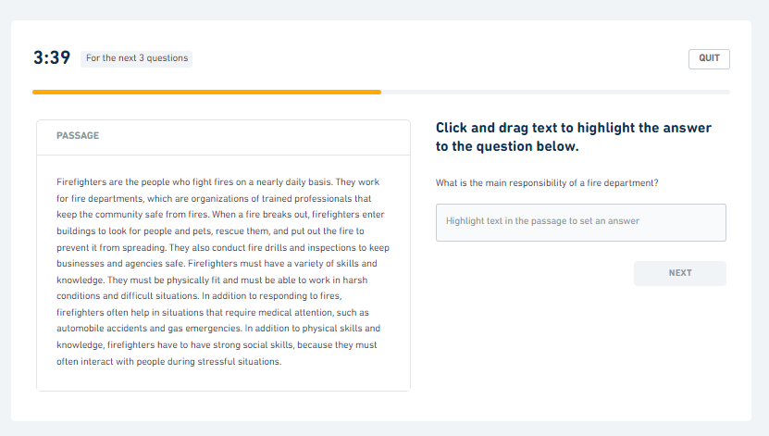

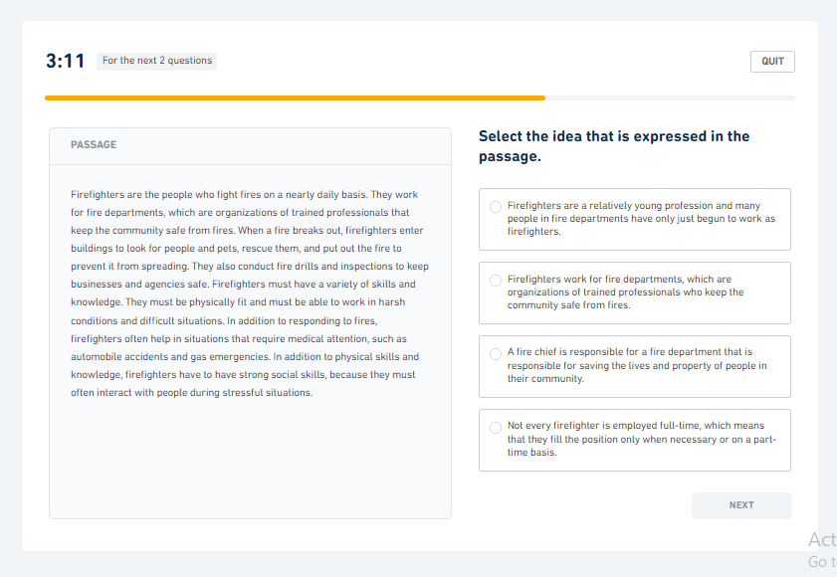

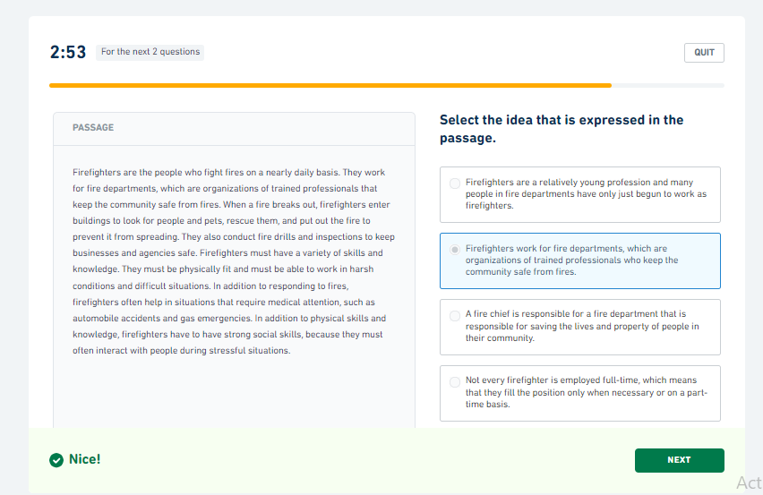

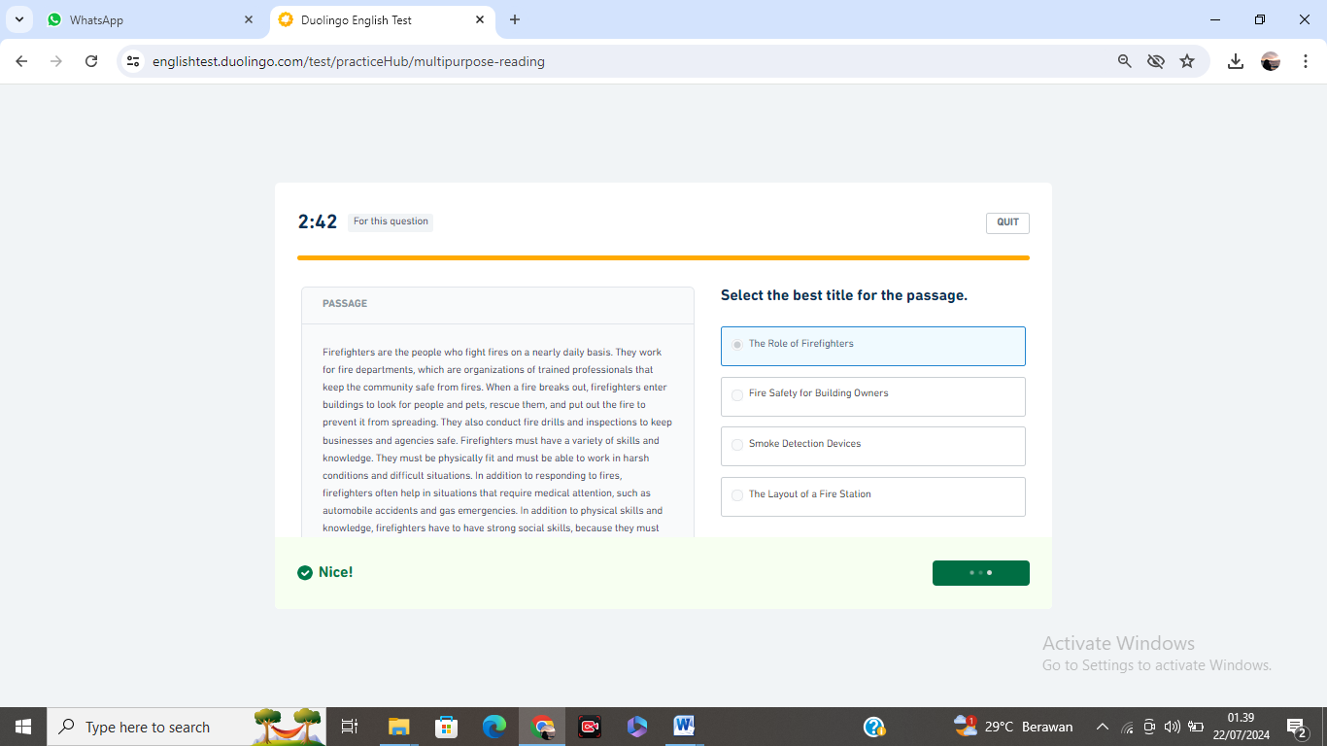
Session 13
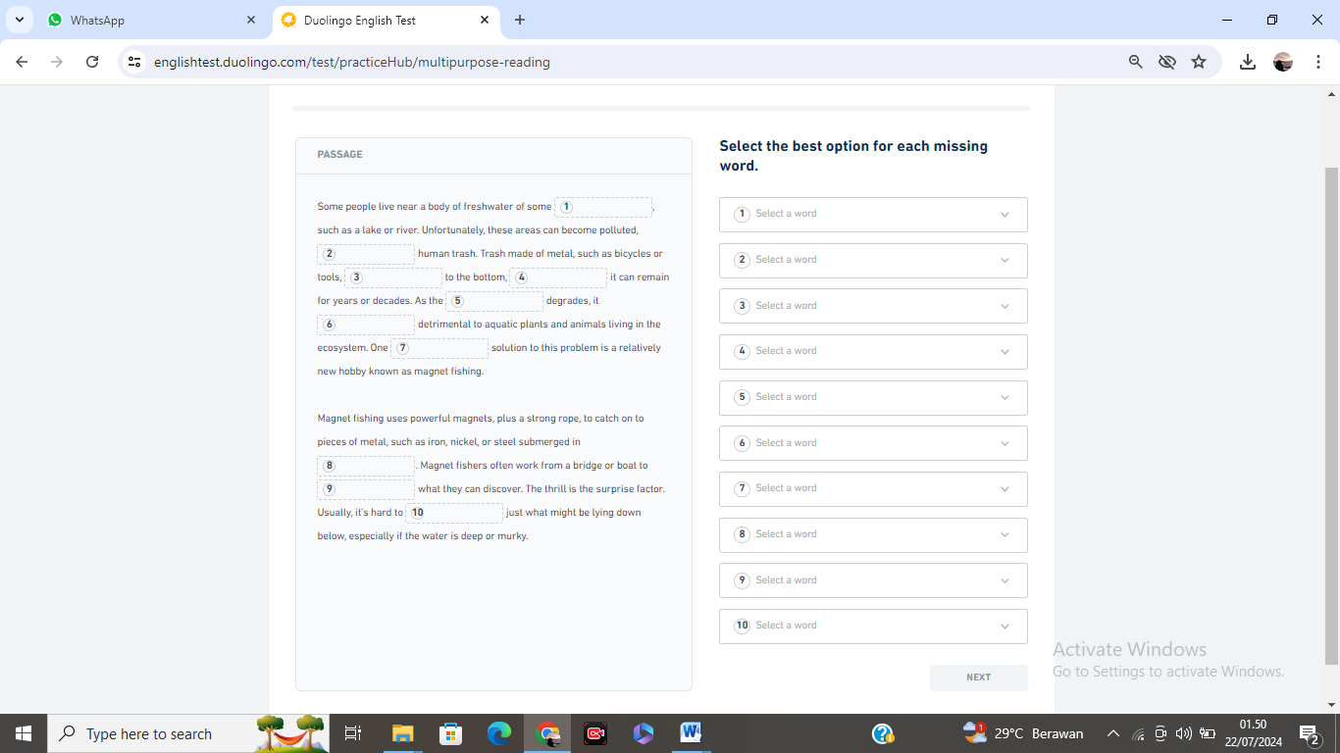

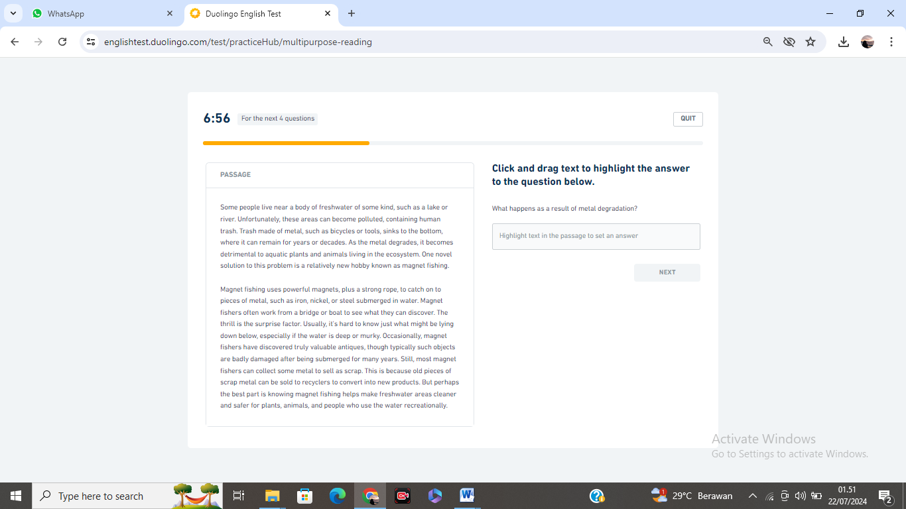

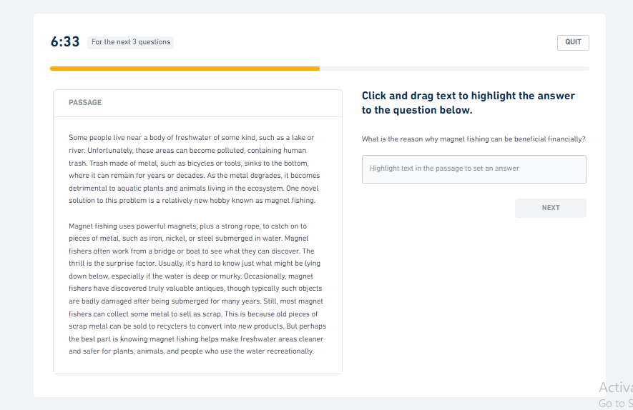

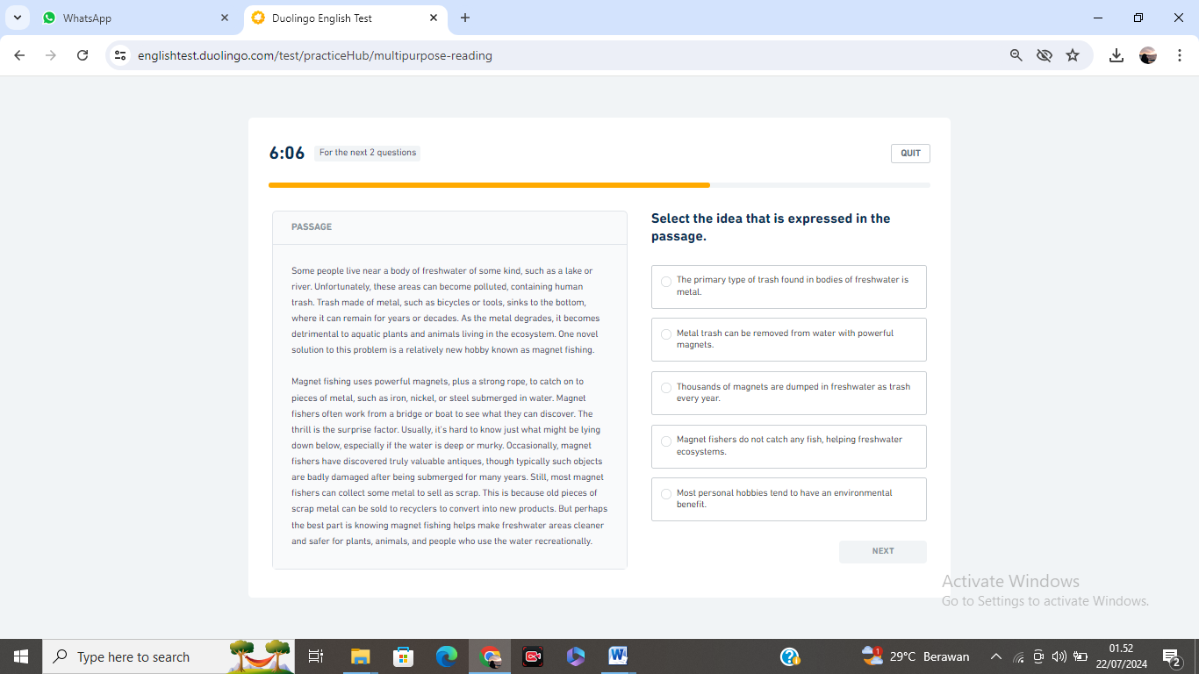

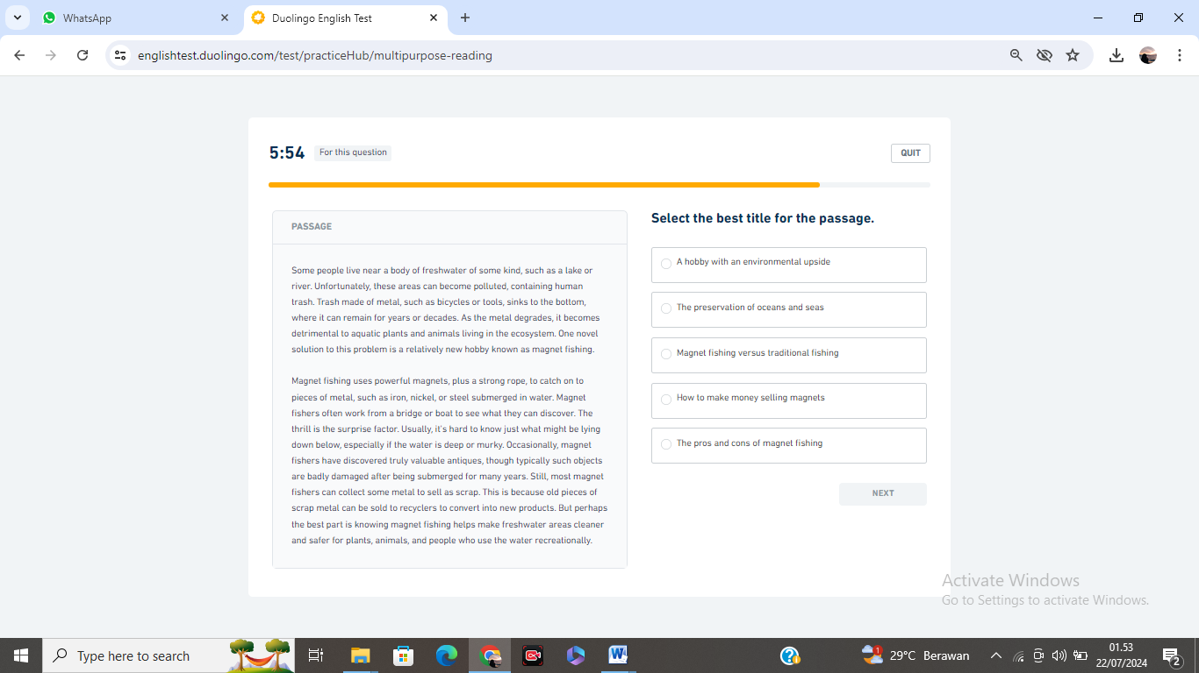

Session 14
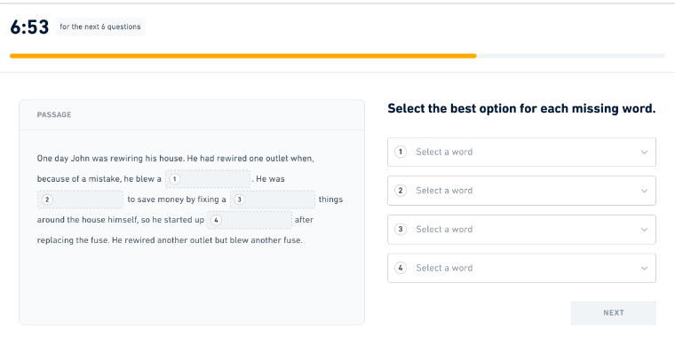

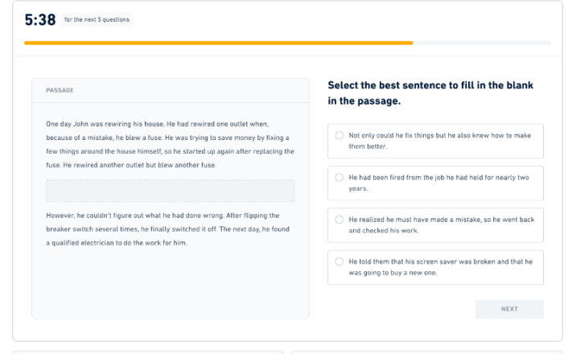

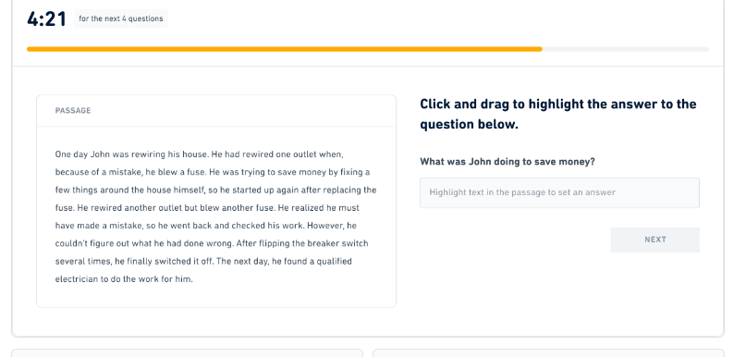

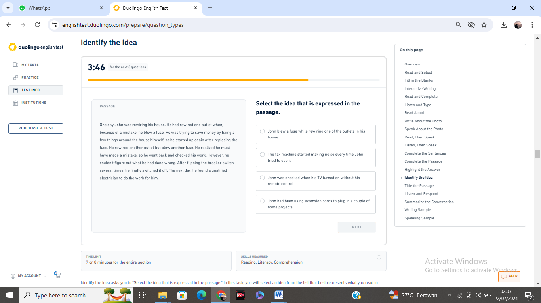

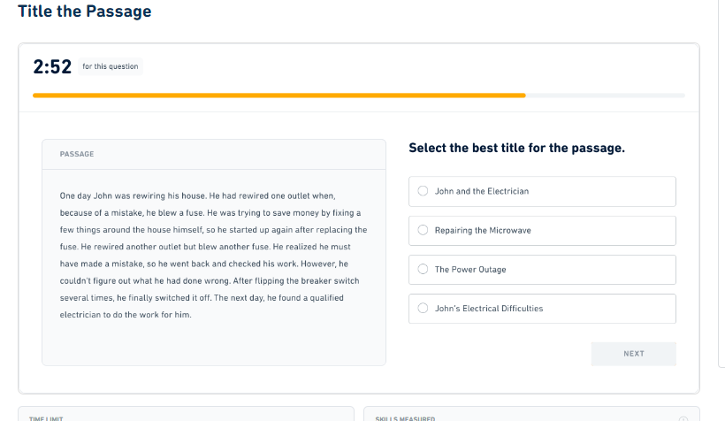

Session 15
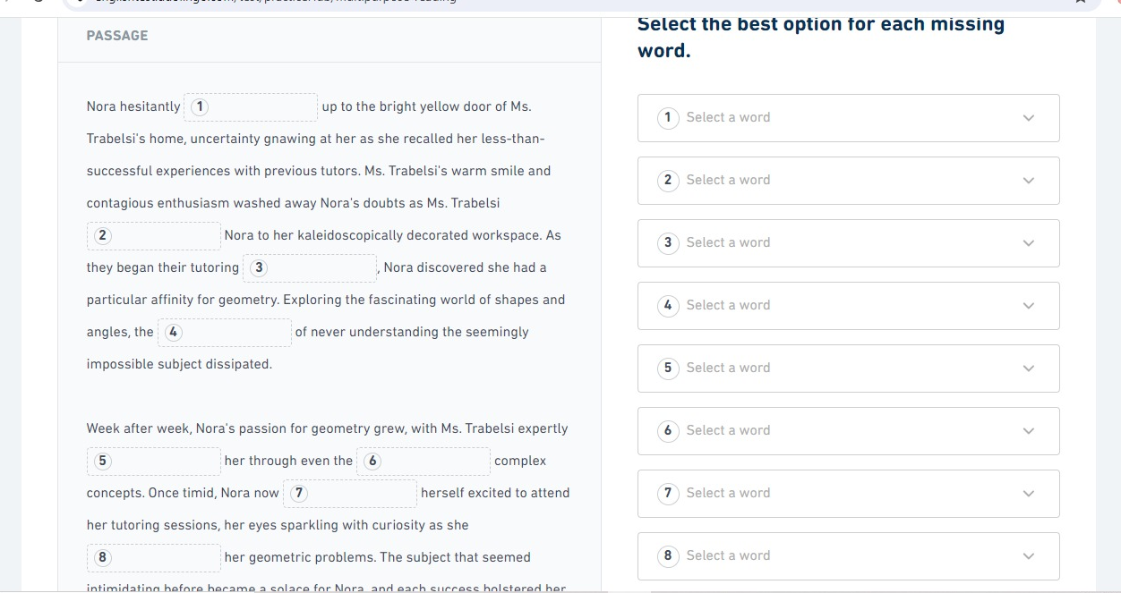

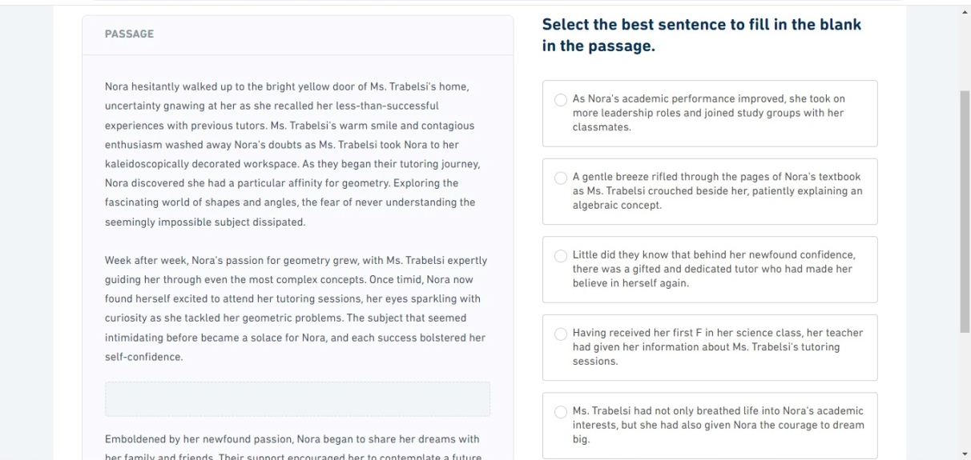

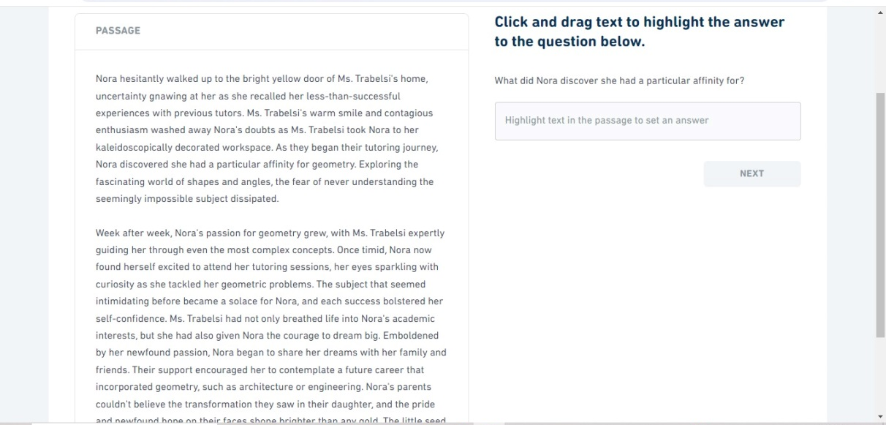

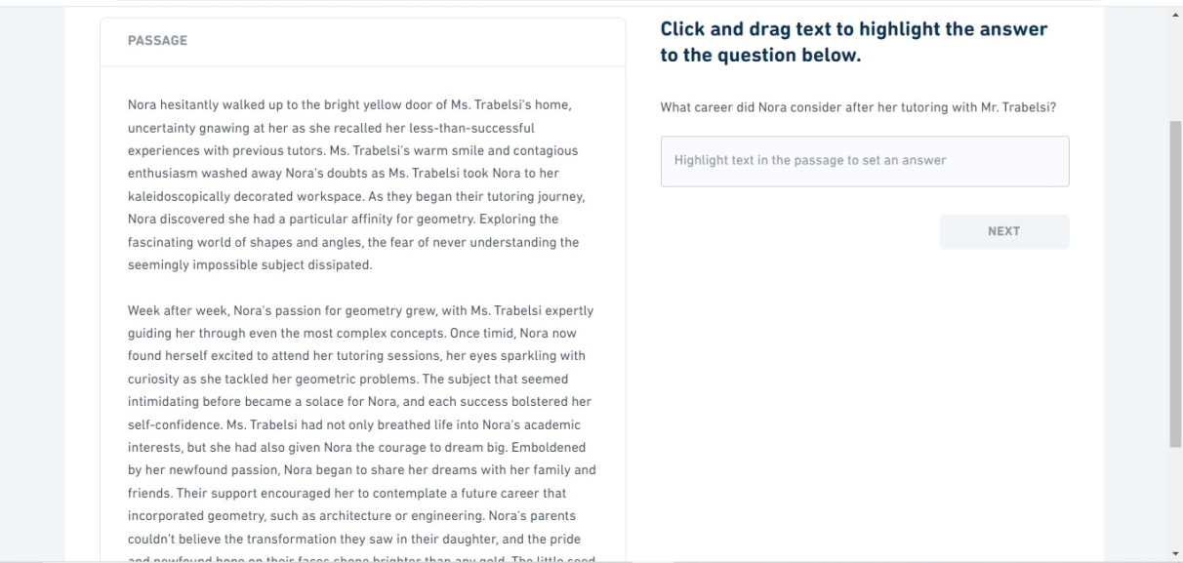

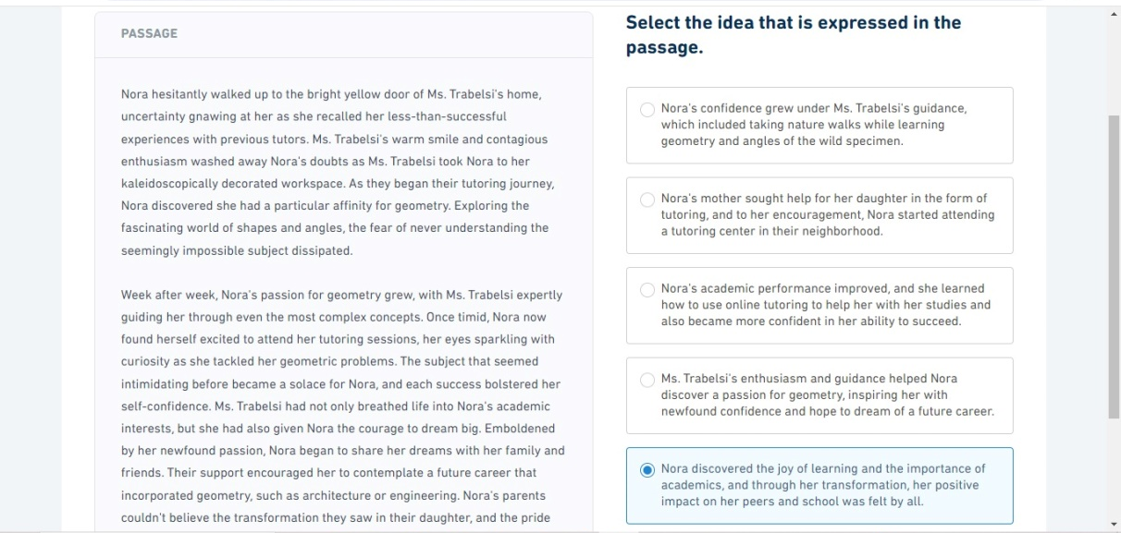

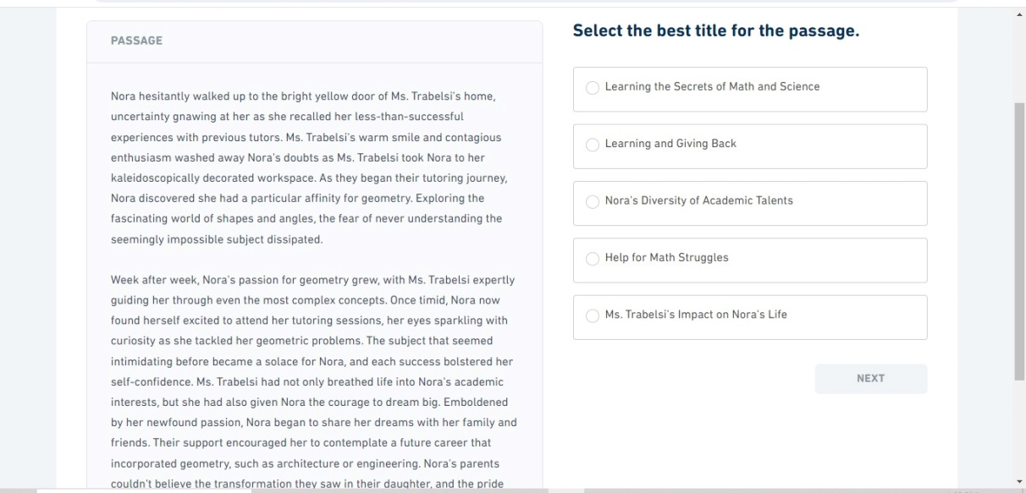

Session 16
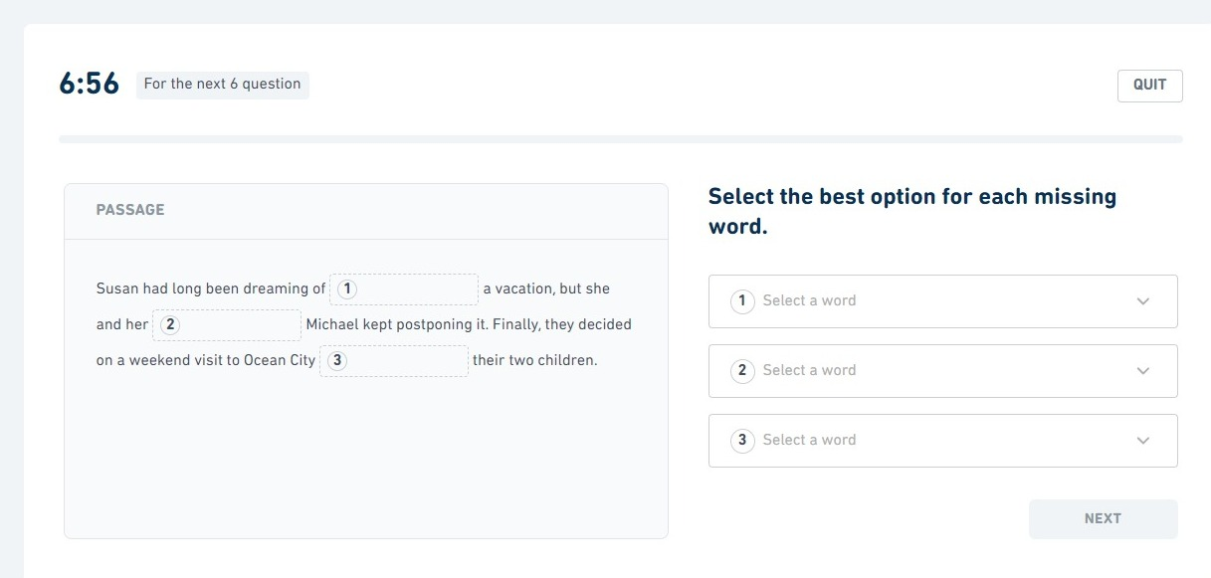

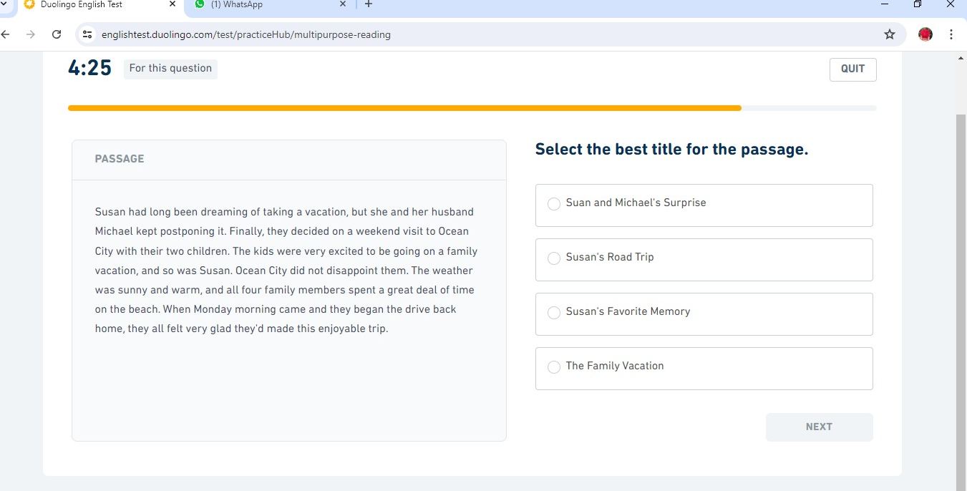

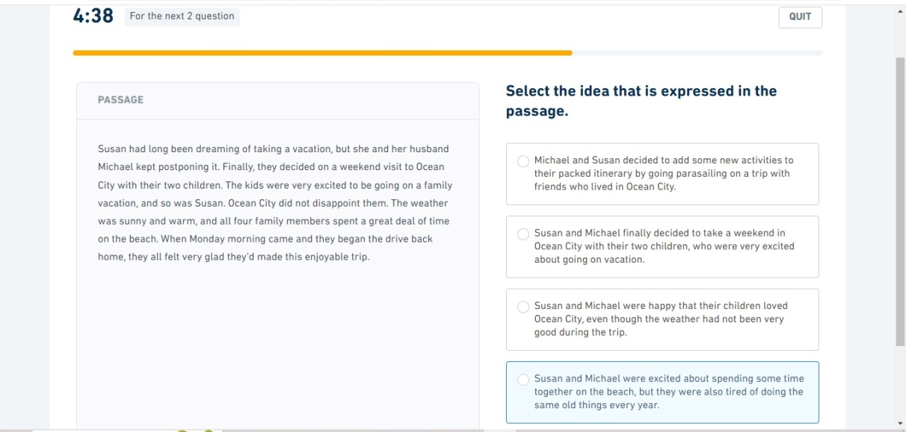

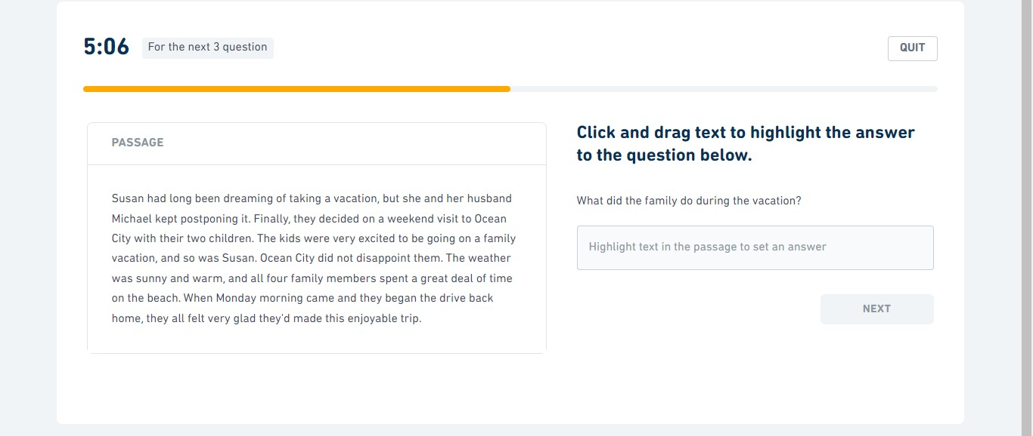

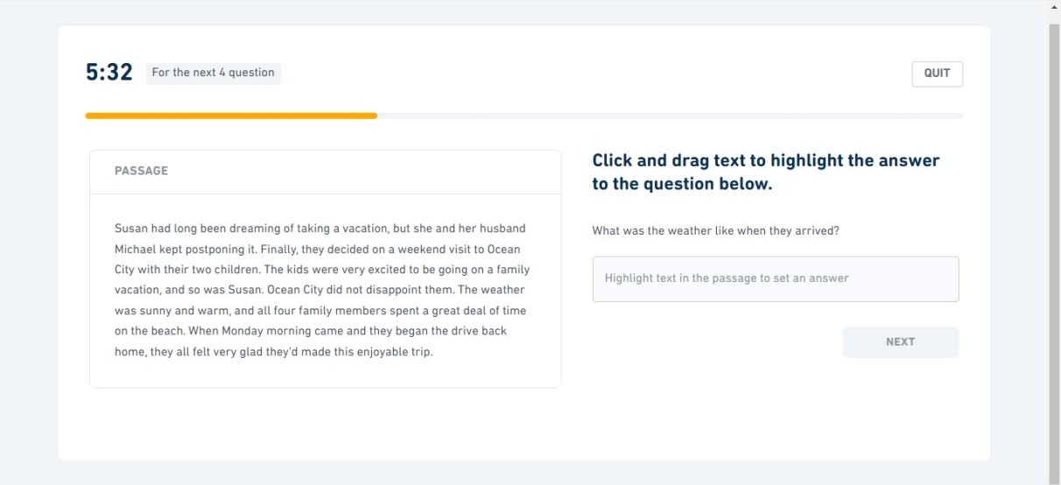

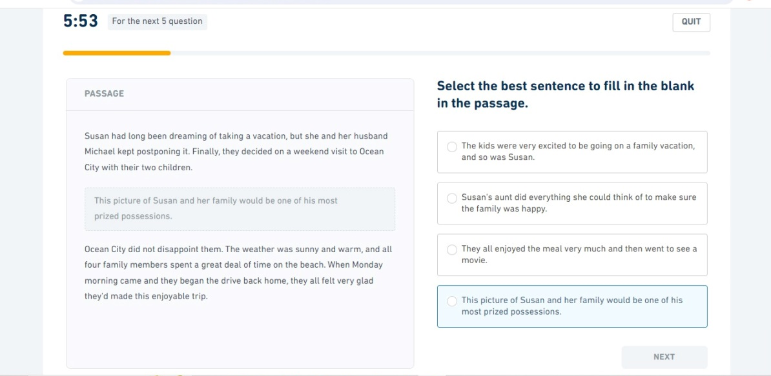

Session 17
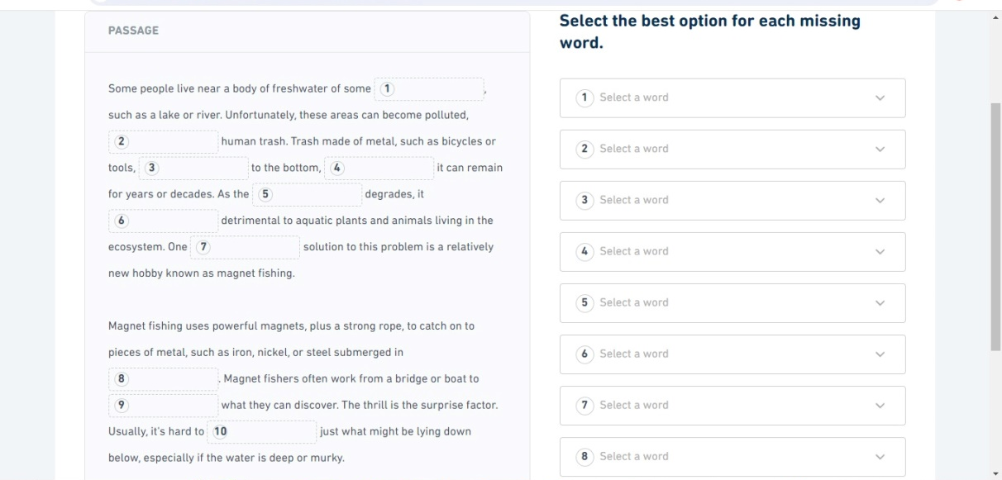

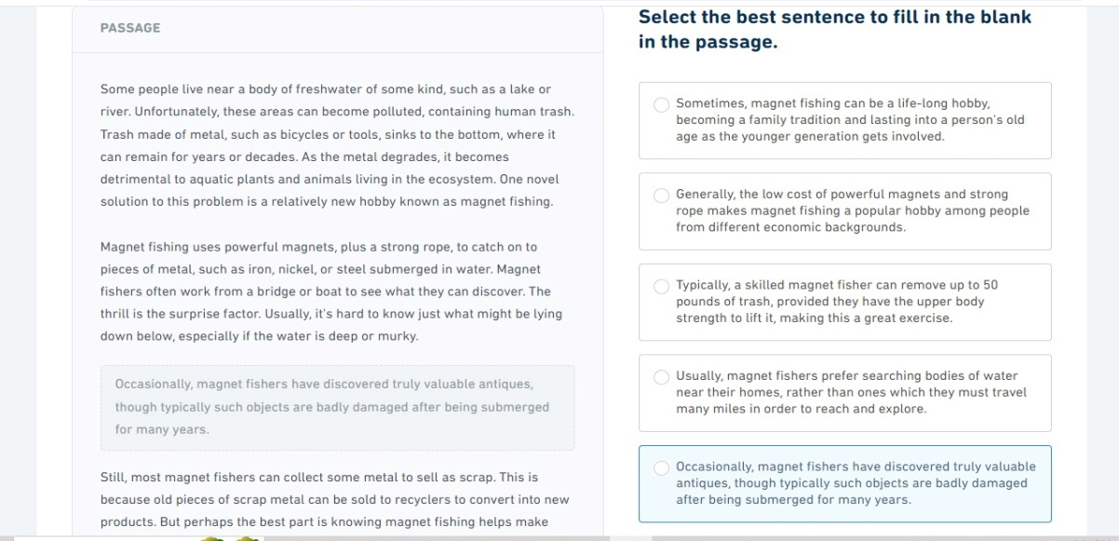

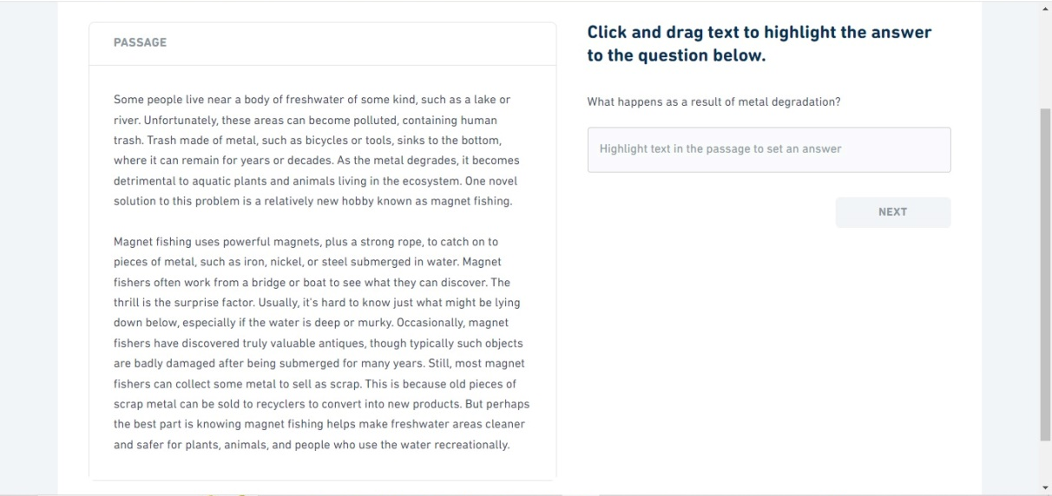

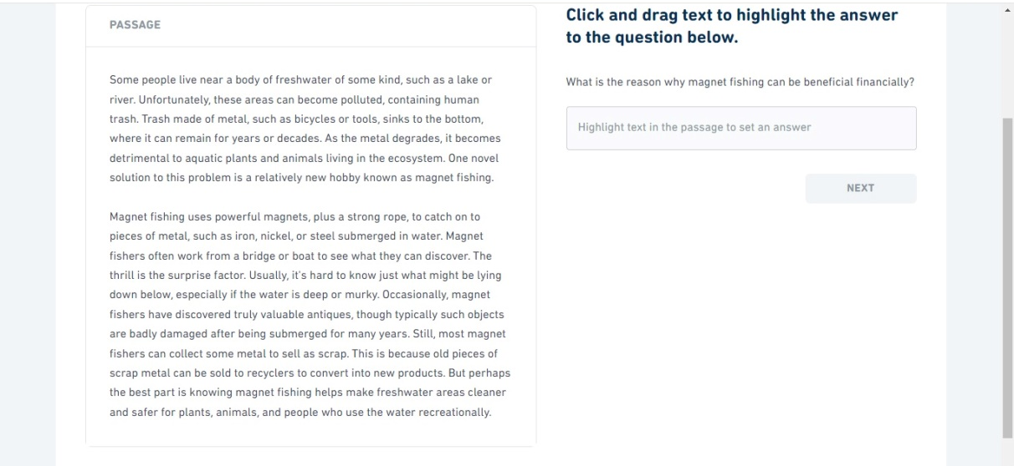

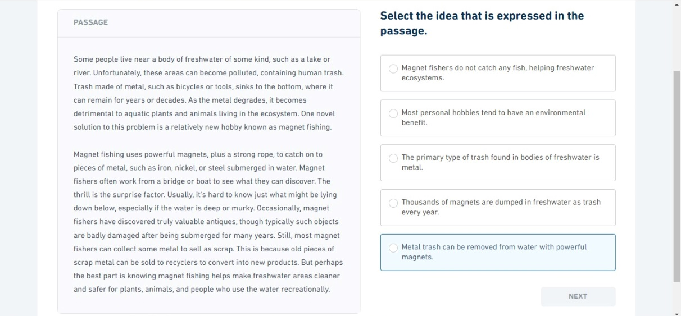

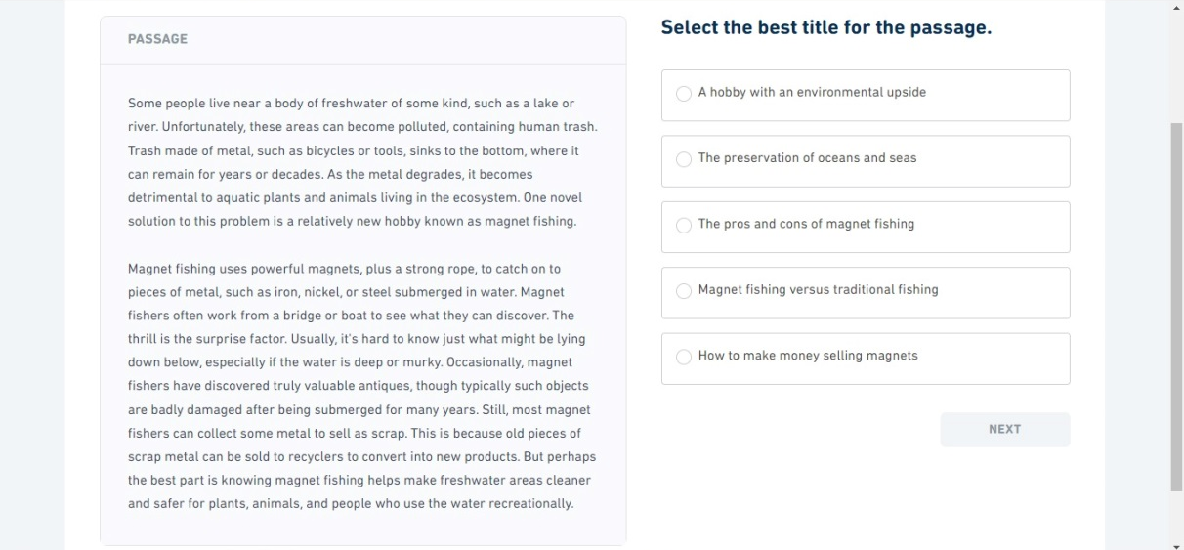

Session 18
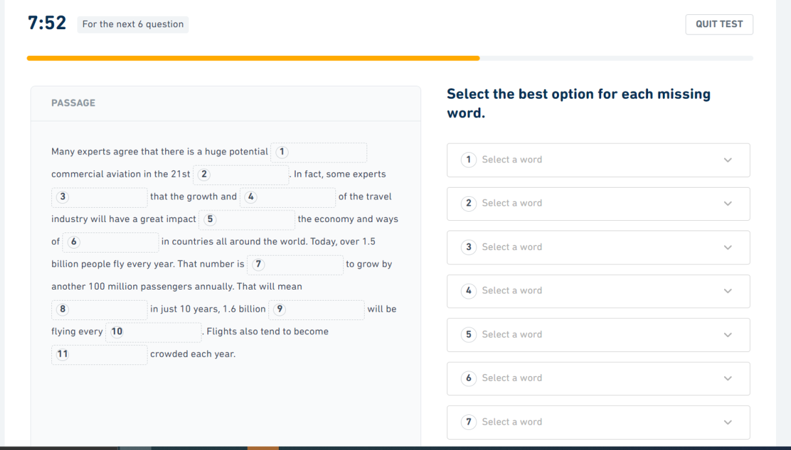

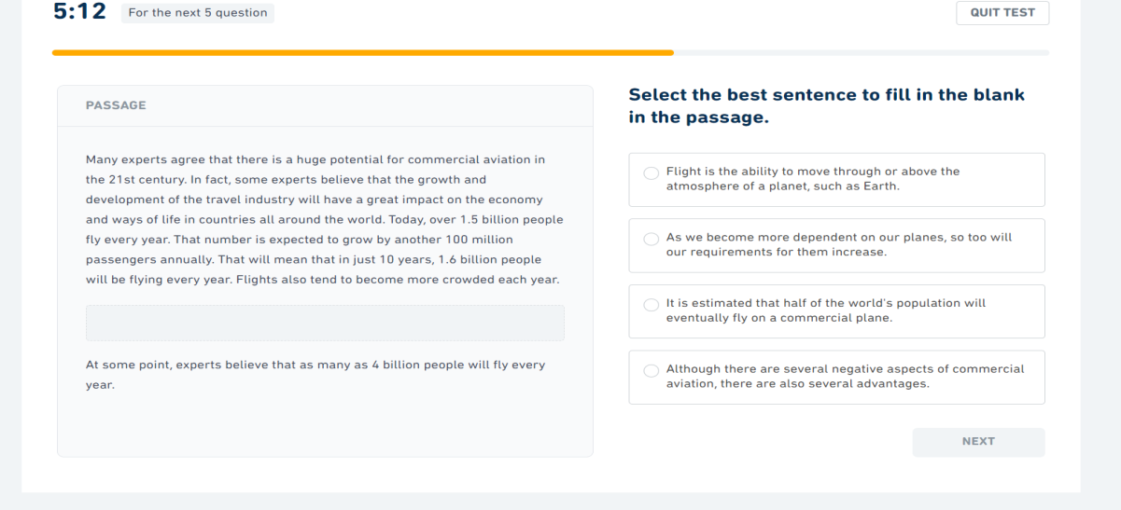

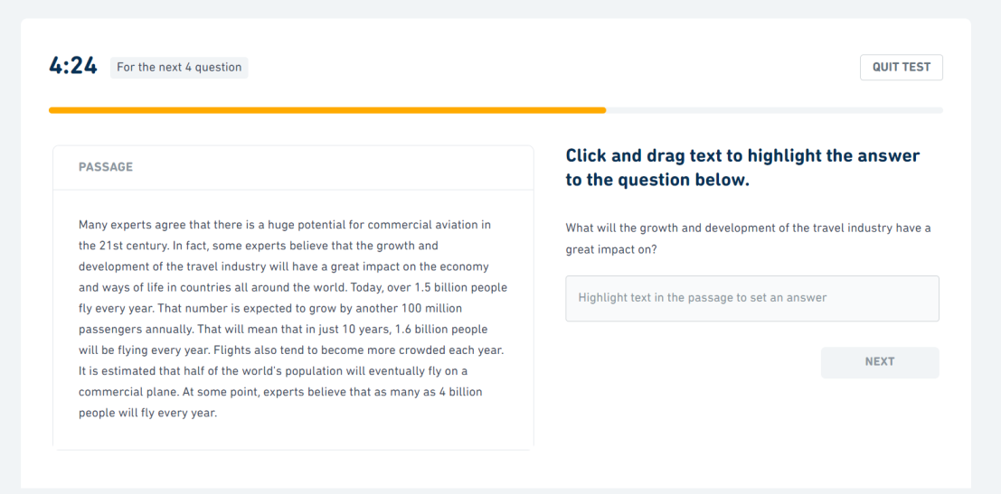

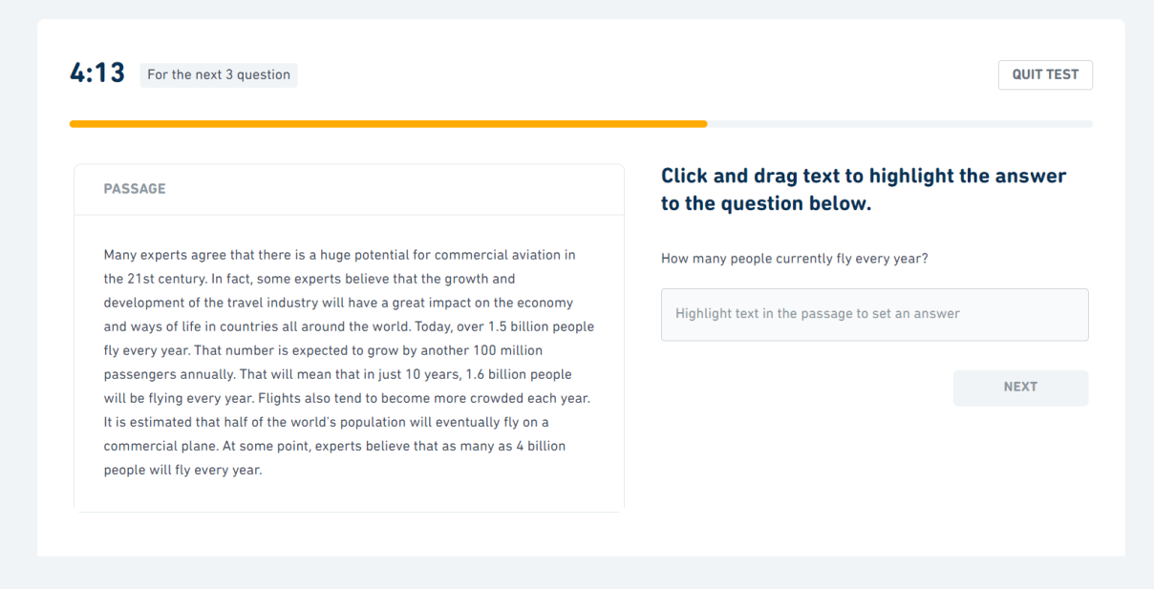

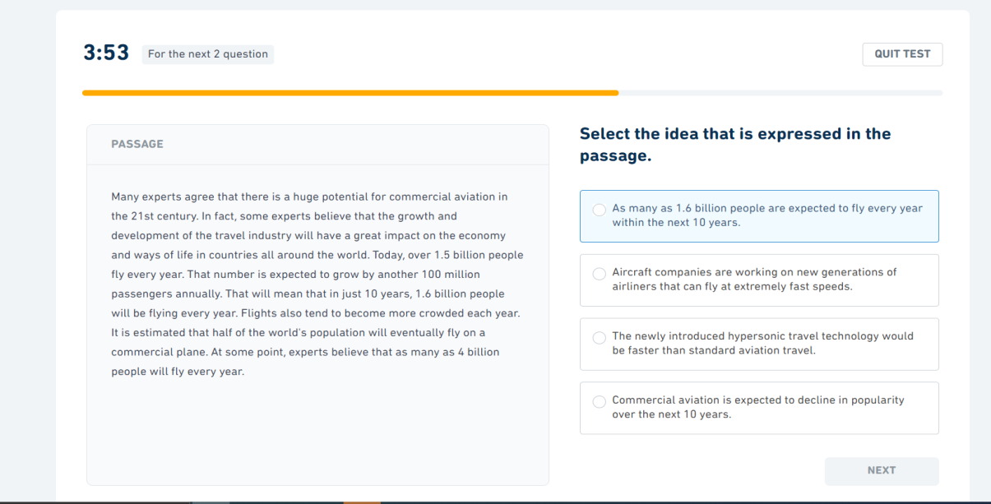

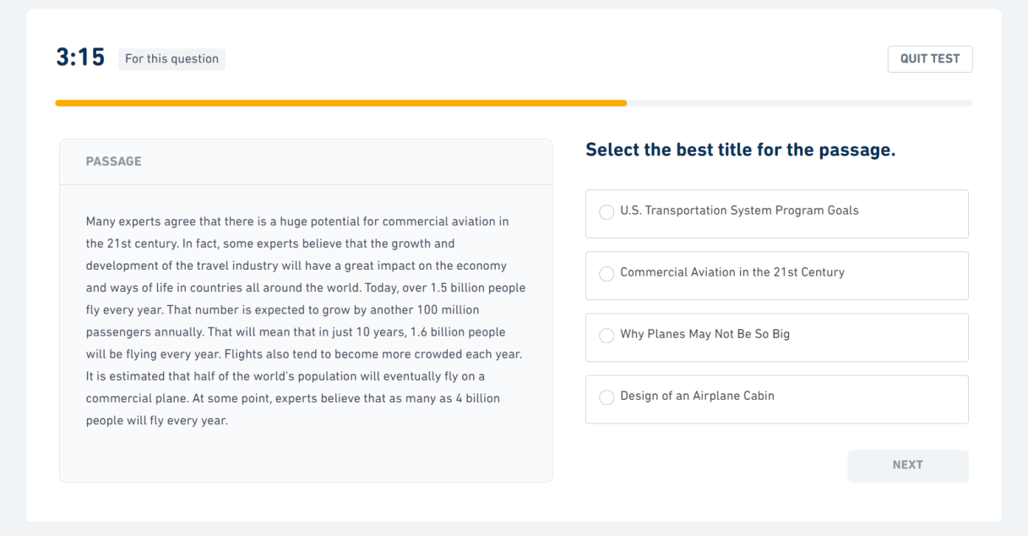

Session 19

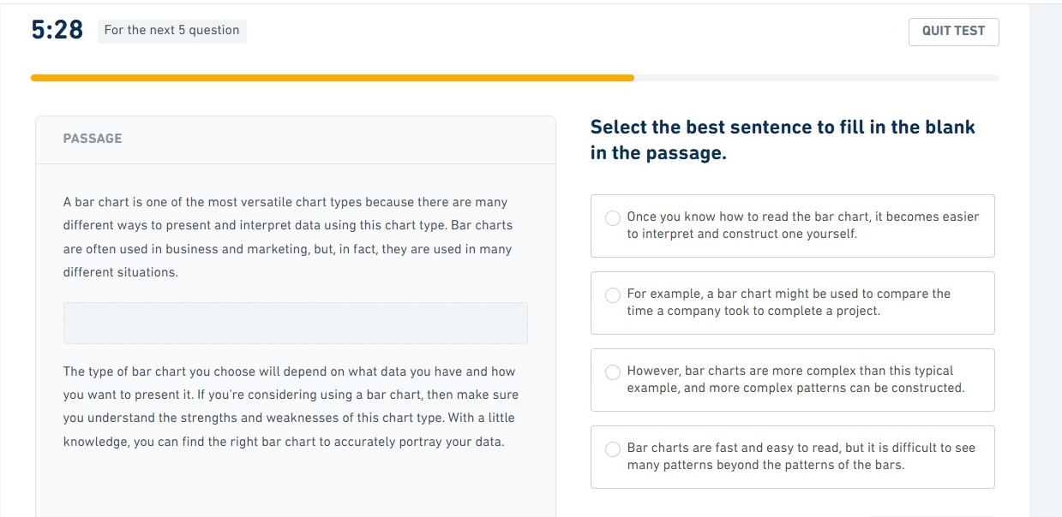
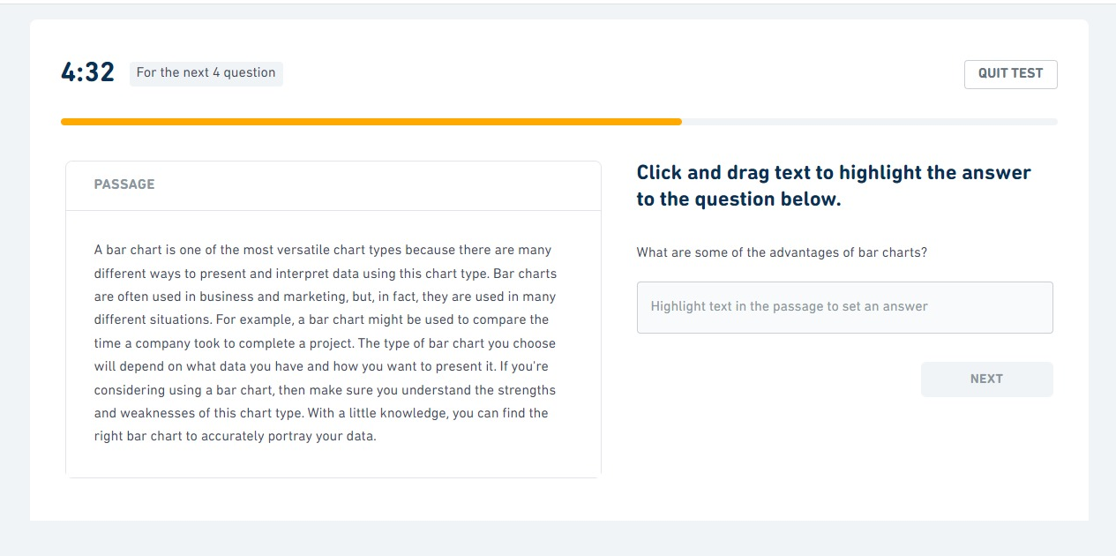

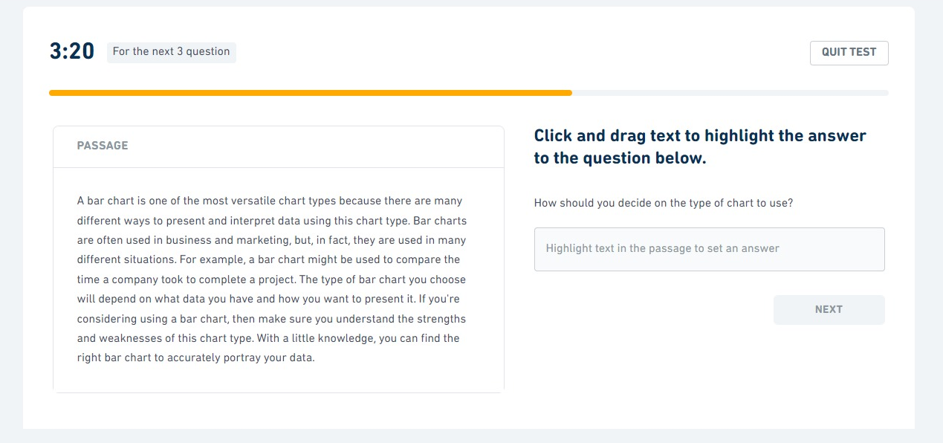

Session 20

