STUDENTS PERCEPTION ON @JAGOBAHASA ACCOUNT
AND THE IMPACT OF THE VOCABULARY

UNDERGRADUATE THESIS

Skripsi

Submitted to the English Education Department of the University of Serambi Mekkah as a fulfilment for the degree of Sarjana Pendidikan

ZULBAIDAH
NPM. 2011080014



ENGLISH EDUCATION DEPARTMENT
FACULTY OF TEACHER TRAINING AND EDUCATION
THE UNIVERSITY OF SERAMBI MEKKAH
BANDA ACEH
2024

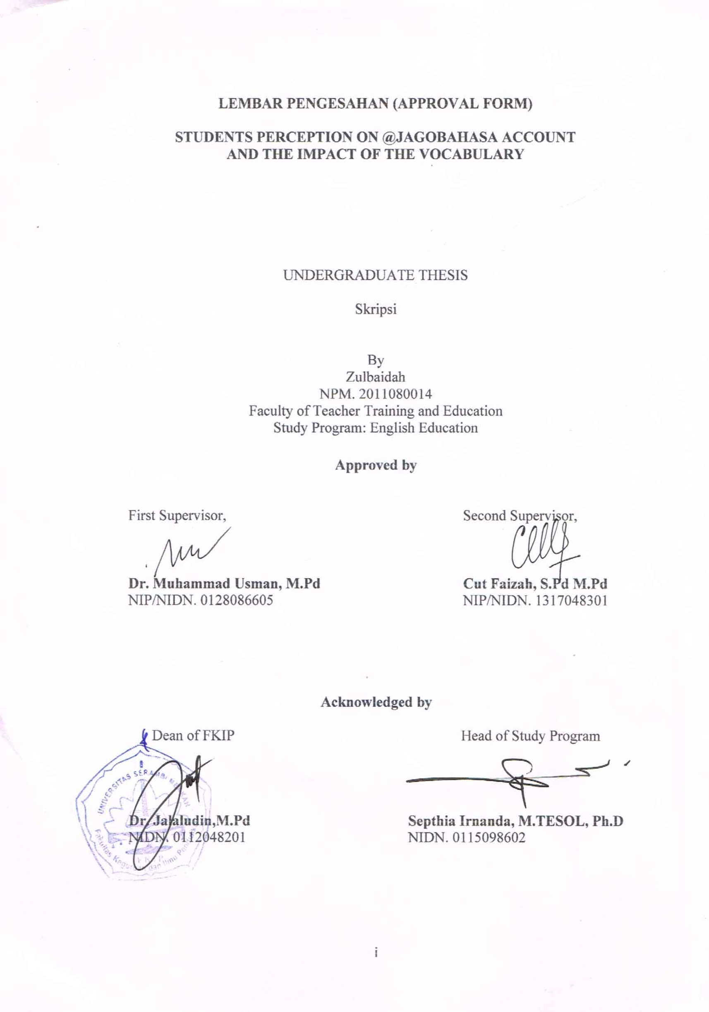
LEMBAR PENGESAHAN (APPROVAL FORM)

STUDENTS PERCEPTION ON @JAGOBAHASA ACCOUNT
AND THE IMPACT OF THE VOCABULARY

UNDERGRADUATE THESIS

Skripsi

By
Zulbaidah

NPM. 2011080014

Faculty of Teacher Training and Education
Study Program: English Education

Approved by

First Supervisor, Second Supervisor,

Dr. Muhammad Usman, M.Pd Cut Faizah, S.Pd M.Pd
NIP/NIDN. 0128086605 NIP/NIDN. 1317048301

Acknowledged by

Dean of FKIP Head of Study Program

Dr. Jalaludin,M.Pd Septhia Irnanda, M.TESOL, Ph.D
NIDN. 0112048201 NIDN. 0115098602

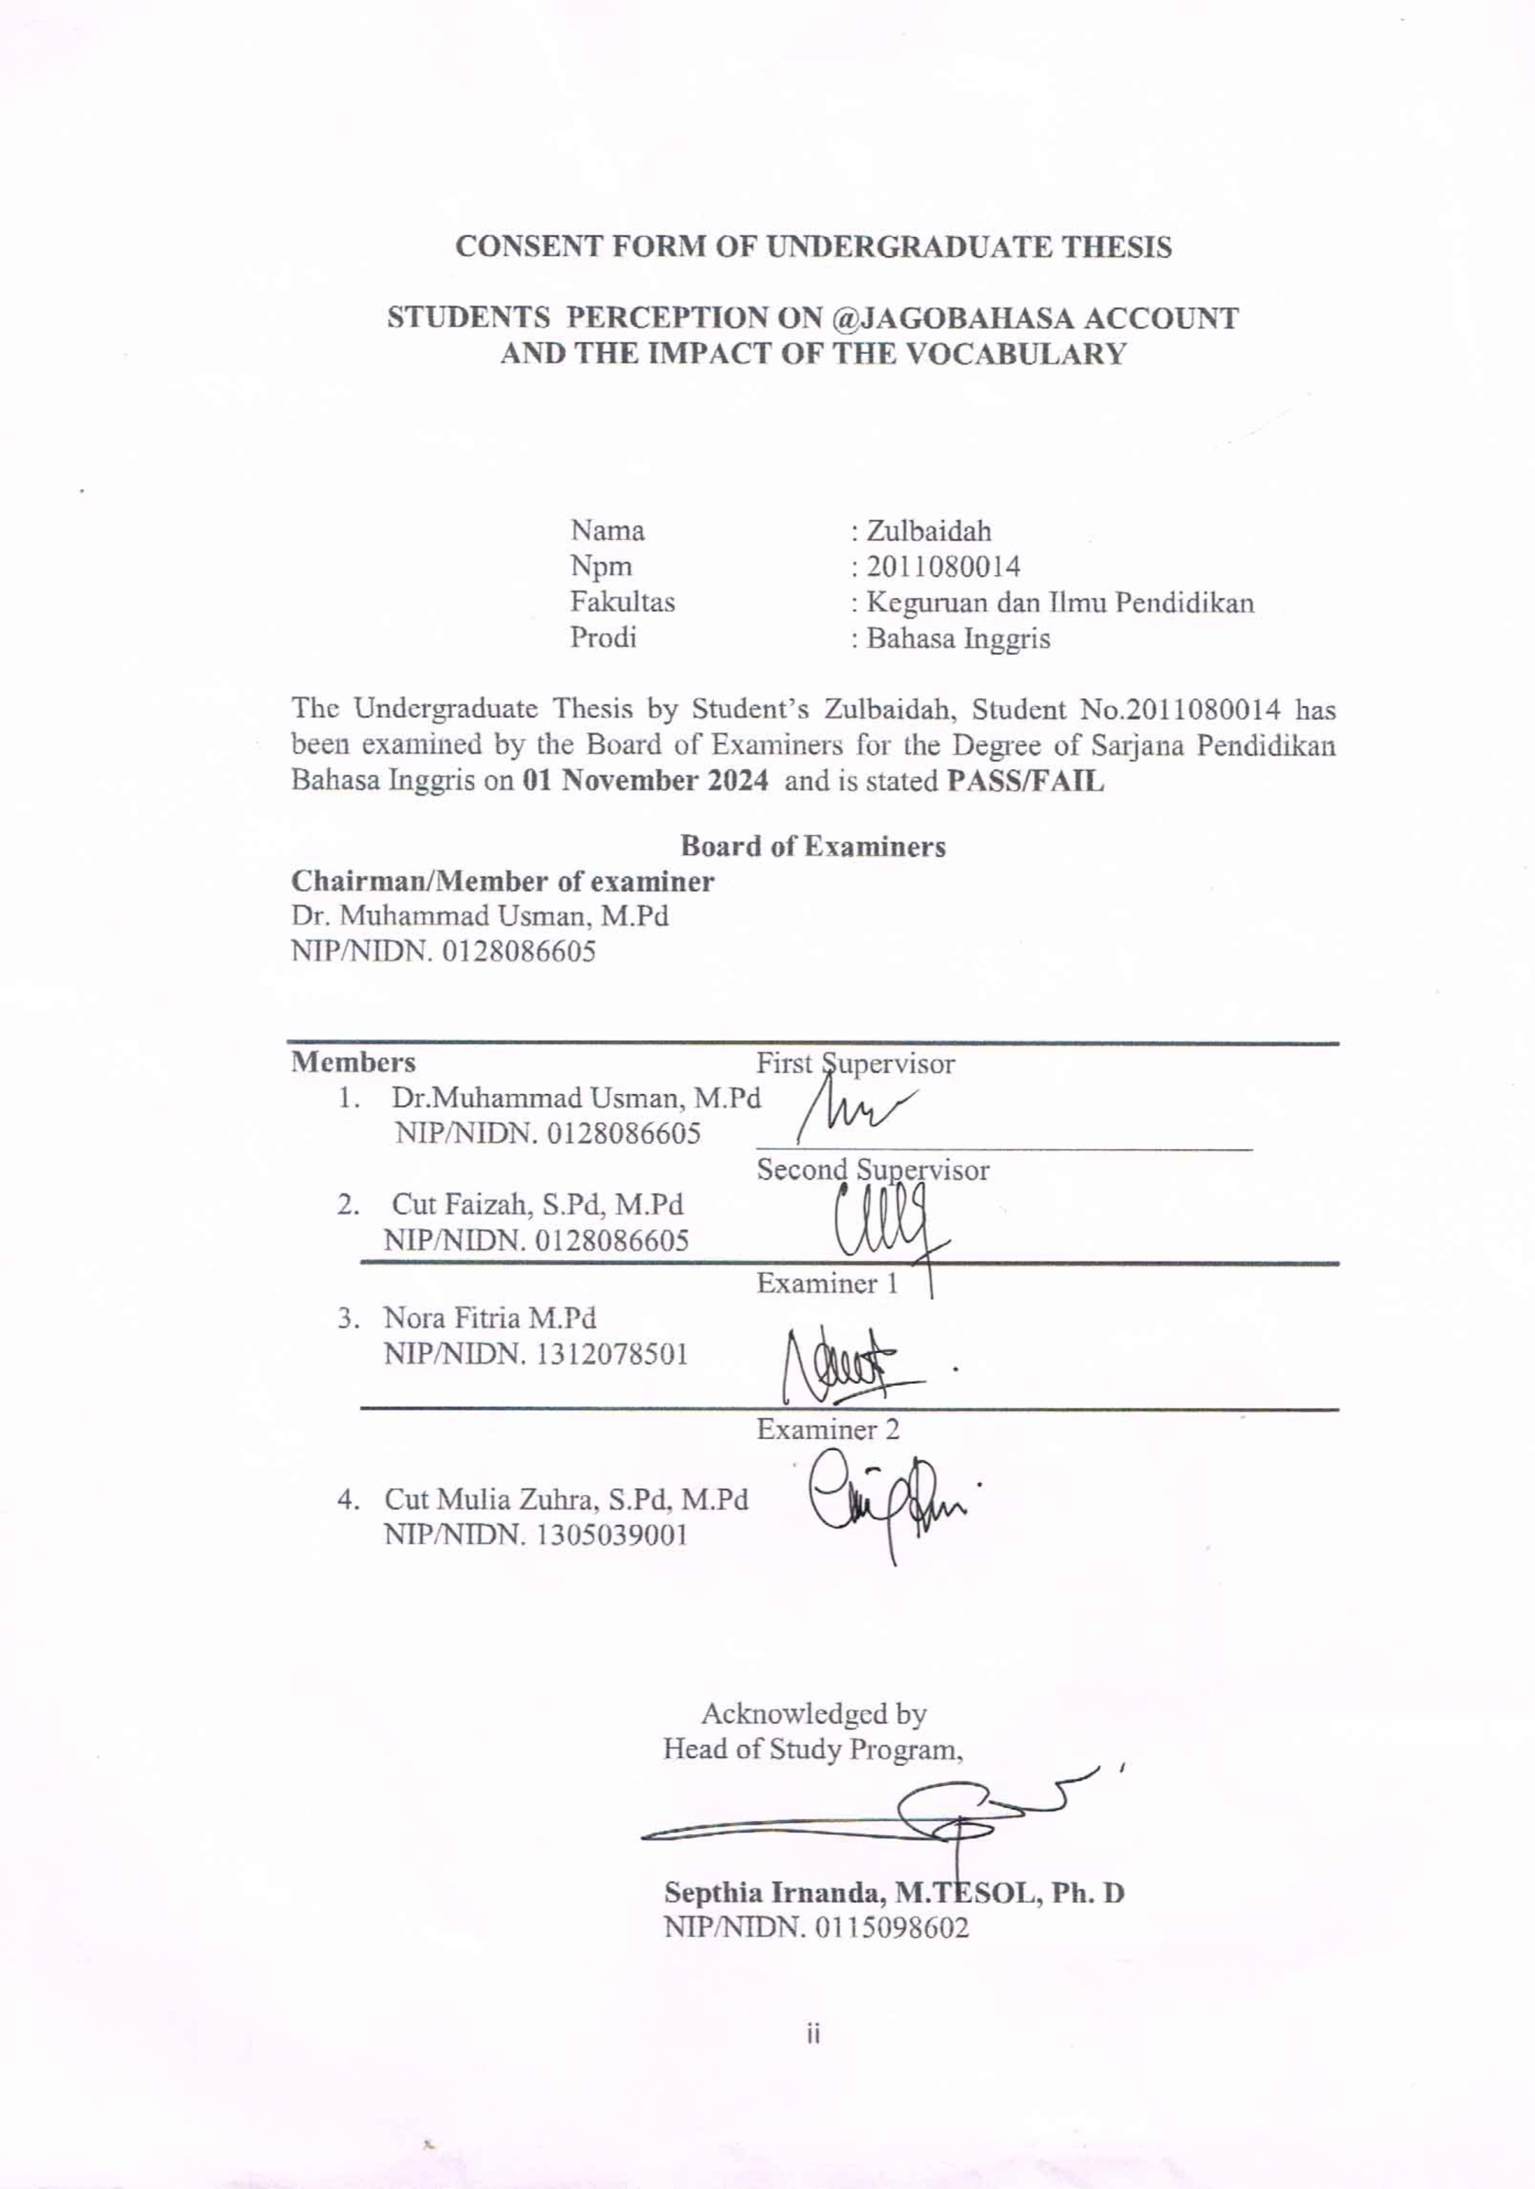
CONSENT FORM OF UNDERGRADUATE THESIS

STUDENTS PERCEPTION ON @JAGOBAHASA ACCOUNT
AND THE IMPACT OF THE VOCABULARY

Nama : Zulbaidah
Npm : 2011080014
Fakultas : Keguruan dan Ilmu Pendidikan
Prodi : Bahasa Inggris

The Undergraduate Thesis by Student’s Zulbaidah, Student No.2011080014 has been examined by the Board of Examiners for the Degree of Sarjana Pendidikan Bahasa Inggris on 01 November 2024 and is stated PASS/FAIL

Board of Examiners
Chairman/Member of examiner
Dr. Muhammad Usman, M.Pd
NIP/NIDN. 0128086605

Members First Supervisor
- Dr.Muhammad Usman, M.Pd
NIP/NIDN. 0128086605 ________________________________
Second Supervisor
- Cut Faizah, S.Pd, M.Pd
NIP/NIDN. 0128086605
Examiner 1
- Nora Fitria M.Pd
NIP/NIDN. 1312078501

Examiner 2

- Cut Mulia Zuhra, S.Pd, M.Pd
NIP/NIDN. 1305039001

Acknowledged by
Head of Study Program,

Septhia Irnanda, M.TESOL, Ph. D
NIP/NIDN. 0115098602
SURAT PERNYATAAN
(PERSONAL STATEMENT)

Saya yang bertanda tangan di bawah ini:

Nama : Zulbaidah
NPM : 2011080014
Program Studi : Pendidikan Bahasa Inggris
Judul Skripsi : Students Perception on @Jagobahasa Account and the Impact of the vocabulary

Dengan ini menyatakan bahwa Skripsi ini merupakan hasil karya tulis ilmiah saya sendiri, dan bukanlah merupakan karya orang lain yang pernah diajukan untuk memperoleh gelar sarjana atau dipublikasikan lewat media apapun. Adapun karya atau pendapat pihak lain yang dikutip, baik secara langsung atau tidak langsung ditulis sesuai dengan kaidah penulisan ilmiah yang berlaku.
Pernyataan ini saya buat dengan penuh tanggung jawab dan saya bersedia menerima segala konsekuensi apapun sesuai dengan aturan dan hukum yang berlaku bilamana dikemudian hari diketahui bahwa pernyataan saya ini tidak benar.

Banda Aceh, November 01 2024

Zulbaidah

ACKNOWLEDGEMENT

Thanks to ALLAH SWT,for giving me pattient in every step i take so that this thesis can be completed properly and far from perfect.
I dedicate this thesis to:
- My first love, my father (Alm) Tgk. Zainan R bin Tgk. Cut Ali, who did not have the opportunity to see my education and the door to heaven, my mother Nurhabibah, and Mr. Buchari P, thank you for all the sacrifices and sincere love given. He did not have time to experience college education, but always gave his best and tirelessly prayed and supported until the author was able to complete his studies in obtaining a bachelor's degree. May Mom and Dad be healthy, blessed with life and always happy.
- My sister Fera Jumaida My brother Muhammad Azhar thank you for the attention and sacrifice given during college, may ALLAH SWT reward the goodness and glory for my brother and sister.
- Dr. Muhammad Usman, M.Pd and Cut Faizah, S.Pd M.Pd, who have provided direction and guidance in completing this thesis, thank you for your knowledge and time, may ALLAH give good rewards in the world hereafter and in the protection of the almighty.

Banda Aceh, November 01 2024

Zulbaidah

ABSTRACT

Name : Zulbaidah
Student No. : 2011080014
Study Program : English Education
Thesis Title : Students Perception on @Jagobahasa Account and the Impact of the vocabulary

This study describes students' perceptions of using Instagram as an additional medium to improve their vocabulary. The aim is to find out how better vocabulary production is by using the Instagram account @jagobahasa. The background of this study highlights the importance of English in daily life and the role of information and communication technology in language learning, especially through the use of Instagram and @Jagobahasa. @Jagobahasa can help in various skills including in improving vocabulary, this study uses a qualitative approach, which involves data collection through questionnaires and interviews. The study population included students from various semesters at Serambi Mekkah University Banda Aceh, with a sample of 50 students from the English language education program. The results showed that overal from 98% from the questionnaire most students follow and use @Jagobahasa as a tool to improve vocabulary and the similarity of the results of the interview is the same and positife. Conclusion the majority of students follow @Jagobahasa account as an medium that is easy and helpful in improving vocabulary.

Keywords: Instagram, @Jagobahasa, Vocabulary.

ABSTRACT

Name : Zulbaidah
Student No. : 2011080014
Study Program : English Education
Thesis Title : Students Perception on @Jagobahasa Account and the Impact of the vocabulary.

Penelitian ini mendeskripsikan persepsi siswa dalam menggunakan Instagram sebagai media tambahan untuk meningkatkan kosa kata mereka. Tujuannya adalah untuk mengetahui bagaimana produksi kosa kata yang lebih baik dengan menggunakan akun Instagram @jagobahasa. Latar belakang penelitian ini menyoroti pentingnya bahasa inggris dalam kehidupan sehari-hari dan peran teknologi informasi serta komunikasi dalam pembelajaran bahasa, terutama melalui penggunaan media instagram dan @Jagobahasa. @Jagobahasa dapat membantu dalam berbagai keterampilan termasuk dalam meningkatkan kosakata, penelitian ini menggunakan pendekatan kualitatif, yang melibatkan pengumpulan data melalui kuesioner dan wawancara. Populasi penelitian mencakup mahasiswa dari berbagai semester di Universitas Serambi Mekkah Banda Aceh, dengan sampel sebanyak 50 mahasiswa dari program pendidikan bahasa inggris. Hasil penelitian menunjukkan secara keseluruhan 98% dari kuesioner sebagian besar mahasiswa mengikuti dan menggunakan @Jagobahasa sebagai alat untuk meningkatkan kosakata dan kesamaan hasil dari wawancara sama dan positif. Kesimpulan ,mayoritas siswa mengikuti akun @Jagobahasa sebagai media yang mudah dan membantu dalam meningkatkan kosakata.

Keywords: Instagram,@Jagobahasa, Vocabulary.

TABLE OF CONTENT

Title Page
Approval Form i

CHAPTER 1: INTRODUCTION 1
1.1 The Background of the Study 1
1.2 The Problem of the Study 4
1.3 The Aim of the Study 4
1.4 The Significance of the Study 4
1.5 The Scope of the Study 5
1.6 The Definition of Key Terms 5
1.7 The Organization of the Study 5

CHAPTER 2: LITERATURE REVIEW 7

  - Definition of Instagram 7
  - Instagram Social Media 8
  - Vocabulary 9

CHAPTER 3: RESEARCH METHODOLOGY 11

  - The Research Design 11
  - The Population and Sample 11
    - Population of the Research 11
    - Sample of the Research 12
3.3 The Research Instrument 12
3.4 The Data Analysis 13

CHAPTER 4: RESEARCH FINDING AND DISCUSSION 14

  - Research finding 14
    - The student’s perception with @Jagobahasa account in improving Englis vocabulary................................................................................ 14
4.1.2. Utilized @Jagobahasa as motivation to learn everyday vocabulary in English 18
4.1.3 Student’s familiarity with @Jagobahasa........................................... 22
4.2 Discussion 24

CHAPTER 5 CONCLUSION AND SUGGESTION 25

  - Conclusion 25
  - Suggestion 25
References 25

LIST OF TABLES

Table 4.1.1 The Students’ Perception with @Jagobahasa account improving English vocabulary 14
Table 4.1.2 Utilized @Jagobahasa as a motivation 18
Table 4.1.3 Student’s familiarity with @Jagobahasa ................................................. 22

LIST OF FIGURES

Figure 4.1.1 The student’s perception with @Jagobahasa account improving English vocabulary 18
Figure 4.1.2 Motivation to learn daily vocabulary 20
Figure 4.1.3 Students familiarity with @Jagobahasa .................................................. 22

LIST OF APPENDICES
- Research Letter
- The Questionnaire
- Interview

CHAPTER I
INTRODUCTION

  - The Background of Study
Vocabulary is all the words in a language, the wealth of words a speaker or writer has, and the words used in a field of science. According to Soedjito in Hilaliyah (2018). The specific words used by individuals in constructing sentences determine their vocabulary, directly influencing to articulate the spoken word clearly.
English is one of the languages that is difficult to understand and learn, especially in Indonesia. Indonesian students lack skills in the field of English because of the lack of vocabulary they have. However, the ability to communicate in English is still limited because English is not a commonly used language in Indonesia.
Various types of technology are used to get knowledge and information in the field of education in the era of globalization which is increasingly advanced along with the developments in science and technology. There is some information that can be obtained to add insight or ability in learning vocabulary, one of which is the Instagram account @Jagobahasa. Indonesia is among the nations with poor English competence, particularly among students, suggests Crystal, D. (2003). Students in Indonesia struggle with memorization, lack exposure to new vocabulary, practice speaking foreign languages, and have little access to tools for acquiring a wide variety of vocabulary. They grow disinterested and believe that learning English is one of the most challenging and tedious languages. Naturally, vocabulary is where we begin when trying to improve our communication because it is the foundation of speaking English. Given that English is the most widely spoken and understood language in the world today a result of globalization its significance cannot be understated (Nishanthi, 2020). According to Tajeddin et al. (2020), English has long been the most often used foreign language in institutional curricula and foreign language teaching and learning systems.
Education and knowledge can now be acquired through more than only formal and informal means. Instagram is one of the many social media platforms that many people use to obtain knowledge. according to peterson et.al (2018). We need to become proficient in speaking, vocabulary, grammar, reading, writing, listening, and speaking in English, among other many other areas and abilities. Out of all the components and skills listed above, we will concentrate on the vocabulary the difficult to master vocabulary skills of all of the components. The ability to comprehend what is heard, read, written, and spoken by others is facilitated by having a strong vocabulary. Learning new words necessitates "deep experience or active interaction with the vocabulary being learned," according to J. Harmer (1991). Students can accomplish this by studying terminology they find useful or enjoyable. As a result, it is crucial to employ instructional strategies and media that can foster a learning environment where students can engage with the vocabulary or concepts they are studying thoroughly (immersion). Tarigan (1993: 109) states that a person's language skills depend on the quantity and quality of his/her vocabulary.
Because many students find it difficult to express a sentence or when speaking they are constrained in vocabulary, it is necessary to increase learning efforts to improve daily vocabulary by memorizing a lot of basic vocabulary. Therefore, many students can’t speaking English because of their lack of vocabulary.
There are several media that can be made a reference as a learning media to increase vocabulary in English, many accounts dedicated to education and personal development follow such accounts can provide content that focuses on increasing vocabulary and literacy, one of which is by using Instagram media one of which is by using Instagram media. Instagrams is one of the media applications for sharing photos, videos and others that can be accessed to add vocabulary through accounts on Instagram, one of which is the @jagobahasa account. Instagram is a social media platform that focuses on sharing photos and videos. Therefore, many students can’t speaking English because of their lack of vocabulary
Launched in 2010, Instagram has become one of the most popular apps in the world, with over a billion monthly active users, there are various features on Instagram ranging from stories, IG shopping, content creators, reels and more. Users can also create their own videos and users can customize the filters that users want on the Instagram app. The reason is to find out how vocabulary production is improved by using the Instagram account @jagobahasa based on the results of the pre-test, and post-test, and to analyze the students' perceptions of the @jagobahasa Instagram account in supporting them in improving their vocabulary based on Gibson et al. (2019) theory. His research is to be carried out to answer all the problems being studied that following the @Jagobahasa Instagram account is very effective in supporting student learning in acquiring vocabulary.
Additionally, 80% of the students followed various Instagram accounts that provided English education, according to Agustin and Ayu (2021). Additionally, 95% of the students said that Instagram is helpful for expanding their vocabulary in English and honing their listening comprehension. Since students' vocabulary increased dramatically, Instagrams seems to be a useful teaching tool for vocabulary development. Some previous studies have excamined the improvement of English vocabulary by using Instagrams apps so that it can help in this study.
Based on previous study by Lausiry et al. (2023 ) entitled Student’ Perception of Using the Instagram Account @jagobahasacom in Improving Student English Vocabulary at SMEA Muhammadiyah 1 Yogyakarta. It was found that using the Instagram account @jagobahasa can improve their daily vocabulary. However, there are no specific study findings on student perceptions of Instagram media development tools in improving vocabulary ability. His research was conducted to find out how effective the use of @Jagobahasa account is in improving students'.
Based on previuos second study by Hanum et al. (2023) entitled the Effectiveness of Jagobahasa’s video on Instagram towards Student’s Vocabulary Acquisition at the second grade Students of MAN 1 JEMBER. It was found choose a longer duration video type, can improving the comprehensiveness of the video making it easier for students accsess and retain vocabulary in utilizing video language champion as a learning tool.
Therefore, this study is conducted to find out the students’ perception on @Jagobahasa account followers about the impact of the vocabulary.
Based on this explanation, it can be seen that @Jagobahasa account users can improve students' vocabulary skills, but this research has not examined the extent of their university on @ Jagobahasa account, so the researcher felt this research needed to be carried out and determined to analyze students' perception with @Jagobahasa account as a medium that can improve vocabulary skills.

1.2 The Problem of the Study
Based on the background povided, the problems that can be formulated are
1 To what extent do students perceive @jagobahasa account as a tool to enhancing vocabulary?

1.3 The Aim of the Study
The purpose of this research is the vocabulary growth strategy, in particular the Instagram account @Jagobahasa as a tool to improve vocabulary:
1. To find out how English students' opinions on the use of @jagobahasa Instagrams account in improving English vocabulary.

1.4 The Significance of the Study
A.Theoretical significances
The significance of this research has two majors, such as teoritical significances and practical significances.
1. In this research provides a solution that the @Jagobahasa Instagram account can be used as a teaching platform to help students learn to improve their vocabulary.

B. Practical significances
This practical significance can be used by
1. For student
The students can improve their English vocabulary skills by using @jagabohasa instagrams
2. For the teacher
The teachers can use the @jagobahasa account Instagram as a learning media to improve students' vocabulary.
3. For future research the results of this study can be the basis for further research conducting similar research in different places, especially in improving vocabulary.

1.5 The Scope of the Study
This research focused on English Departmen students. This is due to the fact that vocabulary memorization assists students in retaining the knowledge they have learned, improving their comprehension, better learning focus, and long-term memory. The main objective of this research is to measure the level of familiarity, the frequency of use, and students' perception of @Jagobahasa account in improving English vocabulary.

1.6 The Definition of Key Terms
1.Instagram
The Instagram is an application platforms based on the Internet and technology that enables the exchange and generation of user-generated content. (Kaplan & Haelein, 20014). Instagrams is a digital-based application that can helpful in improve English vocabulary. @jagobahasa is a platform specifically designed to improve English language skills independently using the concept of SLD (self-directed learning).
2. Vocabulary
According to Saleh (2000). Vocabulary are words or groups of words that have a certain meanings as well as all the words used by a person in the communication activities.Vocabulary is a collection of words understood in a particular language of words that are assembled and combined into sentences used in everyday human life.

1.7 The Organization of The Study
This research is organized into three chapters. Chapter I introduction that describe the general the background of the study, the problem of study, the aims of the study, the significance of the study, theoritically significances, practically significances, the scope of the study, the definition of key terms, and the organization of the study. Chapter II is review of literature that consist of definition of Instagrams, Instagram social media, definition vocabulary. Chapter III is research methodology of the study tell about the research design, the research instrument, the data collected procedure, the data analysis and time line. Chapter IV the research presents findings and discussion. Chapter V is research conlusion and suggestion.

CHAPTER II
LITERATURE REVIEW

  - Definition of Instagrams
- Vocabulary
According to saleh (2000) vocabulary is aword or group of words that have a certain meaning and all words used by a person used in communication activities.
- Instagrams
Meodia (2020) claims that Instagram is currently the most popular visual social networking platform, with over one billion people actively using the app each month. According to Kaplan (20014:26), Instagram is a collection of web-based tools and applications that facilitate user-generated content production and exchange. Out of the overall population, 84.8% of Indonesians use Instagram. Instagram usage as a teaching tool can be one of the options; this is especially true when it comes to expanding students' vocabulary, as mastery of vocabulary is the primary requirement for students. The development of kids' vocabulary can have a big impact on their writing and reading abilities. Consequently, educators require an efficient method to maximize the caliber of pupils' vocabulary (Blair & Seraford, 2014). Instagram has the potential to enhance. Rhodes (2022) believes that Instagram is a social media application that allows users to take photos and videos, apply digital filters (giving effects to photos) and share them on various social media, including Instagram itself.

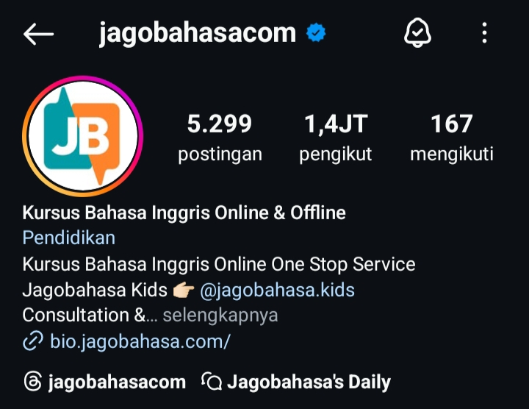
@Jagobahasa is one of the digital-based media plat forms that is used as a guide for learning,especially in enriching vocabulary and so on. The vocabulary taught @Jagobahasa in english is relevant to the daily life we use which can increase the effectiveness of vocabulary.
Meanwhile, according to Budiargo, quoted by Wahyono et al., (2020), instagram is a medium that makes sharing easy online by photos, videos and also social networking services which users can use to retrieve and share to their friends. Burbn, Inc. is a technology startup that was founded in 2010 and is solely focused on creating mobile applications. Burbn, Inc. first concentrated too much on mobile HTML5, but its two CEOs, Kevin Systrom and Mike Krieger, made the decision to concentrate on only one area. After a week of trying to come up with a good idea, they eventually created a prototype of Burbn, however it still had a few flaws. The final iteration of Burbn, a smartphone application, has an excessive number of functions. It was difficult for Kevin Systrom and Mike Krieger to reduce the existing features and start again from the beginning, but in the end they only focused on the photos, comments, and also the ability to like a photo. That's what Instagram ultimately became (Quinn et al., 2021).
Instagram social media has five main menus, all of which are located at the bottom, the five main menus are first, the home page. The home page is the main page that displays the latest photos from fellow users who have been followed. Second, comments. With the comments column, photos or videos on Instagram can be commented on. Third, explore is a display of popular photos that are most liked by Instagram users. Fourth, profile. On the profile page, users can clearly find out information about Instagram users, both personal profiles and other people's. Fifth, news feed. This news feed feature displays notifications about various activities carried out by Instagram users.

2.2 Instagram Social Media
Pulido et al. (2020) claim that social media is information democracy, transforming users from content consumers into content creators. According to Rhodes (2022), Instagram is a social media platform that lets users snap pictures and videos, add effects to them using digital filters, and share those posts on other social media platforms in addition to Instagram.

2.3 Vocabulary
The foundation of language is vocabulary, which enables one to communicate coherently in English and express feelings to others. Vocabulary is the riches of language owned by a language owned by (contained in) a language, claims Nurgiantoro (2016, p. 338). Knowledge of vocabulary is a crucial element. It may even be referred to as the secret to learning a foreign language because a person's vocabulary richness dictates the caliber of their language proficiency. The quality of a person's language abilities is also determined by their vocabulary. According to Hasanah (2016), vocabulary is a crucial component of language. a crucial component of language since without vocabulary, it is impossible for others to understand what one is saying. Hilaliyah (2018) defines vocabulary as all of a language's words, the abundance of words that a writer or speaker possesses, and words that are utilized in a certain field of study.
The theory of vocabulary involves a variety of approach to the way words are shaped, utilized, and understand in language. Here are some important aspects:
Semantic: It deals with the meaning of words. In Semantics, vocabulary is divided into categories, such as synonym (words that have the same meaning), anthonym (words that have opposite meanings), and homonym (words that sound the same but have different meanings).
Morphology: This is the study of the structure of words. Vocabulary can consist of morphemes (the smallest unit of meaning), which can be roots, prefixes, and suffixes. An understanding of the morphology allows us to comprehend the way words are formed and changed.
Pragmatics: This covers how context affects word usage. The meaning of a word can change depending on the situation or context in which it is used.
Vocabulary Acquisition: The process by which individuals learn and internalize new vocabulary, which can occur through formal learning, social interaction, or everyday experiences.
Cognitive Theory: Explores how the human mind processes vocabulary, including how we organize and remember words.
Breadth of Vocabulary knowledge this dimension refers to the number of words know by a person.
Depth of Vocabulary knowledge this dimension refers to how deep one’s understanding of a word is, it includes aspects such as: synonyms and antonyms, collocation(word that often appear together), connotative meanings, grammatical categoryof the word and contextual use of the word.

CHAPTER III
RESEARCH METHODOLOGY

3.1 The Research Design
The design of this study was a descriptive qualitative research which aims to explains empirical phenomena accompanied by statistical data, characteristics and patterns of relationships between variables. According to Sugiyono (2018: 213). Qualitative research methods are founded on the philosophy used to research on scientific settings (experiments) where the researcher is an instrument. The goal of descriptive qualitative research methodology is to examine and characterize events or study subjects by means of social interactions, individual or group perspectives, and attitudes. According to Moleong (2005: 4), a qualitative descriptive approach is a research approach in which the data collected are in the form of words, pictures and not numbers. These data can be obtained from interviews, field notes, photos, videos and personal documentation.
In particular, this research will assess students' familiarity with following the @Jagobahasa account as a tool for improving their vocabulary by utilizing qualitative data gathered through questionnaires. In order to further deepen students' experience and perceptions, qualitative data will also be collected through interviews.

  - The Population and Sample
3.2.1 Population of the Research
In research, population refers to the entire group of individuals or elements that a study aims to investigate. It includes all members that fit the criteria specified by the research objectives. Accurately defining the population is essential for ensuring that the findings are relevant and can be generalized to the larger group. The population in this study were the students of the English Study Program at Universitas Serambi Mekkah Banda Aceh. The students three semester,fifth semester and eight semesters student English Department.

3.2.2 Sample of the Research
The respondents in this study will be every English student Universities in Banda Aceh. The Universities In Banda Aceh are Serambi Mekkah University. The researcher wanted to know more about students’ opinions of the @Jagobahasa account that could improve speaking skills. The total sample was 50 sample for the questionnaire. It was classed by 16 students in the three semester, 24 students in the fifth semester, and 10 students in the seventh semester. Anattempt to obtain a sample by distributing questionnaires and selecting respondents for voluntary interviwes.

3.3 The Research Instrument
In this study, researchers used an instrument in the form of a questionaire and Interview, questionaire by answering the questions given, as well as measuring the frequency of the extent of understanding and vocabulary they get in the videos posted and picture on the @jagobahasa account. In addition, the researcher also recorded additional information from the interviews using field notes. Interview to obtain in depth data on the views, experiences, and perception of individuals. The research started with giving the participants a questionnaire to fill out and then interviewed the participants to collect accurate data. This questionnaire was made uses sheets of answer paper English department students in the students 2021,2022 and 2023.
The researcher used unstructured interview. An unstructured interview is a research process in which the interview questions do not have structured answers, but rather unrestricted answers. This interview comprised ten question and was conducted face-to-face or through the phone. The researcher records each participant's response to each question. To preserve the research authenticity, participants' answers are not guided or modified.
There are four possible scores: agree (3), disagree (2), strongly disagree (1), and strongly agree (4). (1). twenty questions in the questionnaire, which was used to address one research issue.

3.4 Data Analysis
The research employed the following percentage formula to analyze the data collected through the questionnaire that study participants completed:
P= F/N x 100% information
P= percentage
F= frequency responded
N= amount of data / sample

During the interview, the researcher used the descriptive statistics of the researcher analyzing the data, interview then recording the interview before describing the data that had been collected. The recording was then transcribed by the researcher, in the final stage the researcher selected responses from participants that were relevant to the topic and then analyzed.

CHAPTER IV
RESEARCH FINDINGS AND DISCUSSION

In this chapter, the researcher presents the research findings and discussion. After collecting information from third, fifth and seventh semester English students, the researcher found students' perceptions of the @jagobahasa account as a tool for enhancing vocabulary.

4.1 Research Findings
Data were obtained through questionnaires and interviews. Students of English Department in the third, fifth and seventh semesters. There were 20 questions in the survey relating to the @Jagobahasa account and improving vocabulary. To get a better understanding of participants' opinions and experience, a questionnaire was administered in addition to the interviews. Ten interview questions were used to obtain detailed responses from the participants. Students answered the interview questions and completed the questionnaire based on their perception and experience. The data collected showed mixed results regarding the perception of @Jagobahasa account as a tool to improve vocabulary. Therefore, the following is the explanation: Explanation of the perception of @Jagobahasa account in improving vocabulary.
The researcher used questionnaires and interviews to check comprehensive data. Questionnaires provided data to answer questions and support the perception of the following @Jagobahasa account by students, while interviews allowed for in-depth qualitative insights into their perceptions and personal opinions. The utilization of qualitative method techniques provided a deeper understanding of the research subject.

4.1.1 The Students’ Perception with @Jagobahasa account in improving English vocabulary
This table describe about the percentage of the students perception with @Jagobahasa account

Table 4.1.1 The Students’ Perception with @Jagobahasa account in improving English vocabulary
No | Statements | Agree | Strongly Agree | Disagree | Strongly Disagree
1 | Following @Jagobahasa Instagram account made me understand the new vocabulary in English. | 38  76% | 10  20% | 1  2% | 0  0%
2 | I feel that my English vocabulary development has increased after following @Jagobahasa account | 44  88% | 5  10% | 0  0% | 0  0%
3 | Following @Jagobahasa account is an effective method to increase vocabulary | 35  70% | 13  26% | 1  2% | 0  0%
4 | @ Jagobahasa provides clear and easy-to-understand definitions in improving vocabulary | 33  66% | 16  32% | 0  0% | 0  0%
5 | @ Jagobahasa introduced me to idioms and phrases that I rarely encounter elsewhere. | 28  56% | 19  38% | 2  4% | 0  0%
6 | @ Jagobahasa provides clear and easy-to-understand definitions for new English words. | 25  50% | 22  44% | 2  4% | 0  0%
7 | he @Jagobahasa account is very practical for improving English vocabulary | 30  60% | 16  32% | 2  4% | 0  0%
8 | I find it easier to remember new vocabulary taught through social media such as @Jagobahasa | 29  58% | 19  38% | 1  2% | 0  0%
9 | The @Jagobahasa account is very supportive and can improve vocabulary memorization skills. | 27  54% | 20  40% | 2  4% | 0  0%

Based on the table shows that the respondent perception of the ease of enhancing English vocabularies from @Jagobahas account in an academic context, 76% of students agree that @Jagobahasa account can make them understand new vocabularies in English and 20% of respondent strongly agree that a lot of students feel that following @Jagobahasa can they understand new vocabularies. In comparison, 88% of respondents agreed 10% of the respondents strongly agreed that following @Jagobahasa increased their vocabularies after following @Jagobahasa. Strong agreement is also shown in the effectiveness of @Jagobahasa with 70% of the respondent agree and 26% of the respondent strongly agree that @Jagobahsa is effective in improving vocabulary. While 66% of respondent agree and 32% strongly agree that @Jagobahasa provide clear and easily comprehensible definition for new vocabularies.
Moreover, 56% of respondents agreed and 38% of them strongly agreed that @Jagobahasa can introduce phrases and idioms that are not found elsewhere. Furthermore, 50% of respondents agreed and 44% strongly agreed that the definitions provided by @Jagobahasa are easy to understand for new English words, however, 60% of respondents agreed and 32% of respondents strongly agreed that @Jagobahasa has a practical way to remember English vocabulary, while 58% of respondents agreed and 38% of respondents strongly agreed that remembering newly found vocabulary is easier through social media such as @Jagobahasa account. The last statement shows that 54% of respondents agree and 40% of them strongly agree. Overall, the data shows positive results.

Figure 4.1.1 The Students’ Perception with @Jagobahasa account in improving English vocabulary

This chart table shows that the majority of the students are following @Jagobahasa, as many as 96% of students follow the account which shows a high level of awareness. In addition, 98% of students feel that their vocabulary development has increased after following @Jagobahasa. The level of 96% is effective in enhancing vocabulary, as many as 98% of students easily understand the definition of @Jagobahasa. As for 94% of students recognize a lot of idioms and phrases, 94% of students find @Jagobahasa easy with clear definitions, 60% of students remember the vocabulary from @Jagobahasa provided practically. The level of ease obtained by students is 96% in memorizing vocabulary. Lastly, students feel that @Jagobahasa is very helpful, and support in developing good vocabulary skills.

The results of student perceptions of the @Jagobahasa account are supported by the results of the interview
For the first interview question about the perception of following the @Jagobahasa account and relevantly using @Jagobahasa reveals that most students know @Jagobahasa from other social media and then follow it because of its ability to answer various questions in obtaining extensive and accurate information.
Excerpt 1
R1-Q1= “@Jagobahasa sangat relevan dengan kosakata yang saya butuhkan dalam aktivitas sehari-hari”( Jagobahasa is very relevant to my vocabulary needs in my daily activities)
Excerpt 2
R3-Q1= “Saya mengetahui @Jagobahasa dari media sosial, kemudian saya mengikuti akun tersebut”( I found out about @Jagobahasa from social media, then followed the account)
For the second question, about when they interact especially in vocabulary improvement. Some students said that they use @Jagobahasa quite often and every day in vocabulary improvement activities.
Excerpt 3
R2-Q2=” Sering sekali”(Very often)
Excerpt 4
R3-Q2=”setiap hari”( every day)

For the third question regarding the ease of following the @Jagobahasa account and how to use @Jagobahasa
Excerpt 5
R3-Q3=”Sangat membantu dalam meningkatkan kosakata”(very helpful for improving vocabulary)
R4-Q4=” Memudahkan saya dalam mengingat kosakata baru”( Makes it easy for me remember new vocabulary )

Can be concluded that some students know @Jagobahasa from other media and then follow the account because of its ability to answer various questions in obtaining clear and accurate information. The frequency of some students often interact with @Jagobahasa, most students even every day. Students find significant convenience and feel helped by the existence of @Jagobahasa to improvr vocabulary

4.1.2 Utilize @Jagobahasa as a motivation to learn everyday vocabulary in English
This table describes about the percentage of @Jagobahasa as motivation in learning
Table 4.1.2 Utilize @Jagobahasa as a motivation to learn everyday vocabulary in English
No | Statements | Agree | Strongly Agree | Disagree | Strongly Disagree
1 | The content posted by @Jagobahasa motivates me to learn more English vocabulary | 34  68% | 15  30% | 0  0% | 0  0%
2 | The videos and pictures posted by @Jagobahasa make learning English vocabulary fun. | 25  50% | 22  44% | 2  4% | 0  0%
3 | Content and education privide by @Jagobahasa account is interesting and fun in acquiring new words. | 24  48% | 24  48% | 1  2% | 0  0%
4 | @Jagobahasa provides examples of word usage in sentences that help strengthen my vocabulary understanding. | 28  56% | 19  38% | 2  4% | 0  0%
5 | @Jagobahasa provide information that is clear and easy to understand about the use of English vocabulary | 28  56% | 20  40% | 1  2% | 0  0%
6 | I frequently recall the vocabulary taught by @Jagobahasa in daily situations | 34  68% | 13  26% | 2  4% | 0  0%
7 | I feel confident using the vocabulary learned from @Jagoahasa in daily conversation | 31  62% | 13  26% | 0  0% | 0  0%
8 | @Jagobahasa content is often relevant to my English learning needs | 31  62% | 18  36% | 0  0% | 0  0%
9 | I can understand the context in which English vocabulary is used better than ever thanks to @Jagobahasa | 16  32% | 31  62% | 2  4% | 0  0%

According to the table, 68% agreed and 30% strongly agreed that @Jagobahasa motivates and helps them to learn more vocabulary, and 50% of respondents agreed and 44% strongly agreed that the videos and pictures uploaded by @Jagobahasa make learning English vocabulary fun. However, there is a similarity that 48% of the respondent agree and 48% of the respondents strongly agree that the contents and educations offered by @Jagobahasa are interesting and fun. In terms of retention, 56% of respondent agreed and 38% of respondent strongly agreed that the examples of word usage in sentences helped strengthen vocabulary understanding. As for 56% of responden agree and 40% of respondents strongly agreed that the @Jagobahasa account provided clear information that was easy to understand about the use of English vocabulary, but there were 68% of responden agree and 26% of responden strongly agree that respondent often remember the vocabularies taught by @Jagobahasa in everyday situations. Then 62% of responden agree and 26% of responden strongly agree that they were confident applying the vocabularies learned from @Jagobahasa in daily conversations, and 62% of responden agree and 36% of responden strongly agree students feel @Jagobahasa is very relevant to students' needs in learning. Lastly 32% of responden agree and 62% of responden strongly agree that they could understand the context in which the vocabulary was used.
Based on interview and explanation, this result is supported by the questionnaire which shows the percentage based on the table above with a positive percentage.
Figure 4.1.2 motivation to learn daily vocabulary
Based on the graphic above, it is clear that @Jagobahasa has a positive effect on students' learning motivation. The majority of students agree that @Jagobahasa as a motivation to learn, this graphic shows the highest percentage agreeme nt report of 98%. The second position, learning with fun 94% of students agreed. The authors' advice takes the second position with students believing that @Jagobahasa provides advices as learning motivation. The graph shows that 96% of students agree in addition 94% of students agree feel @Jagobahasa can help strengthen understanding in sentences, in addition 96% of students agree that @Jagobahasa the information acquired is clear and easy to comprehend in the users, however 88% agree that @Jagobahasa frequently recall the vocabulary taught in daily situations, lastly 98% agree that @Jagobahasa content is often relevant English learning needs.

The results of @Jagobahasa as motivation to learn daily vocabulary are supported by the results of the interview.
For the first interview @Jagobahasa students agree that @Jagobahasa can be used as one of the motivation media in improving vocabulary.

Excerpt 6
R5-Q5=”Supaya dapat meningkatkan kosakata saya dengan baik”( to increase my vocabulary well)
Excerpt 7
R2-Q5=”Agar kosakata saya meningkat”( to increase my vocabulary)

For the second tentang seberapa efektif @Jagobahasa dapat meningkatkan kosakata. 2 mahasiswa mengatakan bahwa @Jagobahasa sangat efektif
Excerpt 8
R4-Q6=”sangat efektif”( highly effective)
R1-Q6=”efektif dalam memperloeh kosakata dan meningkat”( effective in gaining vocabulary and improving vocabulary.)

The third question about the difference between before and after following the @Jagobahasa account, all students stated that @Jagobahasa made it easy to provide examples of new vocabulary.
Excerpt 9
R4-Q7=”Lumayan dan dapat percaya diri dalam berkomunikasi dengan teman dari sebelumnya”( Better and more confidence in communication with friends than before)
R5-Q7=”Sedikit meningkat”( Slightly improved)

In the fourth question about how they integrate vocabulary, all students said that they often interact with their peers.
Excerpt 9
R5-Q8=Bberinteraksi sesama teman dikelas”( nteract with classmates)
R6-Q8=”Berbicara dengan teman”( talking with friends)
It can be concluded that students stated @Jagobahasa as a learning motivation media in increasing effective and easy vocabulary. the frequency of some students stated that @Jagobahasa can make them confident in integrating vocabulary in daily activities.
4.1.3 Students' familiarity with @Jagobahasa
This table describes the percentage of students' familiarity with @Jagobahasa in daily activities
Tabel 4.1.3 Students' familiarity with @Jagobahasa
No | Statements | Agree | Strongly Agree | Disagree | Strongly Disagree
1 | Interactions with @Jagobahasa such as quizzes help me improve my vocabulary | 34  68% | 15  30% | 0  0% | 0  0%
2 | I will recommend @Jagobahasa to my friends who are learning English to improve their vocabulary. | 25  50% | 22  44% | 2  4% | 0  0%
According to the table above, 68% agree and 30% strongly agree that interacting with @Jagobahasa is very helpful in acquiring vocabulary, and 50% agree and 44% strongly agree that @Jagobahasa will be recommended to friends as a learning media to interact with @Jagobahasa who want to learn vocabulary in English so that they are more familiar and often interact with @Jagobahasa.

Fiugure 4.1.3 Students' familiarity with @Jagobahasa

Based on the graphic above, it is clear that @Jagobahasa has a significant positive impact on how interaction with @Jagobahasa can impact students' vocabulary improvement. The majority of the students agree that interacting with @Jagobahasa as a learning influence, this graphic shows a percentage report of agreement of 68%. The second position, students suggested @Jagobahasa as a learning medium for beginners in increasing vocabularies 50% of students agree.

The results of students' familiarity with @Jagobahasa supported by the interview results
For the first interview, the familiarity of students interacting with @Jagobahasa in acquiring vocabulary students said @Jagobahasa can be used as one of the media and is highly recommended in improving vocabulary.
Excerpt 10
R1-Q9=”Sangat sering dan sangat membantu”( Very frequent and very helpful)
R2-Q9=”Saya sangat sering berinteraksi dengan @Jagobahasa”(I interact with @Jagobahasa very frequently)
The second question is a recommendation that really helps students learn to acquire vocabulary.
Excerpt 11
R3-Q10=” Saya akan merekomendasikan @Jagobahasa kepada teman sebagai media belajar dalam meningkatkan kosakata”( I will recommend @Jagobahasa to my friends as a learning media in improving vocabulary)
It can be concluded that students state @Jagobahasa as a recommended media for beginners who learn English in obtaining vocabulary learning motivation in increasing effective and easy vocabulary. the frequency of some students stated that @Jagobahasa can create confidence in integrating vocabulary in daily activities.

4.2 Discussion
The topic of this study is how students from various semesters perceive the use of @Jagobahasa in improving vocabulary skills. This study examines the general perception, following and overall impact of the @Jagobahasa account on its effectiveness in improving students' vocabulary. The findings are based on the results of interviews and questionnaires conducted with students from various semesters with different academic backgrounds.
Most students are familiar with @Jagobahasa and it is clear from the findings that their perceptions of following the @Jagobahasa account are very influential and agree and also the results from the interviews show that most students often interact with @Jagobahasa for academic purposes. The results of this study are similar to previous research conducted by Lausiry et al (2023, where the researchers found positive results that students use the @jagobahasa Instagram account as the main learning resource in supporting their vocabulary skills because Instagram can be used as an enhanced learning experience. As shown in the table, students agree that following the @Jagobahasa account as a learning tool can improve their vocabulary.
The research findings of this study using questionnaires and interview where the questionnaire as a tool in answering questions from the findings of this study as well as interviews to answer all questions related to the findings of this thesis provide a favorable response.
The interview results show the positives of fpllowing the language champion account which is used as an alternative learning media that support increasing vocabulary. On the whole the respondents answer show satisfactory result.

CHAPTER V
CONCLUSION AND SUGGESTION

  - Conclusion
Based on the results of data analysis and discussion, the researcher obtained the following conclusions:
- The majority of students follow @Jagobahasa account as an effective medium that is easy and helpful in improving vocabulary. Students following the @Jagobahasa account also recognize from other media. Students stated that they were greatly helped easily and effectively in acquiring and improving their vocabulary thanks to @Jagobahasa. Meanwhile, from the results of the interview research, it is known that students often interact with @Jagobahasa in academic purposes.
- The results of the questionnaire stated that students felt very helpful in increasing vocabulary with @Jagobahasa, they can find new words and can understand the context contained in the @Jagobahasa account
- The research results obtained by @Jagobahasa is a very effective tool to increase their vocabulary in daily activities so that they can be more confident in applying the new words obtained from @Jagobahasa.

  - Suggestion
Based on the research results and conclusions previously described, the researcher provides several suggestions, including the following:
- The results of this study can provide more information for further research.
- Although @Jagobahasa is a powerful tool, it is important to educate their students about its limitations. They should be encouraged to use it as an additional tool.
- @Jagobahasa's recommendations should be complemented with critical thinkingFor students, this account is highly recommended to help students learn English easy.

REFERENCES
1. Agustin, R. W., & Ayu, M. (2021). The impact of using Instagram for increasing vocabulary and listening skill. Journal of English Language Teaching and Learning, 2(1), 1-7.
2. Apriliyana,M. (2020). The use of describing picture in teaching speaking skill at the elevanth grade students of ma al amiriyah blokagung banyuwangi in academic year of 2019/2020 (Doctoral dissertation, Institut agama islam darusalam blokagung banyuwangi).
3. Blair, K., & Johnson, M. (2022). “I am Invictus”: Parasport, the Invictus Games, and Disability Performance in Canada. Theatre Research in Canada, 43(1), 96-114.
4. Crystal, D. (2003). English as a global language. Cambridge university press.
5. Gibson, M., Bunta, F., Johnson, C., & Huárriz, M. (2022). The production of English syllable-level timing patterns by bilingual English-and Spanish-speaking children with cochlear implants and their peers with normal hearing. Journal of Phonetics, 95, 101194.
6. Giridhar, P., Wang, S., Abdelzaher, T., Ganti, R., Kaplan, L., & George, J. (2017, May). On localizing urban events with instagram. In IEEE INFOCOM 2017-IEEE Conference on Computer Communications (pp. 1-9). IEEE.
7. Harmer, E., & Lumsden, K. (2019). Online othering: An introduction. Online othering: Exploring digital violence and discrimination on the web, 1-33.
8. Hasanah, I. (2020). The effect of english children short story toward students’ vocabulary achievement at the second grade of MTs Tarbiyatul Qurra’Selagalas in Academic Year 2019/2020 (Doctoral dissertation, UIN Mataram).
9. Hilaliyah, T. (2018). Penguasaan Kosakata dan Kecerdasan Interpersonal dengan Kemampuan Menulis Karangan Narasi Siswa. Jurnal Membaca (Bahasa dan Sastra Indonesia), 3(2), 157. doi:10.30870/jmbsi.v3i2.5237
10. Hilaliyah, T. (2018). Penguasaan Kosakata dan Kecerdasan Interpersonal dengan Kemampuan Menulis Karangan Narasi Siswa. Jurnal Membaca Bahasa dan Sastra Indonesia, 3(2), 157-168.
11. Hanum, I. F., & Agustina, F. R. (2023). The Effectiveness Of Jago Bahasa’s Video On Instagram Towards Students’ Vocabulary Acquisition At The Second Grade Students Of Man 1 Jember. Jurnal Pendidikan Indonesia, 4(10), 1038-1048.
12. Jansen‐van Vuuren, R. D., Armin, A., Pandey, A. K., Burn, P. L., & Meredith, P. (2016). Organic photodiodes: the future of full color detection and image sensing. Advanced Materials, 28(24), 4766-4802
13. Lausiry, D. A., & Akmal, A. (2023). Student’Perception of Using the Instagram Account@ jagobahasacom in Improving Student English Vocabulary at SMEA Muhammadiyah 1 Yogyakarta. JIIP-Jurnal Ilmiah Ilmu Pendidikan, 6(9), 7079-7083.
14. Mubaroq, H., & Hidayati, Y. N. (2022). Pengaruh Penggunaan Media Sosial Instagram Dan Facebook Dalam Pembentukan Budaya Alone Together Pada Kalangan Remaja Di Desa Ambulu Kecamatan Sumberasih Kabupaten Probolinggo. Populika, 10(2), 54-61
15. Mukti,S. (2024). THECORRELATION BETWEEN STUDENTS’HABIT IN WATCHINGENGLISH MOVIES AND THEIR MASTERY OF PHRASAL VERBS (A Study At Class 2020 English Education Students of Raden Intan State Islamic University Lampung) (Doctoral dissertation, UIN RADEN INTAN LAMPUNG).
16. Nishanthi, R. (2020). Understanding of the importance of mother tongue learning. International Journal of Trend in Scientific Research and Development, 5(1), 77-80.
17. Peterson, L. M., & Thompson, S. (2018). Webwise: using existing habits to combat meal planning challenges. AADE in Practice, 6(1), 14-18.
18. Pulido, C. M., Villarejo-Carballido, B., Redondo-Sama, G., & Gómez, A. (2020). COVID-19 infodemic: More retweets for science-based information on coronavirus than for false information. International sociology, 35(4), 377-392.
19. Quinn, E. K., Fazel, S. S., & Peters, C. E. (2021). The Instagram Infodemic: Cobranding Of Conspiracy Theories, Coronavirus Disease 2019 And Authority-Questioning Beliefs. Cyberpsychology, Behavior, and Social Networking, 24(8), 573-577.
120. Rhodes, S. C. (2022). Filter Bubbles, Echo Chambers, And Fake News: How Social Media Conditions Individuals To Be Less Critical Of Political Misinformation. Political Communication, 39(1), 1-22.
21. Tajeddin, Z., & Chamani, F. (2020). Foreign language education policy (FLEP) in Iran: Unpacking state mandates in major national policy documents. Teaching English as a Second Language Quarterly (Formerly Journal of Teaching Language Skills), 39(3.1), 185-215.
22. Tarigan, K. E., Sawalmeh, M. H., & Stevani, M. (2021). Storytelling in Instagram: Exploring a creative learning in digital era. International Journal of English Language Studies, 3(12), 01-09.
23. Utomo, S. B., Suharmono, S., Nathanael, G. K., Mahmudin, T., & Wahyono, T. T. (2023). Cultural Identity As Tourism Branding For East Java Province In Instagram Content@ Disbudparjatimprov. Jurnal Ilmiah Edunomika, 8(1).
24. Wulandari, N. P. (2022). THE USE OF ENGLISH LEARNING ACCOUNTS IN INSTAGRAM TO IMPROVE EFL STUDENTS VOCABULARY. EJI (English Journal of Indragiri): Studies in Education, Literature, and Linguistics, 6(2), 363-374.
25. Hanum, I. F., & Agustina, F. R. (2023). The Effectiveness Of Jago Bahasa’s Video On Instagram Towards Students’ Vocabulary Acquisition At The Second Grade Students Of Man 1 Jember. Jurnal Pendidikan Indonesia, 4(10), 1038-1048.

Kuestionnaire

Name:
Npm:
Semester:

1. Following @Jagobahasa instagram account makes me understand new vocabulary in English
- Agree
- Disagree
- Strongly agree
- Strongly disagree

2. I feel that my English vocabulary development has increased after following @Jagobahasa account.
- Agree
- Disagree
- Strongly agree
- Strongly disagree

3. Following @Jagobahasa account is an effective method to improve vocabulary
- Agree
- Disagree
- Strongly agree
- Strongly disagree

4. @Jagobahasa provides clear and easy-to-understand definitions for new vocabulary in English.
- Agree
- Disagree
- Strongly agree
- Strongly disagree

5. I often remember the vocabulary taught by @Jagobahasa in everyday situations.
- Agree
- Disagree
- Strongly agree
- Strongly disagree

6. I feel confident using the vocabulary learned from @Jagobahasa in my daily conversations.
- Agree
- Disagree
- Strongly agree
- Strongly disagree

7. he content presented by @Jagobahasa motivates me to learn more English vocabulary
- Agree
- Disagree
- Strongly agree
- Strongly disagree

8. The videos and pictures posted by @Jagobahasa make learning English vocabulary fun.
- Agree
- Disagree
- Strongly agree
- Strongly disagree

9. @Jagobahasa provides clear and understandable definitions for new English words.
- Agree
- Disagree
- Strongly agree
- Strongly disagree

10. The @Jagobahasa account provides clear and easy-to-understand information about the use of English vocabulary.
- Agree
- Disagree
- Strongly agree
- Strongly disagree

11. Interaction with @Jagobahasa content such as quizzes helps me to improve my vocabulary
- Agree
- Disagree
- Strongly agree
- Strongly disagree

12. @Jagobahasa provides examples of word usage in sentences that help strengthen my vocabulary understanding
- Agree
- Disagree
- Strongly agree
- Strongly disagree

13. @Jagobahasa introduces me to idioms and phrases that I rarely encounter elsewhere
- Agree
- Disagree
- Strongly agree
- Strongly disagree

14. I find it easier to remember new vocabulary when taught through social media such as @Jagobahasa
- Agree
- Disagree
- Strongly agree
- Strongly disagree

15. @Jagobahasa content is often relevant to my English learning needs
- Agree
- Disagree
- Strongly agree
- Strongly disagree

16. The @Jagobahasa account provides a practical way to remember English vocabulary.
- Agree
- Disagree
- Strongly agree
- Strongly disagree

17. The @Jagobahasa account is very supportive and can hone vocabulary memorization skills well
- Agree
- Disagree
- Strongly agree
- Strongly disagree

18. I will recommend @Jagobahasa account to friends who are learning English in improving vocabulary
- Agree
- Disagree
- Strongly agree
- Strongly disagree

19. The content and education provided by @Jagobahasa account is interesting and fun in acquiring new words.
- Agree
- Disagree
- Strongly agree
- Strongly disagree

20. I can understand the context in which English vocabulary is used better thanks to @Jagobahasa.
- Agree
- Disagree
- Strongly agree
- Strongly disagree

Interview
1. Is @Jagobahasa relevant to the vocabulary you need?
2.Where did you find out about @Jagobahasa?
3. How often do you interact with @Jagobahasa?
4. Do you find it helpful after using @Jagobahasa in improving your vocabulary?
5. What is your reason for following @Jagobahasa?
6. Is @Jagobahasa effective for you in improving your vocabulary?
7. Do you feel more confident than before after following and using @Jagobahasa?
8. How do you apply the vocabulary you get from @Jagobahahasa?
9. Do you often use @Jagobahasa?
10. Would you recommend @Jagobahahasa to others as a learning media?

Documentasion

