AN ANALYSIS OF UNIVERSITY STUDENTS’ ABILITY ON PICTURE-CUED STORY-TELLING IN SPEAKING SKILL (A DESCRIPTIVE STUDY AT ENGLISH EDUCATION DEPARTMENT).

UNDERGRADUATE THESIS
Submitted to the English Department of the University of Serambi Mekkah as a fulfillment for the degree of Sarjana Pendidikan

RIZKI ELVIANDARI
NPM. 1711080011



ENGLISH LANGUAGE STUDY PROGRAM
FACULTY OF TEACHER TRAINING AND EDUCATION
THE UNIVERSITY OF SERAMBI MEKKAH
BANDA ACEH
2022
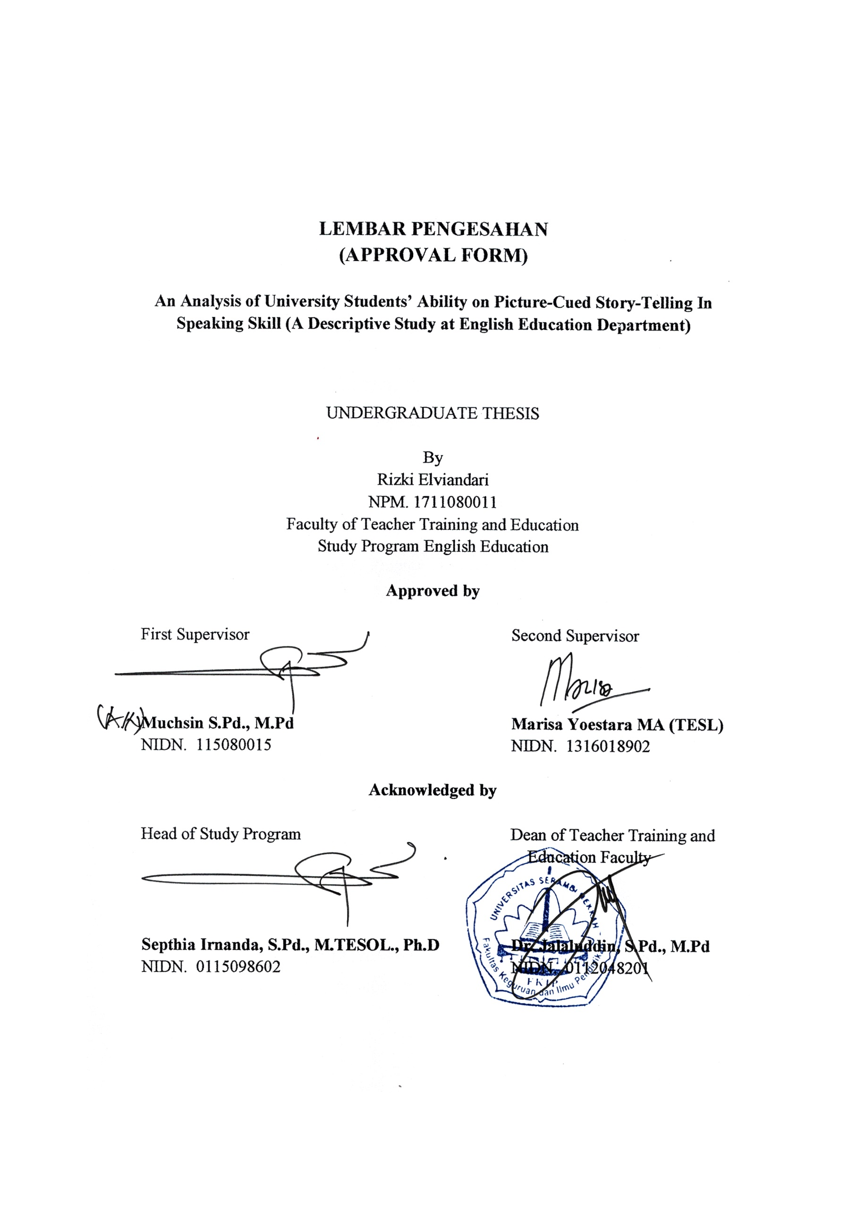
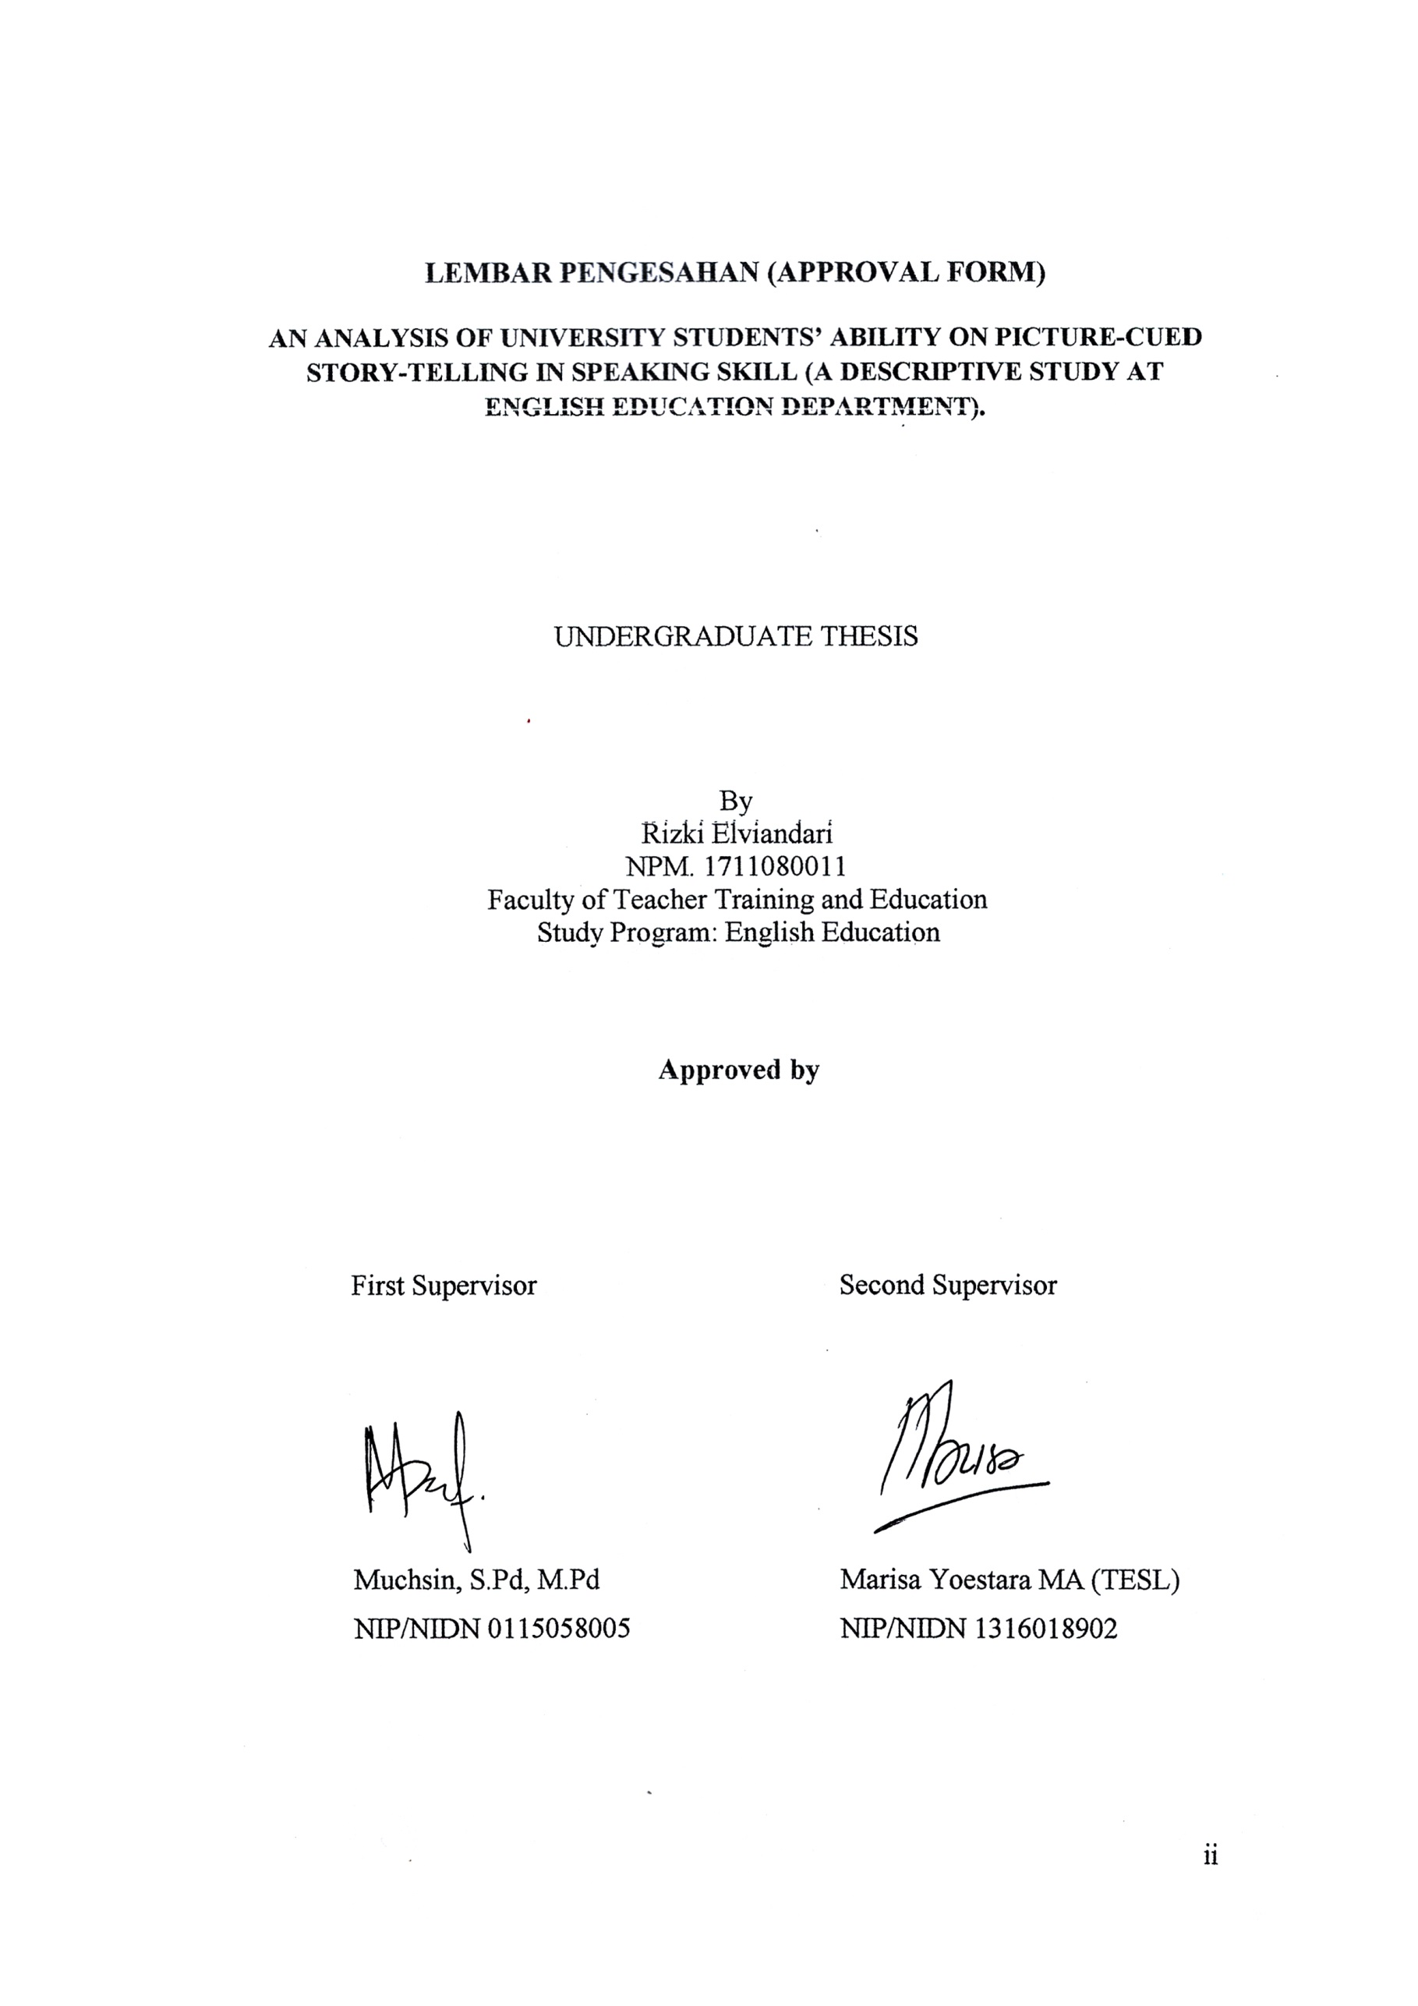
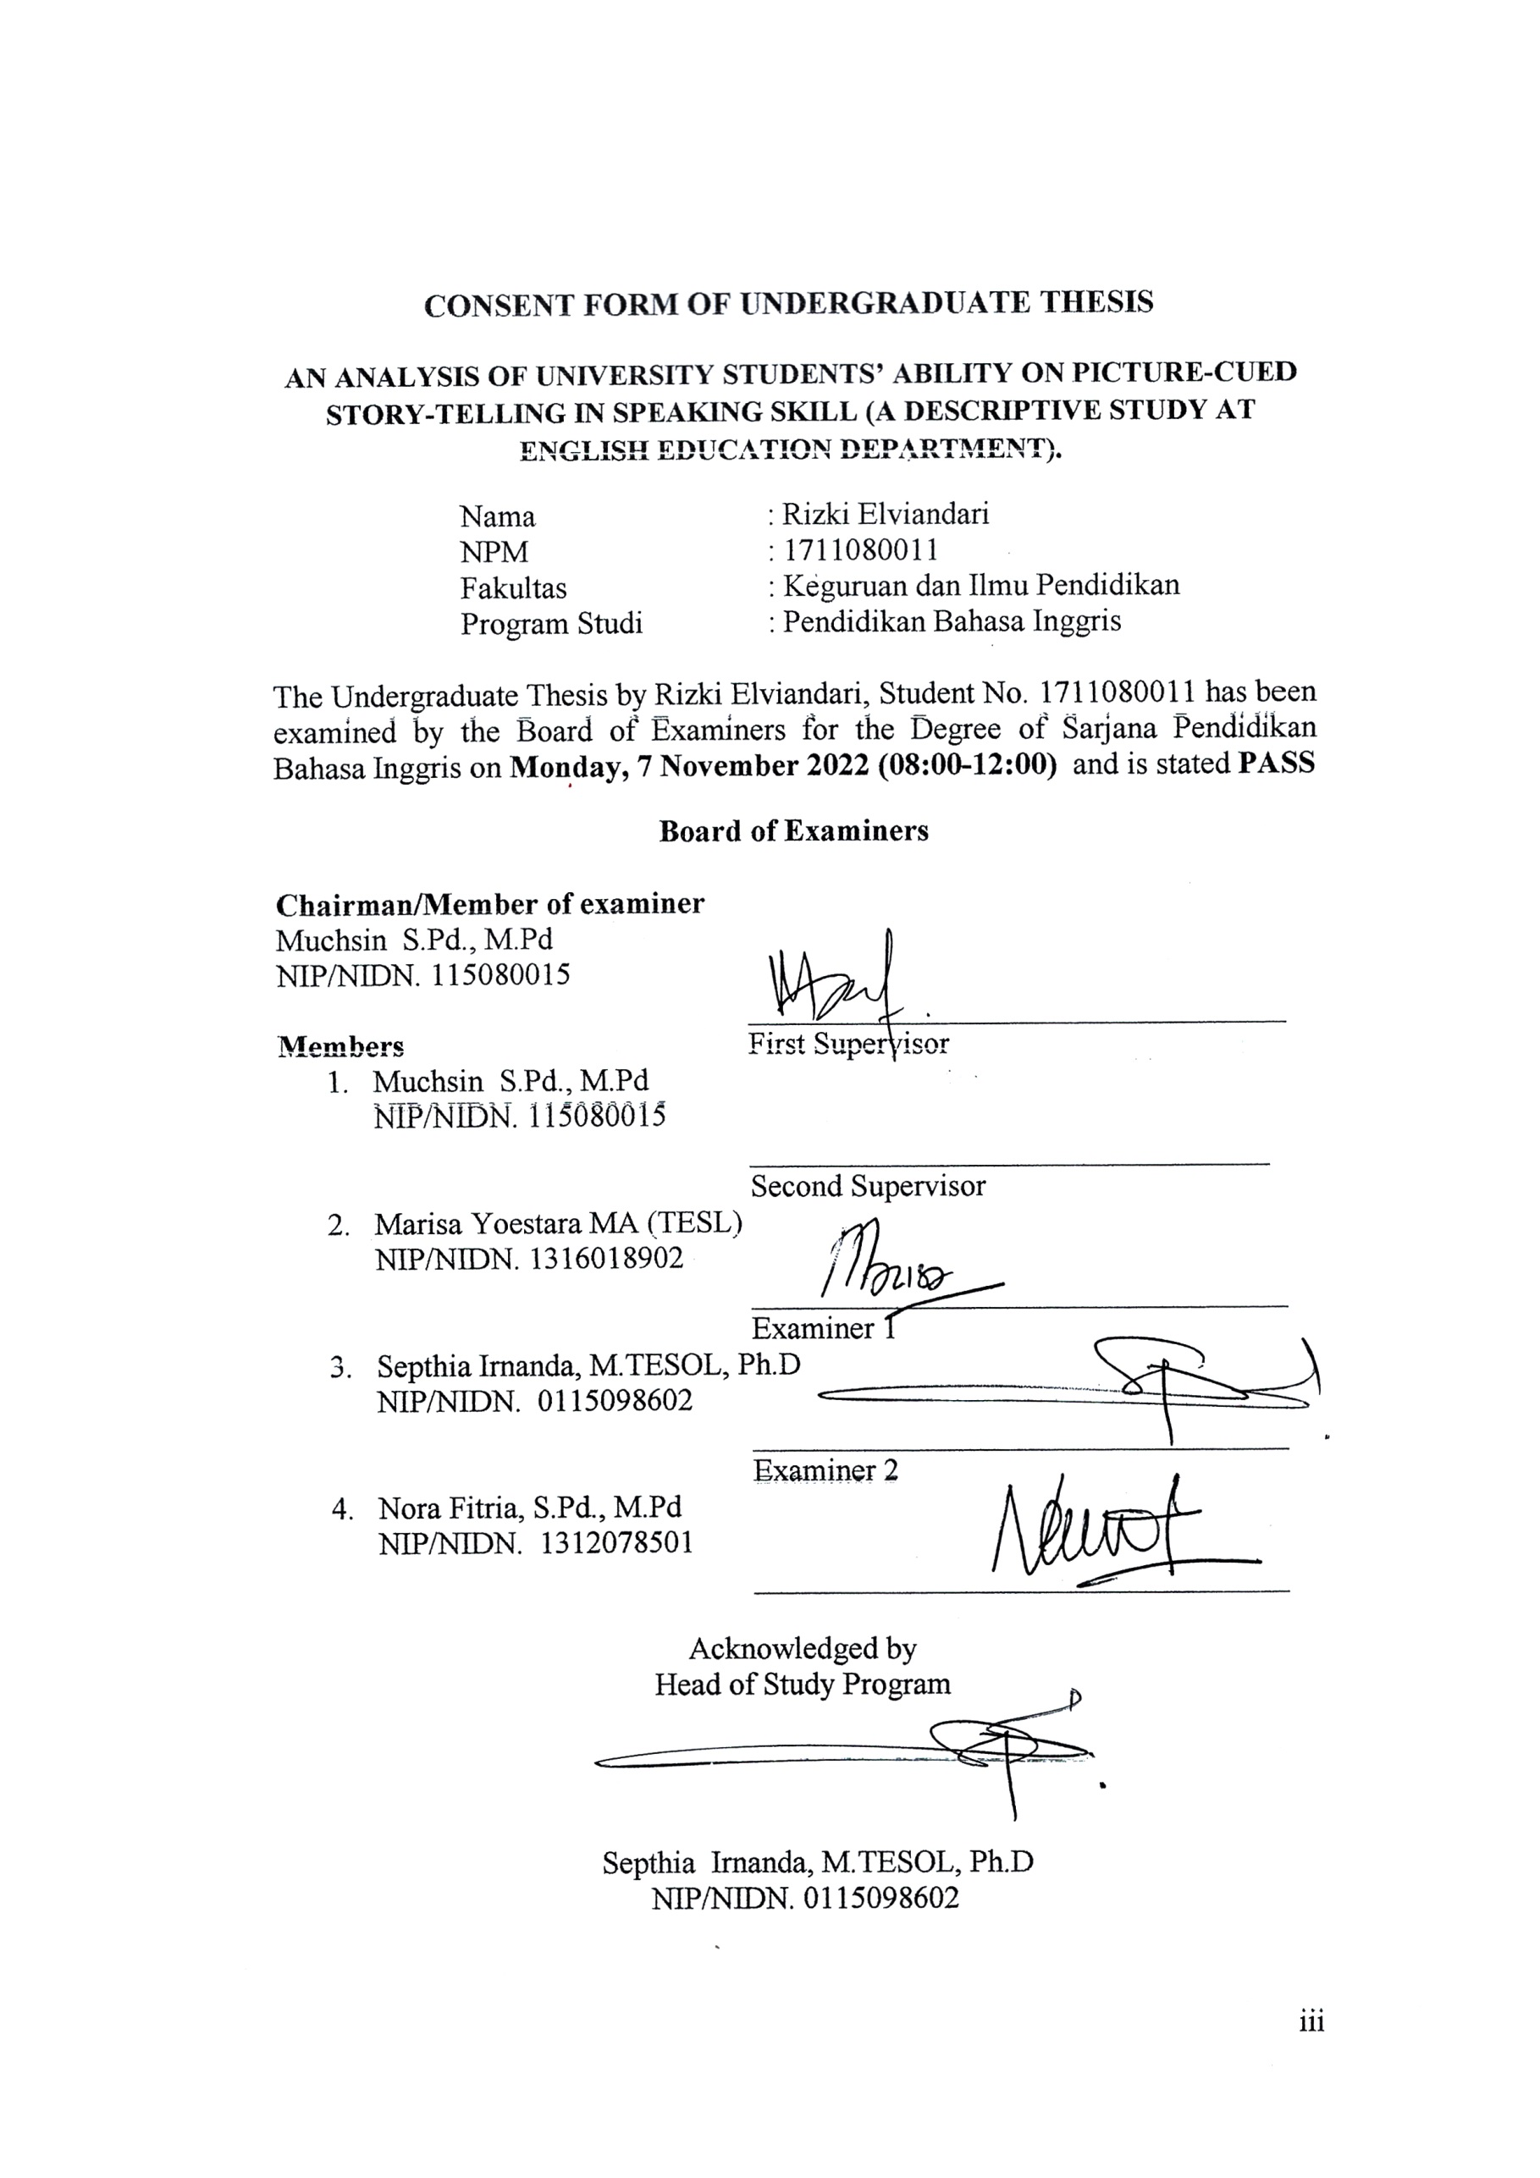
PERSONAL STATEMENT

Saya yang bertanda tangan di bawah ini
Nama | : Rizki Elviandari
NPM | : 1711080011
Prodi | : Pendidikan Bahasa Inggris
Judul Skripsi | : An Analysis Of University Students’ Ability On Picture-Cued Story-Telling In Speaking Skill (A Descriptive Study At English Education Department).
dengan ini menyatakan bahwa Skripsi ini merupakan hasil karya tulis ilmiah saya sendiri, dan bukanlah merupakan karya orang lain yang pernah diajukan untuk memperoleh gelar sarjana atau dipublikasikan lewat media apapun. Adapun karya atau pendapat pihak lain yang dikutip, baik secara langsung atau tidak langsung ditulis sesuai dengan kaidah penulisan ilmiah yang berlaku.
Pernyataan ini saya buat dengan penuh tanggung jawab dan saya bersedia menerima segala konsekuensi apapun sesuai dengan aturan dan hukum yang berlaku bilamana dikemudian hari diketahui bahwa pernyataan saya ini tidak benar..
Banda Aceh, 17 Oktober 2022
Peneliti

Rizki Elviandari
NPM. 1711080011

Acknowledgement

All praises be to Allah the merciful and the beneficent, who always protects and guides us in this life, and who gives me strength to finish the thesis entitled “An Analysis of University Students’ Ability On Picture-Cued Story-Telling in Speaking Skill (A Descriptive Study At English Education Department)”. I would also like to express salutation to our Prophet Muhammad SAW. who had kept directing us to the right path of life.
This thesis will not be finished without contribution from my supervisors. So, I would like to express my deepest gratitude to Mr. Muchsin, S.Pd, M.Pd, as my first supervisor and Ms. Marisa Yoestara, S.Pd., M.A. as my second supervisor, and to all lecturers of the English Department in University of Serambi Mekkah who have taught and guided me during my academic study.
Furthermore, I would like to thank my beloved father Rahimuddin, my beloved mother Rosita, and I would like to thank to all of my siblings, to my first sister Juwindari, my second sister Agus Tiandari, and my last sister Trijajayandari, and also to my brother Selamat Hari Sanjaya, who always encourage me to do things in my life. I also want to express my gratitude to my friends who always help and support me during completing this thesis. Thanks to Asri Mawarni, Salsabila, Cut Lisna Mutia, Maulisa, Cut Nurjannah, and all of the other English Department students in the academic year 2017.
Finally, i would like to express my gratitude to the big family of English Department, especially for all students in semester 4, 6, 8 who have helped me in doing my research. Last but not least i also thanks to all my friends who come from various countries who taught me many good things.

Banda Aceh, 17 October 2022

Rizki Elviandari
Abstract

Name : Rizki Elviandari
Student No. : 1711080011
Study Program : English Education
Thesis Title : An Analysis of University Students’ Ability Picture-Cued Story-Telling in Speaking Skill (A Descriptive Study at English Education Department)

The aim of this research is to know the university students’ ability on picture-cued story-telling in speaking skill. This research was conducted by using descriptive research design. The participants of this study were students at Serambi Mekkah University from semester 4, 6, and 8. Semester 4 consisted of 10 students, in semester 6 consisted of 10 students, and in semester 8 consisted of 10 students. So, the total sample was 30 students. In collecting the data, the writer used an instrument; that’s story-telling test. In analyzing the data, the researcher collecting the students' voice recordings, and the researcher listened them repeatedly in order to know the speech. The results of the story-telling test show that 70% of the students got a good achievement in speaking skill. Furthermore, 30% of the students got an excellent achievement in speaking skill. The writer concluded that the average value of the students' ability in picture-cued story-telling in speaking skill reaches the good category.

Keywords: Analysis, Ability, Picture-Cued Story-Telling

Abstrak

Name : Rizki Elviandari
Nomer Mahasiswa : 1711080011
Program Study : Pendidikan Bahasa Inggris
Judul Skipsi : Menganalisis Kemampuan Siswa Dalam Picture-Cued Storytelling Pada Kemampuan Berbicara (Sebuah Studi Deskriptif Di Pendidikan Bahasa Inggris)

Tujuan dari penelitian ini adalah untuk mengetahui kemampuan mahasiswa dalam bercerita dengan isyarat gambar dalam keterampilan berbicara. Penelitian ini dilakukan berdasarkan desain penelitian deskriptif. Partisipan dari penelitian ini adalah mahasiswa Universitas Serambi Mekkah dari semester 4, 6, dan 8. Dari semester 4 terdiri dari 10 mahasiswa, dari semester 6 terdiri dari 10 mahasiswa, dan dari semester 8 terdiri dari 10 mahasiswa. Jadi, jumlah keseluruhan sampelnya adalah 30 siswa. Dalam pengumpulan data, penulis menggunakan satu instrumen yaitu tes mendongeng. Dalam menganalisis data, peneliti mengumpulkan rekaman suara siswa, dan peneliti mendengarkan rekaman tersebut berulang kali untuk mengetahui kata kata dari rekaman tersebut. Hasil tes bercerita menunjukkan bahwa 70% siswa memperoleh nilai yang baik dalam keterampilan berbicara. Selanjutnya, 30% siswa mendapat nilai yang sangat baik dalam keterampilan berbicara. Penulis dapat menyimpulkan bahwa nilai rata-rata kemampuan siswa dalam bercerita dengan isyarat gambar dalam keterampilan berbicara mencapai kategori baik.

Kata Kunci: analisis, kemampuan, picture-cued story-telling

TABLE OF CONTENT

Page

Title Page i
Approval Form ii
Consent Form iii
Personal Statement iv
Acknowledgement v
Abstract vi
Abstrak vii
Table of Content viii
List of Tables x
List of Figures xi
List of Appendices xii

CHAPTER I INTRODUCTION
  - The Background of the Study 1
  - The Problem of the Study 3
  - The Aims of the Study 3
  - The Significance of the Study 3
  - The Scope of the Study 3
  - The Definition of Key Terms 4
  - The Organization of the Study 4

CHAPTER II LITERATURE REVIEW
- The Definition of Speaking 5
- The Elements of Speaking 6
- Speaking Assessment 8
- Types of Assessment in Speaking 10
- Picture-Cued Story-Telling 13

CHAPTER III RESEARCH METHODOLOGY
  - The Research Method 15
  - The Research Participants 15
  - The Research Instrument 15
  - The Data Analysis 16

CHAPTER IV RESEARCH FINDINGS AND DISCUSSION
  - Research Findings 18
  - Discussion 21

CHAPTER V CONCLUSIONS AND SUGGESTIONS
  - Conclusion 23
  - Suggestion 23
References 25
Appendices
Autobiography

LIST OF TABLE

Table 1. The 6 Aspects 16
Table 2. Table of The average of the ability of speaking skills in English education department student’s on picture-cued story-telling 18
Table 3. Categorization Table 20

LIST OF FIGURE

Figure 1. The percentage results of speaking ability of the students of the English Education Department in Picture-Cued Story-Telling 21

LIST OF APPENDICES

- Appendix 1 The Instrument
- Appendix 2 The Guidance Letter
- Appendix 3 The Research Stipulation Letter
- Appendix 4 The Documentation of the Study
- Appendix 5 The Result Of Students Voice Recordings

CHAPTER I
INTRODUCTION

The Background of the Study
In this globalization era, there have been drastic changes taking place all over the world. This extraordinary change occurs when people have a strong desire to achieve something. People's desires are fulfilled when they clearly express their ideas and opinions to others. Rao (2018) said they need to learn communication skills to fulfill their ambitions, desires, and goals. In this modern world, communication skills play a vital role and one must have mastery over these skills to get success in their respective fields. Therefore, speaking is the most important skill among all of the four language skills to communicate well in this global world. As English is widely used all over the world, there is a need for learners to acquire the communication skills of it to get success in their respective fields. Speaking is an ability to convey messages through spoken language (Darmuki, dkk: 2016).Speaking is the ability to convey messages orally (Darmuki, dkk : 2017)
According to Tarigan (2008), speaking is an important tool to communicate or to deliver mind things about what the speaker will be saying to their society. That is why speaking is very important. There are many ways to assess speaking; one of them is Picture-Cued Story-Telling. Luoma (2004), speaking skill is an important part of the curriculum in language teaching preliminary research was carried out to find out what lessons have been taught, as well as what syllabus and assessment techniques were used by the teacher. One of the ways to assess speaking ability that is interesting and able to make students' have better speaking skills is picture-cued storytelling. To assess whether speaking ability becomes attractive to the students; the researcher used a media such as picture-cued to create a new situation in speaking assessment. There are some advantages of using picture-cued story-telling in assessing speaking. First, the students can generate their ideas according to the picture given, to be able to speak fluently. Moreover, in the speaking process, the students not only speak but also try to make an interesting narrative monologue. The other advantage of using pictures is that it is easy to be applied. The picture is very simple and it can be found on the internet.
According to Brown (2004), picture-cued storytelling is one of the ways to assess students' speaking-based skills on a series of pictures on cue cards that they previously see and then they describe it. It means that in the pictured-cued storytelling assessment, a series of pictures are provided to the students’ and after seeing the pictures, the students’ tell the story based on the pictures in storytelling. Richards (2002) states a large percentage of the world's language, learners study English to develop proficiency in speaking. In short, the ability to English is measured by the result of speaking skills or oral communication. One of the ways to assess speaking ability that is interesting and able to make students' have better speaking skills is picture-cued storytelling. As a prospective English teacher, of course, students’ majoring in English from the Serambi Mekkah University are expected to have the ability to speak; especially in picture-cued storytelling, because in the future, they will teach their students’ in many ways, one of them is picture cued storytelling.
Based on previous studies data by Komang (2017), Assessing Speaking Ability through Picture-Cued Storytelling of the Ninth Grade Students of the Junior High School National Denpasar in Academic Year 2016/2017, she said that 7.50% of the samples got excellent achievement in speaking ability, 27.50% of the samples got a good achievement, 35.00% of the samples got a sufficient achievement, 15.00% of the samples got an insufficient achievement, and 15.00% of the criteria of a good research instrument. Putinela (2016), Assessing Speaking Skill through Picture-Cued Storytelling of the Eleventh Grade Students of SMK Kharisma Mengwi in Academic Year 2015/2016, she said that there were 65% or 30 samples under the study succeeded in the assessment of speaking skill through picture-cued storytelling. The number of samples that succeeded, showed that the achievement of speaking skills of the eleventh-grade students of SMK Kharisma Mengwi in the academic year 2015/2016 were also sufficient.
However, there has been no similar research that discusses the ability of picture-cued storytelling for University students’ at the University of Serambi Mekkah, so the researcher will conduct a study with the title "An Analysis of University Students' Ability on Picture-Cued Story-Telling in Speaking Skill (A Descriptive Study at English Education Department)”.

The Problem of the Study
The formulation of the problem in this study is: How is the university students' ability on picture-cued story-telling in speaking at english education department?

The Aim of the Study
The purpose of this research is based on the formulation of the existing problems, namely: To know the university students' ability on picture-cued story-telling in speaking skill.

The Significance of the Study
The significance of the study for students:
They become more aware of their ability in picture-cued storytelling.

The Scope of the Study
The scope of this research is limited to analyzing the university students’ ability on picture-cued story-telling in speaking skill at English education department, especially the students in semesters fourth, sixth, and eighth who already took language testing classes. The assessments in this test are assessed by 6 components.

The Definition of Key Terms
- Analysis: Analysis is a careful study of something to learn about its part
- Ability: Ability is talent, skill, or proficiency in a particular area.
- Picture-cued storytelling: Picture-cued storytelling is retold or explains something thru the picture.
The Organization of the Study
This study consists of five chapters. The first chapter is the introduction
that describes the background of the study, the problem of the study, the
aim of the study, the significance of the study, the scope of the study,
the definition of key terms and the organization of the study.
The second chapter is a literature review that consists of the definition of speaking, the element of speaking, speaking assessment, types of assessment in speaking, and picture-cued storytelling.
The third chapter is research methodology consists of the research method, the research participants, the research instrument, and the data analysis.
The fourth chapter is result and discussion of the research. This chapter describes students' achievement in speaking skills on Picture-Cued Story-Telling, the researcher discusses the results of the oral tests that students have taken. This is indicated by English Education Department students.
Finally, the fifth chapter is the last chapter which consists of conclusions and suggestions and this research will be closed with an appendix and an autobiography.

CHAPTER II
LITERATURE REVIEW

The Definition of Speaking
According to Brown (2004), speaking is a productive skill that can be directly and empirically observed; those observations are invariably colored by the accuracy and effectiveness of a test taker’s listening skill, which necessarily compromises the reliability and validity of an oral production test. Speaking in a classroom involves the interaction between teachers and students or among the students’ which depends on how classroom activities are organized. Compared with writing and reading skill (commonly assumed as written language, and receptive skills), speaking has some distinctive characteristics. In speaking, speakers do not typically speak complete sentences; use less specific vocabulary than in written language.
According to Harmer (2007), speaking is the ability to speak fluently and presupposes not only knowledge of language features, but also the ability to process information and language “on the spot”. Turk (2003) states that speaking is a heightened version of familiar day-to-day interactions. It can be seen in the students’ daily communication with others. The students’ professionalism must include certain largeness, ebullience, confidence, and grasp of themself and their material, which can hold the audience’s interest. The performance must be maintained. In addition, lapses or gap in performance is carefully covered. It means that speaking is an important part of the student's daily life and it needs to be maintained to communicate and convey their ideas well. Nation and Newton (2009) state that speaking as a part of work or academic study may involve presenting reports or presenting a viewpoint on a particular topic. Learning English does not mean just learning about the structure grammar and vocabulary, but also learning how to speak the language for good communication with one another since it takes an important part to everybody to avoid misunderstanding during the communication. argues that to the most people, mastering the art of speaking is the single most important aspect of learning a second or foreign language, and Nunan (2001) success is measured in term of the ability to carry out a conversation in the language. As English is widely used all over the world, there is a need for learners to acquire the communication skills of it to get success in their respective fields. Thornbury (2005) states that speaking is a part of daily life that people take for granted. Speaking is used by people to communicate with the others to share information in some different form. He also states that speaking is a speech production that becomes a part of the student’s daily activities. Most of the speaking activities are in form of face-to-face dialogue. Based on the above understanding, it can be concluded that speaking is a productive skill. Speaking in class involves interaction between teachers and students or between students depending on how the classroom activities are organized. Compared to writing and reading skills, speaking has several distinctive characteristics. In speaking, the speaker usually does not pronounce complete sentences, only by using less specific vocabulary than in written language, but the sentence will still be understood.

The Elements of Speaking
According to Brown (2004), the element of speaking is divided into six parts, that’s pronunciation, grammar, vocabulary, fluency, comprehension, and task.
- Pronunciation
Yates and Zelinski in Hasan (2014) state that pronunciation refers to how we produce the sound that we use to make meaning when we speak. It includes the particular consonants and vowels of a language (segments), aspects of speech beyond the level of individual segments, such as stress, timing, rhythm, intonation, phrasing (suprasegmental aspects), and how the voice is projected (voice quality).

- Grammar
According to Richard (2008), grammar is one of the skills involved in using speaking as performance is using correct pronunciation and grammar. The grammar of the language is the description of how words can change their forms. The function of grammar is to arrange the meaning of sentences and it is used to avoid misunderstanding among the speakers. Grammar refers to the fundamental principles and the structure of the language, including clear and correct sentence construction.
- Vocabulary
According to Lehr (2004) vocabulary is knowledge of words and words meaning in both oral and print language and in productive and receptive forms which are used in listening, speaking, reading, and writing
- Fluency
Pollard (2008) states that in the measured fluency aspect of the students, the teacher should allow students to express themselves freely without interruption. The aim is to help students to be fluent with ease. The teacher shall not correct the students immediately. The idea of having many corrections into sentences in that language.
- Comprehension
Comprehension is the ability to get or grasp ideas with the mind. Comprehension refers to students’ understanding of something that they are saying. This aspect is related to the picture-cued storytelling test which is used as the instrument of the present study. This technique needs students’ comprehension while preparing to understand the meaning of each picture of they can make a narrative monologue based on the given picture.
- Task
According to Branden (2006), a task is an activity in which a person engages to reach an objective and requires the use of language

Speaking Assessment
There are six components of speaking to be scored; pronunciation, grammar, vocabulary, fluency, comprehension, and task as Brown (2004) has stated.

Pronunciation
5 = equivalent to and fully accepted by an educated native speaker
4 = errors in pronunciation are quite rare
3 = errors never interfere with understanding and rarely disturb the native speaker. The accent may be foreign.
2 = accent is intelligible though often quite faulty.
1 = errors in pronunciation are frequent but can be understood by a native speaker used to dealing with foreigners attempting to speak his language.

Grammar
5 = equivalent to that of an educated native speaker.
4 = able to use the language accurately on all levels normally pertinent to professional needs. Grammar errors are quite rare.
3 = control of grammar is good. Able to speak the language with sufficient structural accuracy to participate effectively in most formal and informal conversations on practical, social, and professional topics.
2 = can usually handle elementary constructions quite accurately but does not have thorough or confident control of the grammar.
1 = errors in grammar are frequent, but the speaker can be understood by a native speaker used to dealing with foreigners attempting to speak his language.
Vocabulary
5 = speech on a level is fully accepted by educated native speakers in all its features including breadth of vocabulary and idioms, colloquialisms, and pertinent cultural references.
4 = can understand and participate in any conversation within the range of his experience with a high degree of precision of vocabulary.
3 = able to speak the language with sufficient vocabulary to participate effectively in most formal and informal conversations on practical, social, and professional topics. Vocabulary is broad enough that he rarely has to grope for a word.
2 = has speaking vocabulary sufficient to express himself simply with some circumlocutions.
1 = speaking vocabulary inadequate to express anything but the elementary
needs.

Fluency
5 = has complete fluency in the language such that his speech is fully accepted by educated native speakers.
4 = able to use the language fluently on all levels normally pertinent to professional needs. Can participate in any conversation within the range of this experience with a high degree of fluency.
3 = can discuss the particular interest of competence with reasonable ease. Rarely has to grope for words.
2 = can handle with confidence but not with facility most social situations, including introductions, and casual conversations about current events, as well as work, family, and autobiographical information.
1 = (no specific fluency description. Refer to other four language areas for the implied level of fluency).

Comprehension
5 = Equivalent to that of an educated native speaker.
4 = can understand any conversation within the range of his experience.
3 = comprehension is quite complete at a normal rate of speech.
2 = can get the gist of most conversations on non-technical subjects (i.e., topics that require no specialized knowledge)
1 = within the scope of his very limited language experience, can understand simple questions and statements if delivered with slowed speech, repetition, or paraphrasing

Task
5 = speaking proficiency equivalent to that of an educated native speaker.
4 = would rarely be taken for a native speaker but can respond appropriately even in unfamiliar situations. Can handle informal interpreting from and into language.
3 = can participate effectively in most formal and informal conversations on practical, social, and professional topics.
2= able to satisfy routine social demands and work requirements; needs help in handling any complications or difficulties.
1 = can ask and answer questions on topics very familiar to him. Able to satisfy routine travel needs and minimum courtesy requirements, Brown (2004).

Types of Assessment in Speaking
Types of Assessment in Speaking Brown (2004):

- Imitative Speaking
Imitative speaking is the ability to imitate (parrot back) a word or phrase or possibly a sentence. Examples of imitative speaking are, Repetition Task which can be started from minimal pair repetition, word/phrase repetition, and sentence repetition. The second is the PhonePass Test, which is a popular test that uses an imitative production task is phonepass, a widely used, commercially available speaking test in many countries. The PhonePass test elicits computer-assisted oral production over a telephone. Test-takers read aloud, repeat sentences, say words, and answer questions.
- Intensive Speaking
Intensive speaking goes one step beyond imitative to include any speaking performance that is designed to practice some phonological and grammatical aspects of language. Examples of intensive assessment tasks include directed response tasks, it is the test administrator elicits a particular grammatical form or a transformation of a sentence. Next read-aloud tasks, it is include reading beyond the sentence level up to a paragraph or two. Next sentence/dialogue completion tasks and oral questionnaires, test-takers are first given time to read through the dialogue to get its gist and to think about appropriate lines to fill in. Next picture-cued tasks, it is one of the more popular ways to elicit oral language performance at both intensive and extensive levels is a picture-cued stimulus that requires a description from the test-takers. Next translation (of Limited Stretches of Discourse), it is part of our tradition in language teaching that we tend to discount or disdain, if only because our current pedagogical stance plays down its importance. Next responsive speaking, is interaction at the somewhat limited level of a very short conversation, standard greeting and small talk, simple comments and requests, and the like. The next question and answer, it is can consist of one or two questions from an interviewer, or they can make up a portion of a whole battery of questions and prompts in an oral interview. Next giving instructions and directions, this type of assessment entails a student asking the teacher questions. Essentially, the student assumes control over the conversation. Next paraphrasing, the type of assessment requires students to listen to a 4 to 6-sentence paragraph. Upon finishing the paragraph, instructors prompt students to give a 1 to 2-sentence summary of what they just heard. The next Test of Spoken English (TSE Test), is a standardized test that measures the ability of non-native speakers of English to communicate orally in North American English.

- Responsive Speaking
Responsive speaking is interaction at the somewhat limited level of a very short conversation, standard greeting and small talk, simple comments and requests, and the like. The next, question and answer, it is can consist of one or two questions from an interviewer, or they can make up a portion of a whole battery of questions and prompts in an oral interview. Next giving instructions and directions, this type of assessment entails a student asking the teacher questions. Essentially, the student assumes control over the conversation. Next paraphrasing, the type of assessment requires students to listen to a 4 to 6-sentence paragraph. Upon finishing the paragraph, instructors prompt students to give a 1 to the 2-sentence summary of what they just heard. The next Test of Spoken English (TSE Test), is a standardized test that measures the ability of non-native speakers of English to communicate orally in North American English.

- Interactive Speaking
Interactive speaking is; complex interaction that sometimes includes multiple exchanges and/or multiple participants. Examples of interactive assessment tasks include an Interview; it is a test administrator and a test-taker sit down in direct face-to-face exchange and proceeds through a protocol of questions and directives. Next role play is a popular pedagogical activity in communicative language teaching classes. Within constraints set forth by the guidelines, it frees students to be somewhat creative in their linguistic output. Role play allows some rehearsal time so that students can map out what they are going to say. Next discussion and conversation, as an informal technique to assess learners, offer a level of authenticity and spontaneity that other assessment techniques may not provide. Discussion may be an especially appropriate task through which to elicit and observe such abilities. Next games, among informal assessment devices, are a variety of games that directly involve language production. The next Oral Proficiency Interview (OPI) is the result of a historical progression of revisions under the auspices of several agencies.

- Extensive Speaking
Extensive speaking is oral production; including speeches, oral presentation, and story-telling. Examples of extensive assessment tasks include oral presentations, it is also known as public speaking or simply presentations that consist of an individual or group verbally addressing an audience on a particular topic. The next retelling of a story, a news event, is the reconvening of events in words, images, and sounds, often by improvisation or embellishment. The next translation (of Extended Prose), is a process of transforming one language into another. The last is Picture-Cued Story-Telling, Brown (2004).

Picture-Cued Storytelling
Picture-Cued Storytelling is one of the ways used to assess students’ ability based on a series of pictures on cue cards that they previously see and then they describe it. It means that in the pictured-cued storytelling assessment, the series of pictures are provided to the students’ and after seeing the pictures, the students’ tell the story based on the pictures on a storytelling. According to Broughton et al. (2004), visual stimuli maps, photographs, pictures, cartoons, even slides, and films were another useful source of oral language practice. A picture can represent the real situation and relate learning to real situation and relate learning to real life. Moreover, it can easily present the concept or meaning of words or sentences. Picture may also lead students to be more interested and motivated in learning a language. Besides, students can easily express their ideas based on the rendered picture. In addition, there are numerous definitions of picture-cued storytelling. In this case, the researcher wants to quote some related definitions of picture-cued storytelling based on the need of this researcher, through storytelling, students not only practice an essential skill, but they can also practice entertaining themselves and others through their interesting stories. Storytelling is one of the ways in assessing speaking. This assessment can improve the student’s motivation to be more active in speaking English because the cue cards consist of pictures and colors so they easily gain the idea.
One of the most common ways to assess for eliciting oral production is through visual pictures, photographs, diagrams, and charts. We have already looked at this elicitation device for intensive tasks, but at this level, we consider a picture or a series of pictures as a stimulus for a longer story or description.

CHAPTER III
RESEARCH METHODOLOGY

3.1 The Research Method
This study used a descriptive research design. According to Williams (2007), descriptive research is a research method that can determine the situation in current the phenomenon. The use of descriptive research method in this research is to analyze the university students’ ability on picture-cued story-telling in speaking skill.

3.2 The Research Participants
The populations of this study are all students English education department. Meanwhile, the research samples are the students in 4, 6, and 8 semester classes who already took language testing classes, the researcher will take 10 students from each semester. Therefore, the total is 30 students.

3.3 The Research Instrument
The instrument applied in this research is a story-telling test. This research will take a story-telling test of students' voice recording about the video that students have watched orally, then the researcher gave the students to watch together the videos that had been prepared in one class, and give the students 12 cue cards, and then the students take turns individually to describe the story in the pictures spontaneously in front of the researcher. To delivered this experiment, and also to assess the 6 aspects that must be assessed, all of that is done only by the researcher. In one class, this test lasts one day for approximately 2 hours.

3.4 The Data Analysis
In analyzing the data, the researcher collects the students' voice recordings, and then the researcher will listen to them repeatedly to know the speech.
To analyze the data this study used the Formula by Brown (2004):
$$SA=\frac{C+F+G+P+V+T}{6}$$
Explanation:
SA =Speaking ability score
C =Comprehension score
F =Fluency score
G =Grammar score
P =Pronunciation score
V =Vocabulary score
T =Task score (Accomplishing the objective of the elicited task), Brown (2004).

Table 1. The 6 Aspects
No | Aspect | Test Score |  |  |  | Total Score
No | Aspect | 0-49 | 50-59 | 60-79 | 80-100
1 | Grammar
2 | Vocabulary
3 | Pronunciation
4 | Fluency
5 | Comprehension
6 | Task

$$Students score=\frac{Total score}{6}=…$$
Explanation:
0-49 : Poor
50-59 : Average
60-79 : Good
80-100: Excellent

CHAPTER IV
RESEARCH FINDINGS AND DISCUSSION
In this chapter, the researcher presents the research results and discussion. After collecting data from English Education Department students' at the University of Serambi Mekkah, the researcher discussed how the Ability of speaking skills students' on Picture-Cued Story-Telling.

  - Research Findings
    - The Ability of Speaking Skills English Education Department Students' on Picture-Cued Story-Telling.
This table describes the ability of speaking skills English Education Department students' on Picture-Cued Story-Telling. The ability is indicated by the results of the oral tests that students have taken. This is indicated by English Education Department students'.

Table 2. The average score of the ability of speaking skills in English
Education Department students' on Picture-Cued Story-Telling
No | Students’  Name | Aspect |  |  |  |  |  | Total  Score
No | Students’  Name | G | V | P | F | C | T | Total  Score
1 Student 1 |  | 85 | 80 | 90 | 85 | 85 | 80 | 85
2 Student 2 |  | 82 | 80 | 85 | 78 | 80 | 80 | 81
3 Student 3 |  | 75 | 72 | 79 | 72 | 70 | 70 | 73
4 | Student 4 | 85 | 75 | 80 | 75 | 75 | 70 | 77
5 | Student 5 | 85 | 75 | 85 | 75 | 80 | 75 | 80
6 | Student 6 | 73 | 70 | 80 | 75 | 75 | 75 | 75
7 | Student 7 | 80 | 70 | 79 | 72 | 72 | 70 | 74
8 | Student 8 | 75 | 62 | 70 | 70 | 78 | 75 | 72
9 | Student 9 | 80 | 75 | 79 | 75 | 75 | 70 | 76
10 | Student 10 | 60 | 63 | 62 | 60 | 68 | 65 | 63
11 | Student 11 | 75 | 76 | 79 | 75 | 80 | 78 | 76
12 | Student 12 | 85 | 80 | 92 | 80 | 80 | 75 | 82
13 | Student 13 | 80 | 75 | 82 | 80 | 83 | 80 | 80
14 | Student 14 | 74 | 77 | 75 | 75 | 72 | 70 | 74
15 | Student 15 | 67 | 65 | 70 | 63 | 70 | 70 | 68
16 | Student 16 | 80 | 74 | 82 | 70 | 75 | 73 | 76
17 | Student 17 | 60 | 65 | 68 | 63 | 72 | 72 | 67
18 | Student 18 | 83 | 80 | 88 | 85 | 80 | 78 | 82
19 | Student 19 | 78 | 77 | 75 | 77 | 78 | 76 | 77
20 | Student 20 | 65 | 60 | 70 | 60 | 65 | 60 | 63
21 | Student 21 | 69 | 65 | 60 | 60 | 73 | 70 | 67
22 | Student 22 | 88 | 83 | 90 | 80 | 85 | 85 | 86
23 | Student 23 | 57 | 59 | 60 | 60 | 70 | 70 | 63
24 | Student 24 | 65 | 68 | 65 | 69 | 75 | 72 | 69
25 Student 25  26 Student 26 |  | 88 | 85 | 92 | 85 | 88 | 85 | 88
 |  | 77 | 73 | 75 | 75 | 65 | 65 | 72
27 Student 27 |  | 68 | 65 | 70 | 72 | 75 | 75 | 71
28 | Student 28 | 90 | 83 | 85 | 80 | 88 | 85 | 86
29 | Student 29 | 69 | 75 | 77 | 73 | 75 | 74 | 74
30 | Student 30 | 73 | 75 | 75 | 72 | 75 | 75 | 75
Explanation:
G = Grammar score
V = Vocabulary score
P = Pronunciation score
F = Fluency score
C = Comprehension score
T = Task score (Accomplishing the objective of the elicited task)

Speaking assessment is assessed from 6 aspects, namely grammar, vocabulary, pronunciation, fluency, comprehension, and also task. It can be seen from the grammar scores that the highest score is 90, while the lowest score is 60, and the average value is 76. From the vocabulary scores that the highest score is 85, while the lowest score is 59, and the average value is 73. From the pronunciation scores that the highest score is 92, while the lowest score is 60, and the average value is 77. From the fluency scores that the highest score is 85, while the lowest score is 60, and the average value is 76. From the comprehension scores that the highest score is 88, while the lowest score is 65, and the average value is 76, and from the task scores that the highest score is 85, while the lowest score is 60, and the average value is 74. So, the lowest score of students' speaking is in the vocabulary aspect, while the highest score of students' speaking is in the pronunciation aspect.
From the table above, it can be seen that the highest score of students' speaking was 88 which was obtained by 1 student, the lowest score was 63 which was obtained by 3 students, and the average score of students was 75,1. To determine whether students' ability scores are good or bad, the researcher uses the learning assessment table proposed by Brown (2004):

Table 3. Categorization Table
Interval | Category
80 – 100 | Excellent
60 – 79 | Good
50 – 59 | Average
0-49 | Poor

Related to the data grouping of students' speaking ability scores, whether reach the category of poor, average, good, or excellent, look at the following figure:
Figure 1. The percentage results of speaking ability of the students of the English Education Department in Picture-Cued Story-Telling
70%
0%
0%
30%
Based on the figure above, it can be seen that the students’ speaking ability of the English Education Department students’ in Picture-Cued Story-Telling is 30% of the samples got the excellent achievement of speaking ability, 70% of the samples got the good achievement, and no one of the samples got average, and poor achievement concluded that the average score of students reached 75 in the good category.
  - Discussion
From the results obtained, it shows 30% of the samples got excellent achievement of speaking ability, 70% of the samples got a good achievement of speaking ability, and no one of the samples got average, and poor achievement of speaking ability in picture-cued storytelling, and the average score of student’s ability in picture-cued storytelling reached 75 in the good category. Speaking assessment is assessed from 6 aspects, namely grammar, vocabulary, pronunciation, fluency, comprehension, and also task. It can be seen from the grammar scores that the highest score is 90, while the lowest score is 60, and the average value is 76. From the vocabulary scores that the highest score is 85, while the lowest score is 59, and the average value is 73. From the pronunciation scores that the highest score is 92, while the lowest score is 60, and the average value is 77. From the fluency scores that the highest score is 85, while the lowest score is 60, and the average value is 76. From the comprehension scores that the highest score is 88, while the lowest score is 65, and the average value is 76, and from the task scores that the highest score is 85, while the lowest score is 60, and the average value is 74. So, the lowest score of students' speaking is in the vocabulary aspect, while the highest score of students' speaking is in the pronunciation aspect.
The result of the data analysis clearly pointed that the highest score of the students’ speaking ability in picture-cued storytelling was 88, and the lowest score was 63. The average score of student’s ability in picture-cued storytelling reached 75 in the good category. Therefore this result are different from the previous research by Komang (2017), where her research showed the average result achievement got an average category, which the average value is lower than this study, and in this study showed the average result achievement got a good category, which is the average value is higher than the previous study. Besides that, the aspects assessed in this study and the previous study are both assessed through aspects of grammar, fluency, and comprehension, but in this study, there are additional aspects, that is vocabulary, and pronunciation, whereas the previous study not focused on that aspect, so there are additional results.

CHAPTER V
CONCLUSSION AND SUGGESTION
  - Conclusion
Based on the results of the analysis and discussion of the data, the researchers obtained the following conclusions:
From the results obtained, it shows 30% of the samples got excellent achievement of speaking ability, 70% of the samples got a good achievement of speaking ability, and no one of the samples got average, and poor achievement of speaking ability in picture-cued storytelling, and the average score of student’s ability in picture-cued storytelling reached 75 in the good category. Speaking assessment is assessed from 6 aspects, namely grammar, vocabulary, pronunciation, fluency, comprehension, and also task. It can be seen from the grammar scores that the highest score is 90, while the lowest score is 60, and the average value is 76. From the vocabulary scores that the highest score is 85, while the lowest score is 59, and the average value is 73. From the pronunciation scores that the highest score is 92, while the lowest score is 60, and the average value is 77. From the fluency scores that the highest score is 85, while the lowest score is 60, and the average value is 76. From the comprehension scores that the highest score is 88, while the lowest score is 65, and the average value is 76, and from the task scores that the highest score is 85, while the lowest score is 60, and the average value is 74. So, the lowest score of students' speaking is in the vocabulary aspect, while the highest score of students' speaking is in the pronunciation aspect.
  - Suggestion
Based on the result of the study and the conclusion previously explained by the researcher, the researcher gives the following suggestion:
- Lecturers are advised to maintain their learning strategies, especially in picture-cued story-telling.
- Students are advised to maintain or improve their learning strategies, especially in picture-cued story-telling.
- For the future research suggested, this study can be used as a reference to conduct further research at different levels, universities, and material variations.

REFERENCES

Brasell, D., Jacobs, L. C., Sorensen, C,. and Razavieh, A. (2010). Introduction to Research in Education (8th ed.). Canada: Wadsworth Cengage Learning.
Broughton, et all. 2004. Teaching English as a Foreign Language. London: T.J.
Press (Padstow) Ltd
Brown, H. Douglas. 2004. Language Assessment: Principles and Classroom Practices. San Fransisco State University.
Darmuki, A., Andayani, Nurkamto, J., Saddhono, K. 2016. Model Student Learning To Speak For Education Study Language And Literature Indonesia: Document Analysis And Needs Learning To Speak. Prosiding Prasasti
Darmuki, A. Andayani. Nurkamto, J. Saddhono, K. 2017. Cooperative, Synetics, and CTL Learning Models toward Speaking Ability Viewed from Student’s Motivation. Advances in Social Science, Education and Humanities Research (ASSEHR)
Harmer, J.(2007). e practice of English language teaching (4th ed.). London: Longman
Komang (2017), Assessing Speaking Ability Through Picture-Cued Storytelling Of The Ninth Grade Students Of The Junior High School National Denpasar In Academic Year 2016/201. Mahasaraswati Denpasar University.
Lehr, F., Osborn, J., & Hiebert, E. H. (2004).A focus on vocabulary. Honolulu, HI:Pacific Regional EducationalLaboratory. Retrieved July 7, 2009.
Luoma, S. (2004). Assessing Speaking. Cambridge: Cambridge University Press.
Nation, I.S.P. and Newton, J. (2009). Teaching ESL and EFL Listening and Speaking. New York: Routledge Applied Linguistics.
Ni Komang, P.W. 2017. Assessing Speaking Ability Through Picture-Cued Storytelling Of The Ninth Grade Students. SMP National Denpasar.
Nunan, D. (2001). Language Teaching Methodology. Sidney: Prentice Hall.
Pollard, L. (2008). Guide to Teaching English: A Book to Help You through Your
First Two Years in Teaching. Lucy Pollard
Putinela (2016), Assessing Speaking Skill Through Picture-Cued Storytelling Of The Eleventh Grade Students of SMK KHARISMA MENGWI IN ACADEMIC YEAR 2015/2016. Mahasaraswati Denpasar University.
Rao, S. P.(2018), Developing Speaking Skills in ESL or EFL Settings. International Journal of English Language, Literature and Translation Studies
Richard. (2008). Learning to Teach.Jogjakarta: Pustaka Pelajar
Richards, J.C. and Renandya, W.A. (Eds). (2002). Methodology in language
teaching. Cambridge University Piress.
Tarigan. H. G. 2008. Speaking as a Language Skill. Bandung: Space.
Thornbury (2005), Scott, How to Teach Speaking, New York; Pearson Education Limited.
Turk, C. 2003. Effective Speaking: Communicating in Speech. London: Spon Press
Van den Branden, K. editor, 2006: Task-based language teaching in practice. Cambridge: Cambridge University Press.
Williams, C. (2007). Research Methods. Journal of Business & Economics Research (JBER), 5(3).
Zielinski, B., and Yates, L. (2014). “Pronunciation instruction is not appropriate for beginning-level learners,” in Pronunciation Myths: Applying Second Language Research to Classroom Teaching. ed. L. Grant (Ann Arbor: University of Michigan Press), 56–79.

Appendix 4 The Documentation of the Study

Picture 1. Students listen to instructions before taking the test
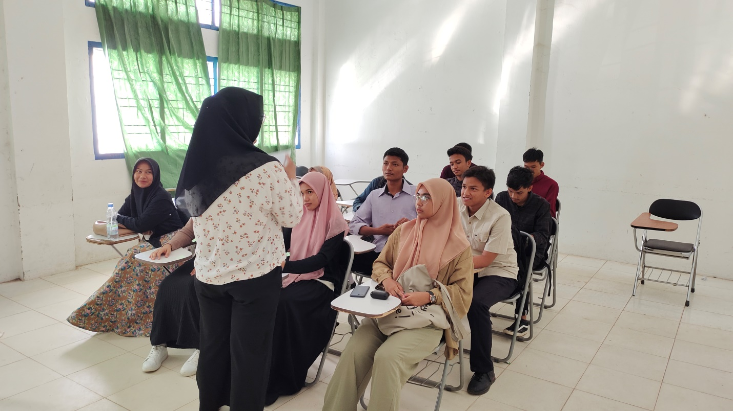

Picture 2. Students watching the video for the test
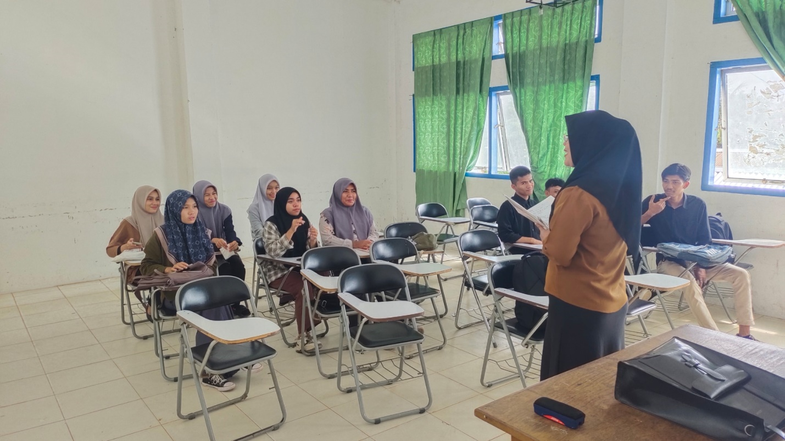
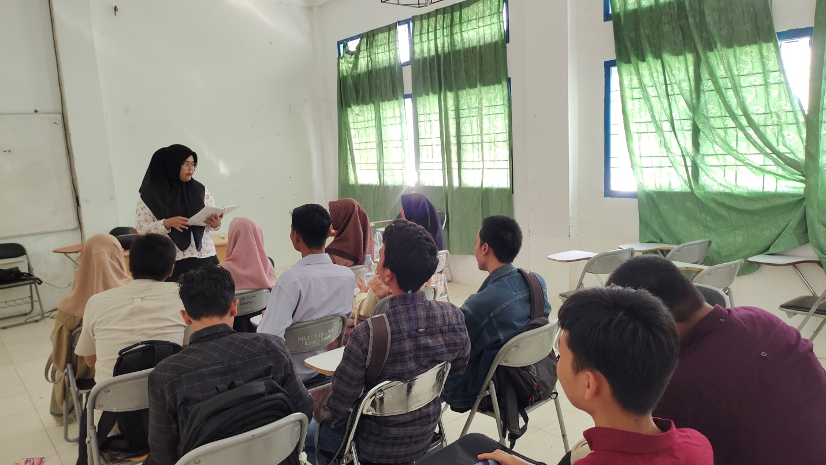
Picture 3. Distribute the cue cards to each student

Picture 4. Students come forward individually for the picture-cued story-telling test.

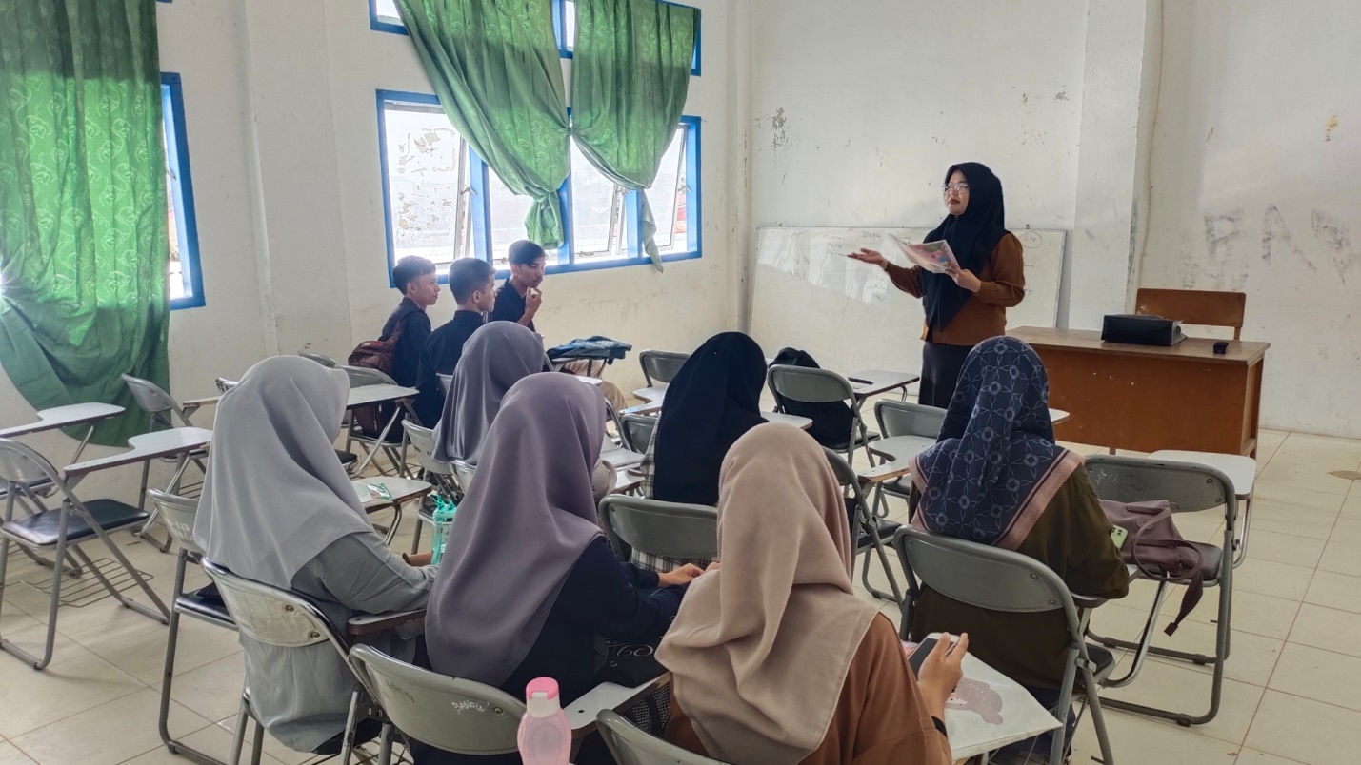
Appendix 5 , The results of student voice recordings

Hi, I ‘am Imam, so I am gonna explain the story about the picture.
So, there’s a man buying a meatball and he saw a girl talking on her cell phone, when he saw that girl, he is attracted by the beauty of that girl. When he see that girl suddenly a dog come close to him, the dog act like he want the meatball that in his hand, and he gave that meatball to that dog.
Then, the next day, there is someone who wanna put his car in the parking area, but the dog stand right there like forbidding that car to feel the parking slot.
After that, there are birds shitting at a car. When that dog see that, and he aware that’s the man’s car whose gave him food yesterday, so he trying to make the birds go away from that car. Not long after that, that dog see there is an another dog pissing at his car wheels, and that dog chases the other dog away from the car, after that that dog take a water pipe then spray that wheels to clean the wheels.
At night, the dog see that man come to his car, then that dog come to him and take his bag, and the man chases the dog somewhere, and not long after that, that dog stop and put his bag in the street, when he see around, then he see there is a girl who was on call yesterday. That girl was trying to find someone who can help her to fix her car, then that man asked her “may I help you”, and she said “yes please”, and after that they talk while trying to fixing her car, and then he is aware and happy knowing that dog trying to make him meet that girl again.

Once upon a time, there is man who is buying a fried meatball.When he was buying a fried meatball, he saw a woman from across the street who was talking on her cell phone. He was very mesmerized by her beauty. When he was busy watching the woman, there came a dog who patted his leg like asking for food that he had. When he saw the dog, without thingking too much he immediately gave the only fried meatball that he have to the dog,after that he left the dog.After that things happend, the dog that fed by him before tried to keep a parking space for him, and he didn't even realize that the dog did it for him, and also the dog didn't even allow it when someone wanted to fill the parking lot that he was kept for him. And when the dog noticed that the man's car was getting closer from the parking lot he had been kept, The dog hides and act like the parking lot is actually already empty. after that, when the dog saw poop of the birds felt right on top of the car next to the man's car, he also kept the man's car from being polluted by the bird droppings like the car next to the man's car, even the dog also tried to chase the bird away until the dog's face was attacked by the bird’s poop. When the man returned to his car, he wondered why his car was kept clean while the car next to his car was filled with bird’s poop. And when the man left his car at that place again, not long after that another dog peed right on the man's car tire, and the dog immediately chased the dog who was urinating in the man's car and chased him away, then the dog took the existing water hose and watered the man's car tire to make it clean again. When the man returned to his car again, he wondered to see the water hose right next to his car. After that he left his car again to go back to his work, not long after that, a security guard came to his car and looked for himself in the man's rearview mirror, and when the dog saw the security guard ,the dog immediately chased the security guard away and chased him.At night, when the man returned to his car, the dog immediately grabbed the man's bag,and the man chased that dog. Not far from where the dog was being chased, and the dog stopped in a place, and there is the woman that the man saw before and she was so confused because something happened to her car,and he talked to her.He looked at the dog and smile when he realized what the was doing. After that, he helped the woman to repair her car.

AUTOBIOGRAPHY


The researcher’s name is Rizki Elviandari, she was born on September 12, 1999, in Padang Tiji, Aceh Pidie. She lives in Kuta Alam, and her religion is Islam. She likes singing, swimming, shopping, and also traveling. Her father’s name is Rahimuddin, and her mother’s name is Rosita. She is the youngest child in her family; she has 3 sisters and a brother. Her first sister’s name is Juwindari, her second sister’s name is Agus Tiandari, and her last sister’s name is Trijajayandari, and also her brother’s name is Selamat Hari Sanjaya.
She graduated from SDN 1 Padang Tiji for 6 years in 2011. Then, she continued her study at MTsN 1 Padang Tiji for 3 years and graduated in 2014. After that, she continued her study at SMA Unggul Negeri 2 Boarding School Banda Aceh for 3 years and graduated in 2017. In 2017, she was finally completing her study in English Department at the University of Serambi Mekkah, Banda Aceh in 2022.

Banda Aceh. 17 October 2022
The writer

Rizki Elviandari
NPM. 1711080011

